

IRCC

Asylum Application

Draft Control Evidence Report



Prepared By

Avaleris Inc.

February 26, 2021

Prepared For

IRCC

# 

#### Document Change Control Log

|  |  |  |
| --- | --- | --- |
| Revision | Date Issued | Summary of Modifications |
|  | 12/02/2021 | Initial Document – Controls from Feb. 8th to Feb. 12th |
|  | 19/02/2021 | Updates – Controls from Feb. 15th to Feb. 19th |
|  | 26/02/2021 | Updates – Controls from Feb. 22th to Feb. 26th |
|  |  |  |
|  |  |  |
|  |  |  |
|  |  |  |
|  |  |  |
|  |  |  |
|  |  |  |

TABLE OF CONTENTS

1 Introduction 1

1.1 Background 1

1.2 Scope 2

1.3 Methodology 3

1.4 Conventions 4

1.5 References 4

1.6 Contributors 5

2 Control Evidence 6

2.1 Account Management (AC) 7

2.1.1 AC-1 7

2.1.2 AC-2 11

2.1.3 AC-2(2) 15

2.1.4 AC-2(4) 15

2.1.5 AC-3 16

2.1.6 AC-3(3) 21

2.1.7 AC-3(4) 22

2.1.8 AC-4 22

2.1.9 AC-4(1) 28

2.1.10 AC-4(8) 30

2.1.11 AC-6 35

2.1.12 AC-7 37

2.1.13 AC-6(1) 37

2.1.14 AC-7 39

2.1.15 AC-12 39

2.1.16 AC-15 40

2.1.17 AC-16 40

2.1.18 AC-20(4) 40

2.2 Awareness and training (AT) 41

2.3 Audit and Accountability (AU) 41

2.3.1 AU-2 41

2.3.2 AU-9 45

2.3.3 AU-9 (2) 45

2.3.4 AU-11 45

2.3.5 AU-12 46

2.4 Security Assessments (SA) 46

2.5 Configuration Management (CM) 46

2.5.1 CM-2(2) 48

2.5.2 CM-6(1) 48

2.5.3 CM-7 48

2.5.4 CM-7(5) 57

2.5.5 CM-10 59

2.6 Contingency Planning (CP) 62

2.6.1 CP-2(2) 62

2.7 Identity and Authentication (IA) 63

2.7.1 IA-1 63

2.7.2 IA-2 63

2.7.3 IA-2(1) 63

2.7.4 IA-2(2) 66

2.7.5 IA-2(6) 68

2.7.6 IA-2(7) 69

2.7.7 IA-2(11) 70

2.7.8 IA-3 70

2.7.9 IA-3(4) 70

2.7.10 IA-5 70

2.7.11 IA-5(1) 71

2.7.12 IA-5 (4) 72

2.7.13 IA-5 (6) 73

2.7.14 IA-5(8) 74

2.7.15 IA-11 74

2.8 Incident Response (IR) 74

2.8.1 IR-6 74

2.8.2 IR-6(1) 75

2.9 Maintenance (MA) 75

2.9.1 MA-4 75

2.10 Media Protection (MP) 75

2.11 System Security Plan (PL) 75

2.11.1 PL-8 75

2.12 Personnel (PS) 76

2.13 Risk Assessment (RA) 76

2.14 Security Authorization (SA) 76

2.14.1 SA-22 76

2.15 System Communications (SC) 77

2.15.1 SC-7 77

2.15.2 SC-7(10) 77

2.15.3 SC-15 79

2.15.4 SC-15(2) 80

2.16 Information Systems Monitoring (SI) 80

2.16.1 SI-3 80

2.16.2 SI-3(1) 81

2.16.3 SI-3(7) 81

2.16.4 SI-4 81

2.16.5 SI-4(2) 94

2.16.6 SI-4(5) 95

2.16.7 SI-4(7) 96

2.16.8 SI-4(12) 96

2.16.9 SI-4(20) 97

2.16.10 SI-8 97

2.17 Physical Environment (PE) 99

2.18 Others (No ITSG33 Control) 100

2.19 Conditional Access Policies 103

2.19.1 Baseline policy: Block Legacy Authentication 106

2.19.2 Baseline policy: Require MFA for Admins 107

2.19.3 Baseline policy: Require MFA for all users 108

2.19.4 Baseline policy: Block Prohibited Locations 109

2.19.5 Baseline policy: Block Access from Untrusted Locations 110

2.19.6 Baseline policy: Block High Sign-in Risk 111

2.19.7 Baseline policy: Block Guest and External Users 112

2.19.8 Term of Use 113

Appendix A - Asylum Application Architecture 1

Appendix B - Office 365 Security Baseline 1.1 – Asylum 2

# Introduction

This document is created for Immigration, Refugees and Citizenship Canada to document all Guardrails and Security Baselines that were implemented for the Asylum Application and its dependent components which includes Asylum Application and the Office 365 instance for Asylum.

This document is organized into the following sections:

* Introduction
* Control Evidence

This introduction section provides the background information on the Project Scope, the methodology used and conventions to highlight important information to the readers.

The Control Evidence section provides screenshots of the PBMM security controls that were implemented in the Asylum Application and the O365 instance for Asylum. The PBMM profile is a baseline security control based on ITSG-33 and aimed to ensure the appropriate mitigation of threats that could compromise the confidentiality, integrity, and availability of cloud-based GC services and the IT assets supporting GC programs, services, and business activities. The Control Evidence section structured in accordance with the control families defined in the Azure and Office 365 Guardrail and the ITSG 33 Annex 3A - Security Control Catalogue family of Controls.

Additional supporting evidence, including the Office 365 Security Baseline Control grid used is provided in the Appendices.

## Background

Immigration, Refugees and Citizenship Canada (IRCC) is the department of the Government of Canada with responsibility for matters dealing with immigration to Canada, refugees, and Canadian citizenship. IRCC is working under tight deadlines to implement a Government of Canada cloud Protected B, Medium Integrity, Medium Availability (PBMM) compliant installation of Azure to host the Asylum Application.

Due to resource availability and lack of exposure to Azure cloud technologies, IRCC requires the assistance of a third party to augment its SA&A team to ensure that all Azure and Office 365 Cloud Guardrails are implemented and configured within this environment and the appropriate documentation is generated to support IRCC SA&A process and to allow it to achieve Authorization to Operate ("ATO").

## Scope

This section describes the scope of the project performed for IIRC to develop this document. It has been provided to provide some context for the implementation of the Guardrails and Security Baseline on Asylum.

| Project Scope Components | Description |
| --- | --- |
| Objectives | * Ensure that all Guardrails and Security Baselines have been implemented for the Asylum Application and its dependent components including: * Asylum Application * Office 365 instance for Asylum * Document Control Evidence for Implemented Controls |
| System (Applications or Infrastructure) | * Asylum Application (subcomponents listed below)   + Azure B2C   + PowerApps Portal   + Common Data Services (CDS)   + Fraud Protection Service   + SharePoint Online   + Azure AD   + Power BI   + Microsoft Flow   + Office 365 (Dedicated to Asylum)   Note: See Architecture provided in Appendix A.  Assumption: Instance is dedicated and solely used for Asylum. |
| Methodologies and Standards | * Government of Canada Cloud Security Risk Management Approach and Procedures * GC Security Control Profile for Cloud-based IT Services - Protected B, Medium Integrity, Medium Availability (PBMM) * Office 365 Security Baseline 1.4 (101 controls) * Azure Security Baseline (99 controls)   Assumptions:   * IRCC will accept all control modifications as described in Azure and Office 365 Security Baseline previously approved by Treasury Board. |
| Target Sensitivity Level | * Protected B |
| Information Gathering | * Documentation Review   + Review Asylum Statement of Sensitivity   + Review of Microsoft / IRCC Azure Architecture   + Review of IRCC Concept of Operations (ConOps) * Interview with Microsoft and IRCC Architects * Interview with other IRCC IT SMEs / Operational Personnel * Guided walkthroughs of Azure and Office 365 configurations   Assumptions:   * IRCC has completed a Statement of Sensitivity and/or targeted sensitivity level does not exceed Protected B. * Architecture Diagrams exist for Asylum Environment (Diagrams will be provided by solution vendor or IIRC) * IIRC SA&A Artifacts are available * Avaleris will have Global Reader, SharePoint Admin, Security Reader access to the Azure and Office 365 tenant used by the service |
| Deliverables | * Assistance with Implementation of Office 365 Guardrails and Security Baseline * Assistance with Implementation of Azure Guardrails and Security Baseline * Control Evidence Report (Notes / Screenshots from Configuration)   Assumption:   * IRCC will have administrative control of changes, Avaleris will direct and support implementation of controls. |

## Methodology

This Methodology section outline the typical phases that, based on Avaleris’ experience, have led to the most successful project outcomes. This approach places emphasis at the beginning of the project on understanding IRCC business, technical and security requirements.

The approach is broken down into the following phases:

* **Phase I - Information Gathering & Review**: Gather the information required from both a business and technology perspective, to prepare for the application of the security controls to the environment and to support the SA&A process.
* **Phase II - Control Review / Implementation:** phase will be executed in conjunction with IIRC staff and will be structured in accordance with the control families defined in the Azure and Office 365 Guardrails. Essentially each control family will be reviewed if a control deviates from an identified guardrail it will be identified and remediated. Controls that will affect / impact the operation of the system will be escalated for review and consideration by the system architect and system stakeholders
* **Phase III - Documentation: document the controls implemented for the Asylum application and supporting services. This document will be submitted to the assessor as part of the evaluation**

The relevant control frameworks that were used for the control review were as follows:

* GC Security Control Profile for Cloud-based IT Services - Protected B, Medium Integrity, Medium Availability (PBMM)
* Office 365 Security Baseline 1.4 (101 controls)
* Azure Security Baseline (99 controls)

**Note:** Security Controls for the PowerApps Portal, PowerApps, and Azure B2C were adapted from similar Office 365 Security controls identified in the Office 365 Security Baseline. These controls were recorded in the Office 365 Security Baseline Control Grid Excel Spreadsheet which is provided in Appendix B.

## Conventions

This document utilizes typographic conventions to highlight important information to readers. These conventions are summarized below:

1. Notes designed to draw attention to a particular step in a procedure, warning, or caution will be in the following format:

**Note:** A note may include a recommendation, warning, or the requirement for caution.

## References

The following documents were provided by IRCC and were used as input to the Control Review.

* **Asylum Architecture Diagram**

## Contributors

The following individuals have contributed to the development of this report through the attendance at workshops, reviewing drafts of the deliverables, and provided feedback in its development.

* Stephane Girad, Infrastructure Manager, IT Operations, IRCC
* Etienne Glass, Systems Administrator, IT Operations, IRCC
* **Sam Raza, Project Manager, Avaleris**
* **Fady Labib, Security Consultant, Avaleris**
* Art Harchenko, Practice Manager, Consumer Identity and Access Management, Avaleris
* Huyen Nguyen, Identity Consultant, Avaleris
* Hugh Lindley, Vice President Cybersecurity and Emerging Technologies

# Control Evidence

This section documents the control evidence for all controls implemented for the Asylum Application for IRCC. The Control Evidence section has been divided in accordance with the ITSG-33 control families as follows:

* Access Management
* Awareness and Training
* Audit and Accountability
* Security Assessment
* Configuration Management
* Contingency Planning
* Identity and Authentication
* Incident Response
* Maintenance
* Media Protection
* System Security Plan
* Personnel Security
* Risk Assessment
* Security Authorization
* System Communication

For each control family, controls that have been configured from Office 365 Security Baseline 1.4 are documented in accordance with their ITSG-33 labelling and numbering scheme. Only controls that were configured are recorded in this section. Controls that were not configured and the justification for not configuring are provided in Appendix B – Office 365 Security Baseline Grid (Asylum). Only controls that were not considered to be part of the architecture, controls that were inactive, deprecated, or not applicable were also not configured. Each control is referenceable back to the Office 365 Security Baseline Grid via a provided identifier. ITSG-33 control families for which controls were not configured, such as AT, SA, MP, PS, RA, and PE are listed in the table of contents for the sake of completeness.

Proof of a control being implemented is provided in the form of a screenshot of the relevant configuration within Azure, Azure AD, or Office 365. If additional explanation is required, a short textual description is provided. If evidence maps to multiple controls, an ITSG-33 control family number reference has been provided to facilitate lookup of the evidence in the document.

Additional controls that do not map to a specific ITSG-33 control have be listed after the control families in section 2.18. Additional detail on the Azure AD Conditional Access Policies for are provided in 2.19.

## Account Management (AC)

### AC-1

(A) O365-RefID-37

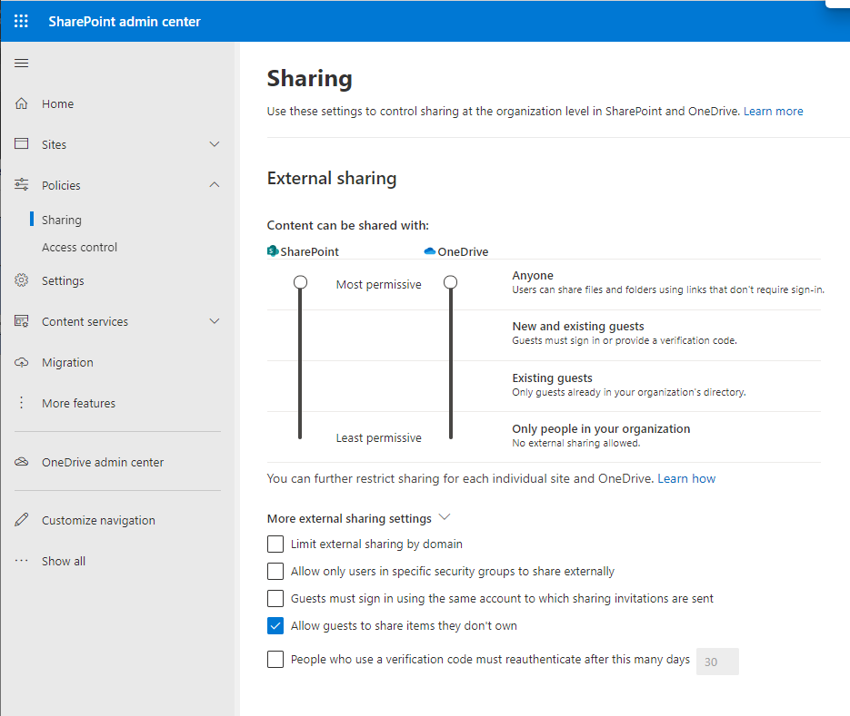

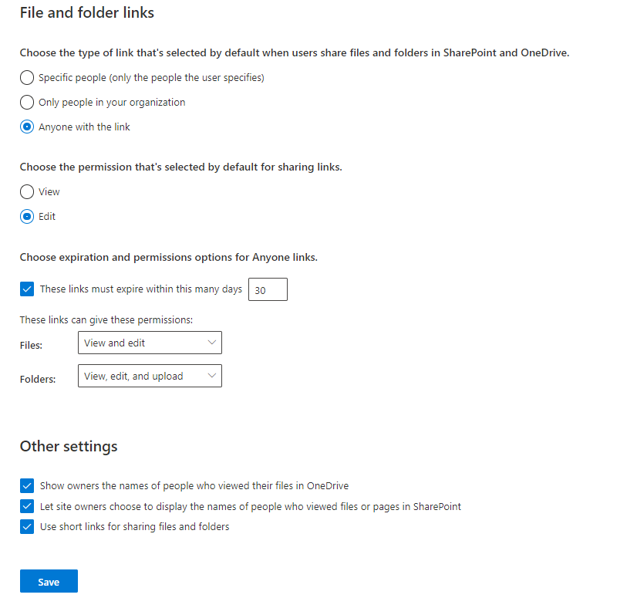

(B) O365 Reference ID 74 (also applies to OD-035, OD-036, OD-037, OD-038)

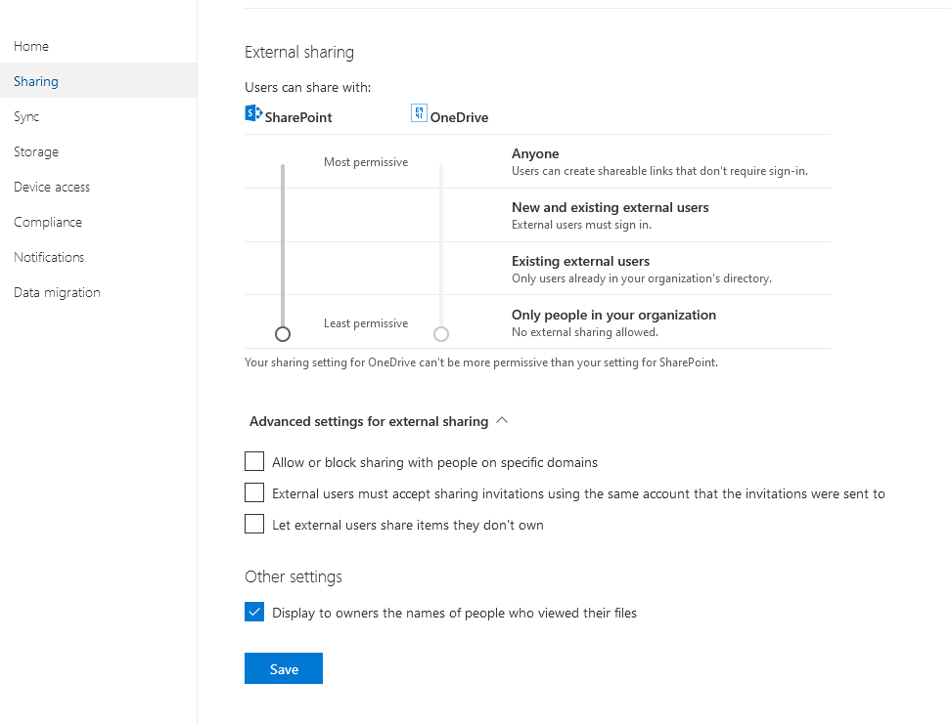

Figure 1 -OneDrive No external sharing allowed

(C) O365 Reference ID 75

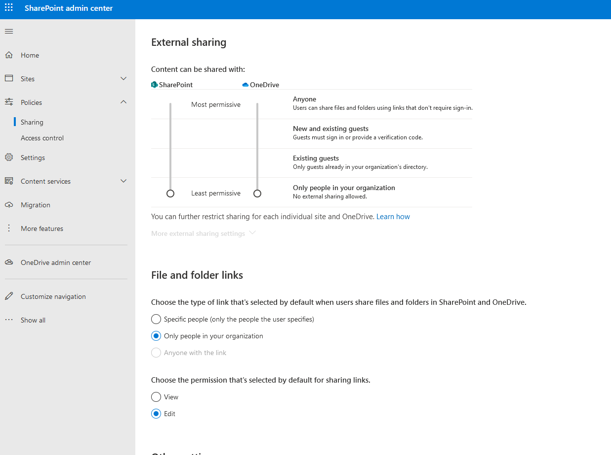

Figure 2 - SPO no external Sharing allowed

(D) O365 Reference ID 79 also ( TM-038)

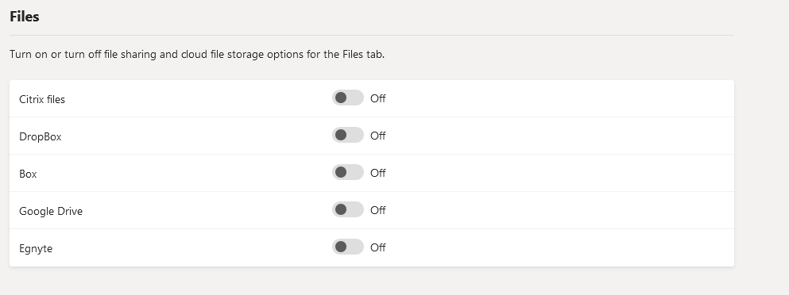

Figure 3 - Teams No File Sharing Allowed

### AC-2

1. O365-RefID-02. List of Global Administrators. Those that are not highlighted are temporary and will be removed after this project. Those highlighted in pink are Break glass accounts; those highlighted in yellow are regular global administrators.

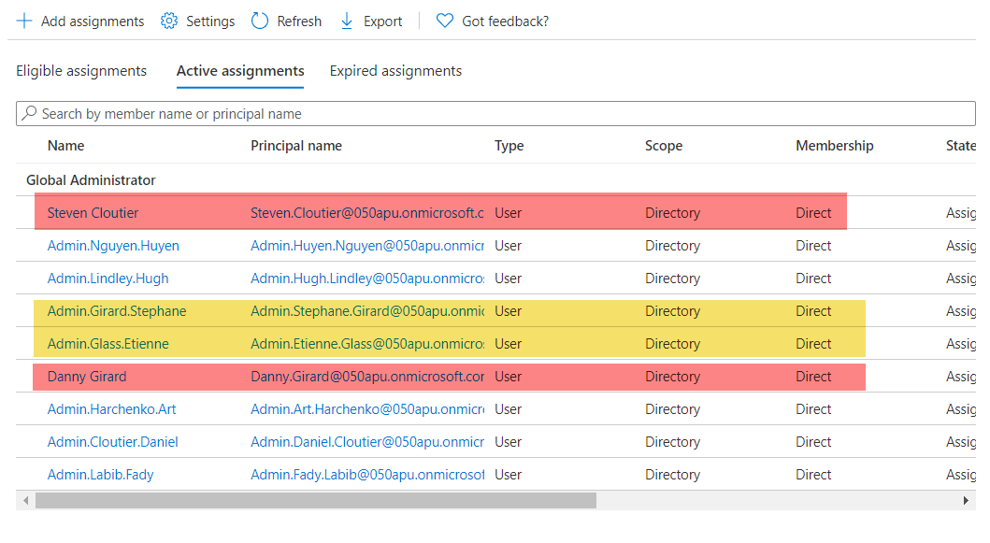

(B) O365 Reference ID 12 refer to IA2 (1) (B)

(C) AZ-L1-007 only members of the tenant are included in all users group

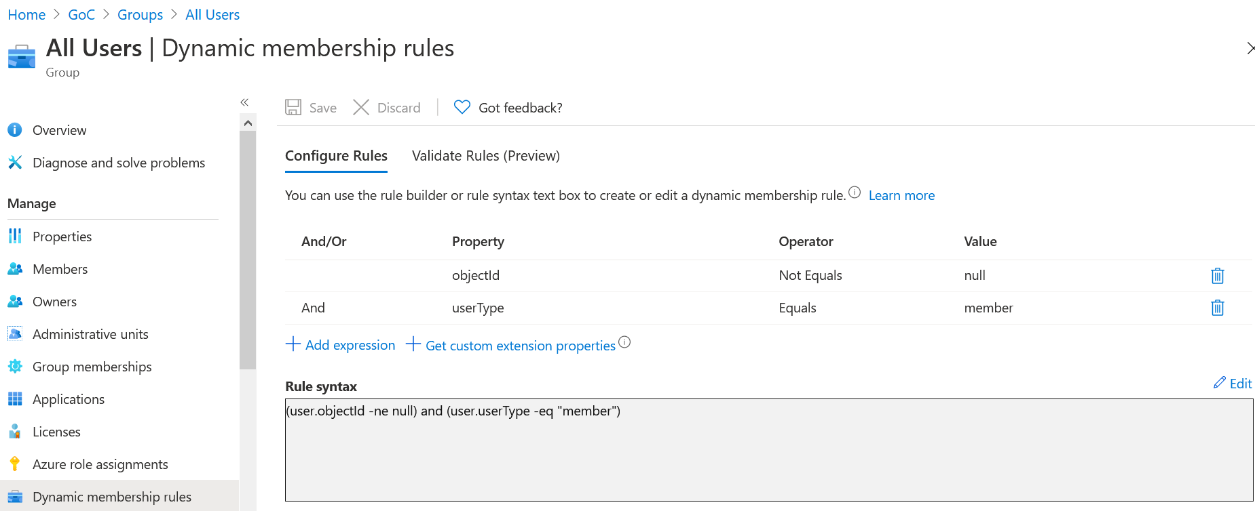

(D) AZ-L3-003 – Break Glass accounts excluded

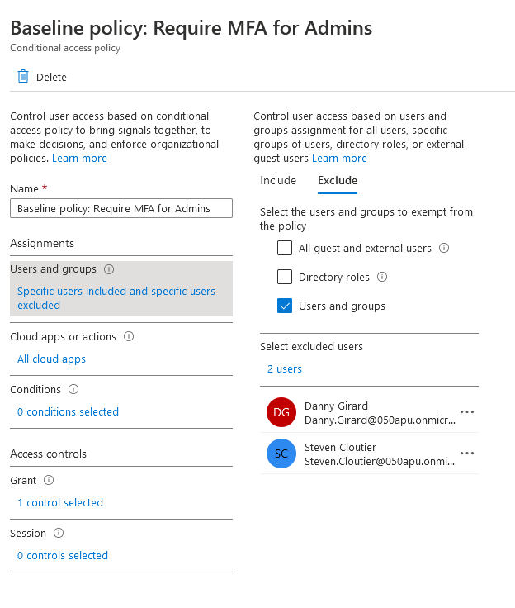

(E) TM-015 refer to SC-7 (B)

(F) TM-031

before

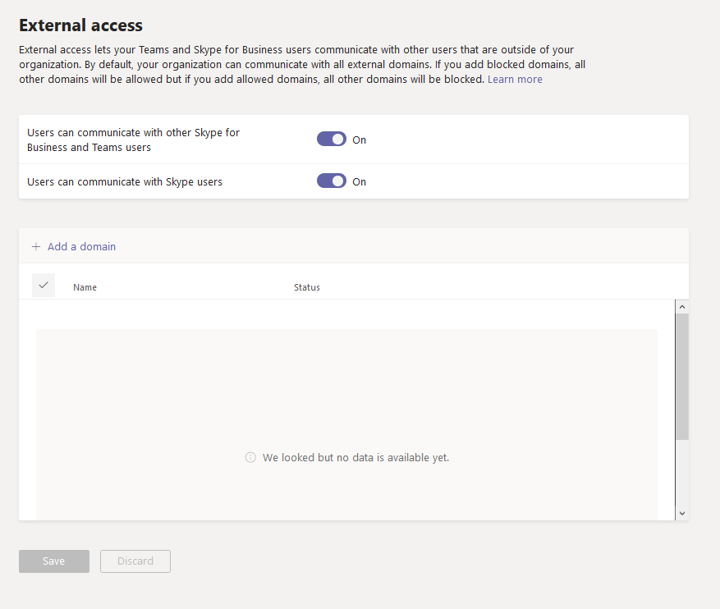

After

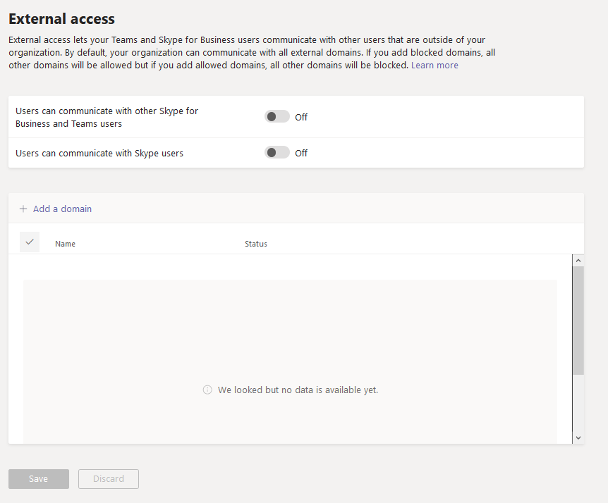

(G) TM-032

Before

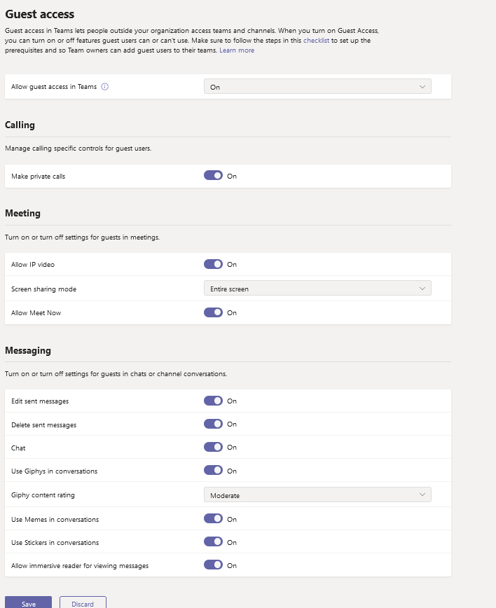

After

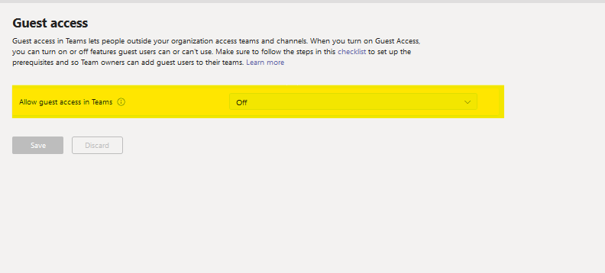

### AC-2(2)

(A) O365 Reference ID 12 refer to IA2 (1) (B)

### AC-2(4)

(A) B2C-004

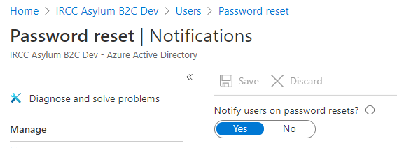

(B) B2C-008

Before:

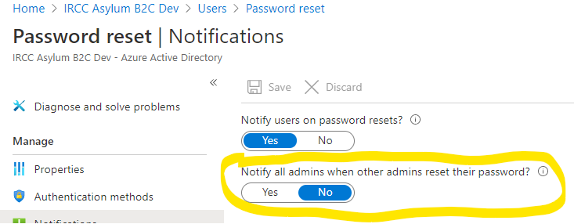

After:

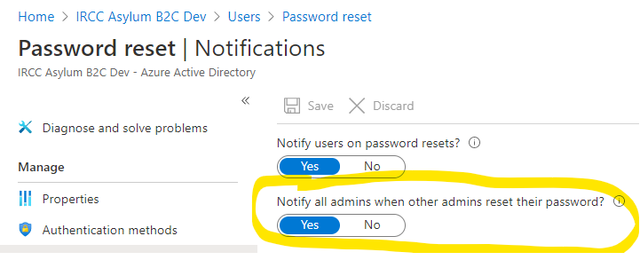

(C) AZ-L1-005 and AZ-L2-003

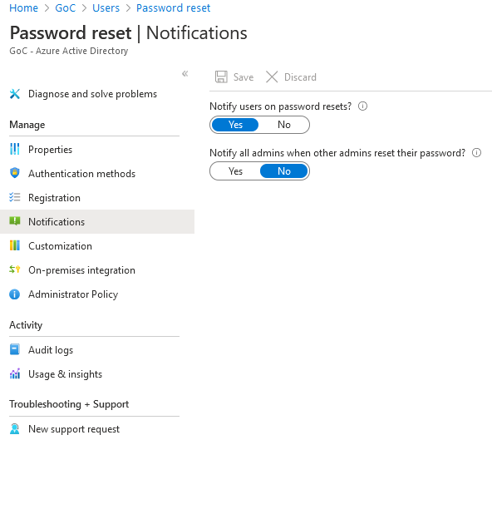

### AC-3

(A) See part (A) AC-1

(B) B2C-009

Before:

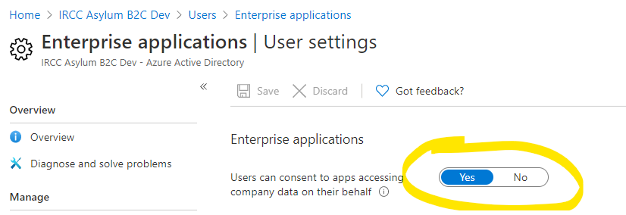

After:

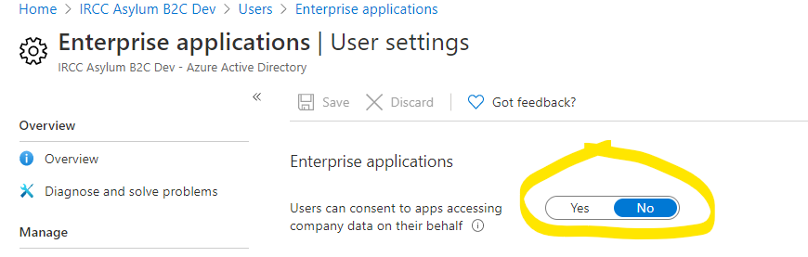

(C) B2C-012

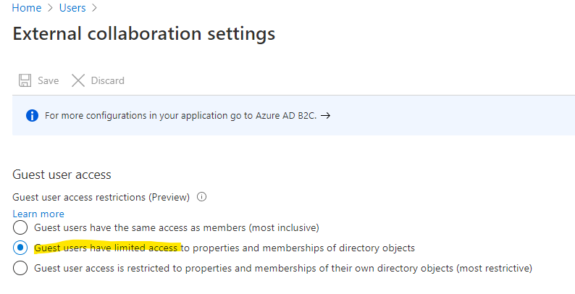

(D) B2C-012 and B2C-013

Before:

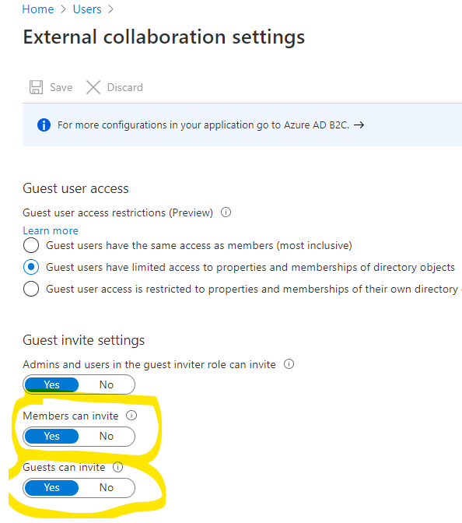

After:

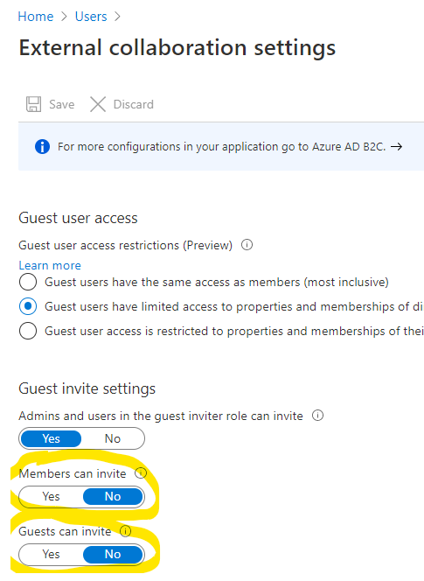

(E) O365 Reference ID 74 (also applies to OD-035, OD-036, OD-037, OD-038) see AC-1 (B)

(F) AZ-L2-004

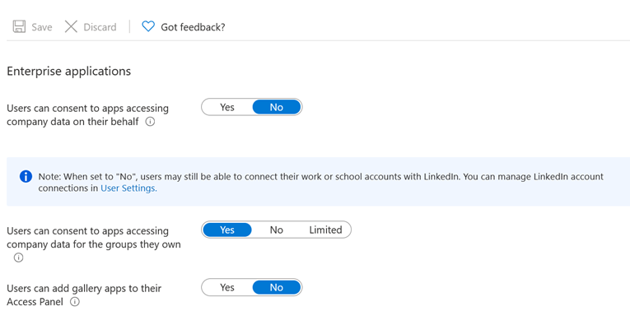

(G) AZ-L2-007

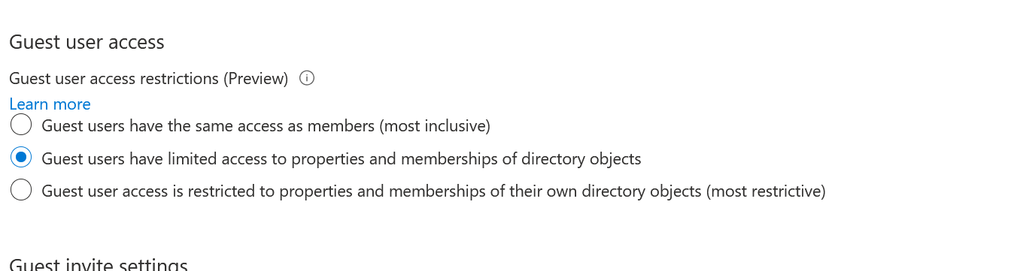

(H) AZ-L2-008 and AZ-L2-009

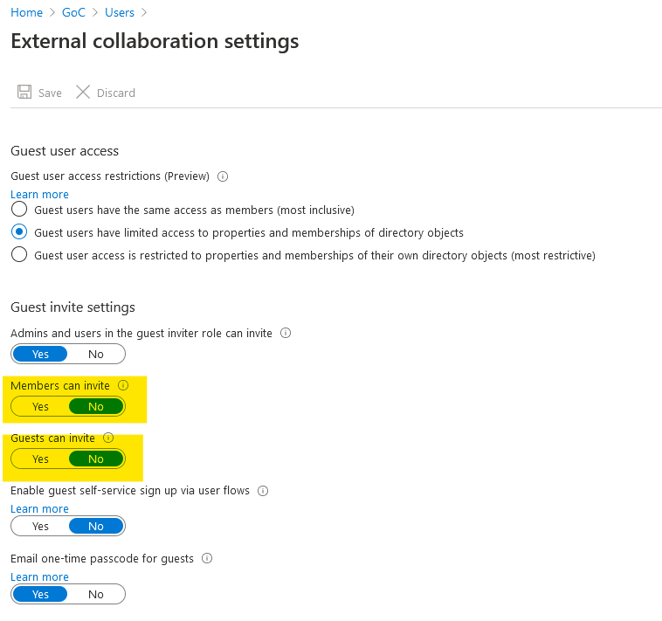

(I) OD-039

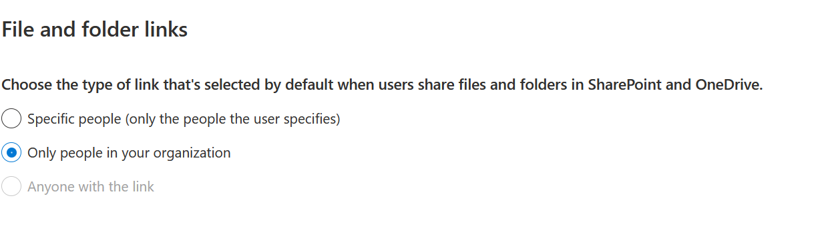

(J) OD-040 and OD-041

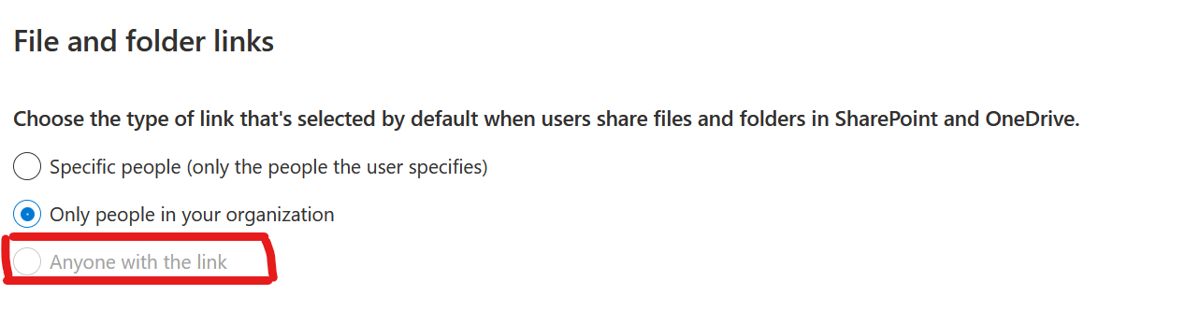

(K) TM-015 refer to SC-7 (B)

(L) TM-031 refer to AC-2 (F)

(M) TM-032 refer to AC-2(G)

### AC-3(3)

(A) O365-RefID-00-29.

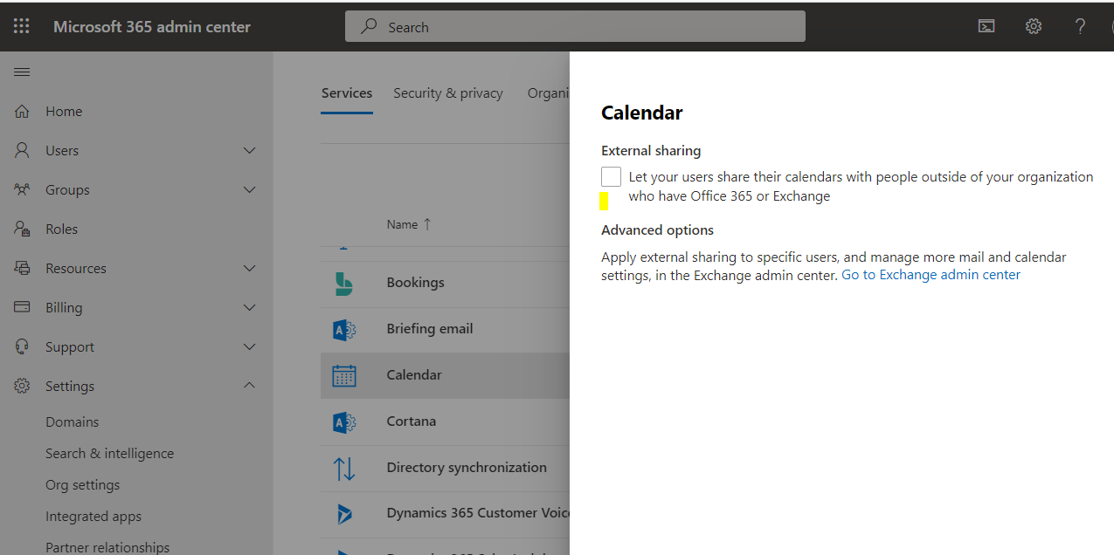

(B) O365 Reference ID 74 (also applies to OD-035, OD-036, OD-037, OD-038) see AC-1 (B)

(C) O365 Reference ID 75 refer to AC-1 (C)

(D) TM-015 refer to SC-7 (B)

(E) TM-031 refer to AC-2 (F)

(F) TM-032 refer to AC-2(G)

### AC-3(4)

1. TM-015 refer to SC-7 (B)

### AC-4

(A) O365-RefID-18. Anti-phishing policy added.

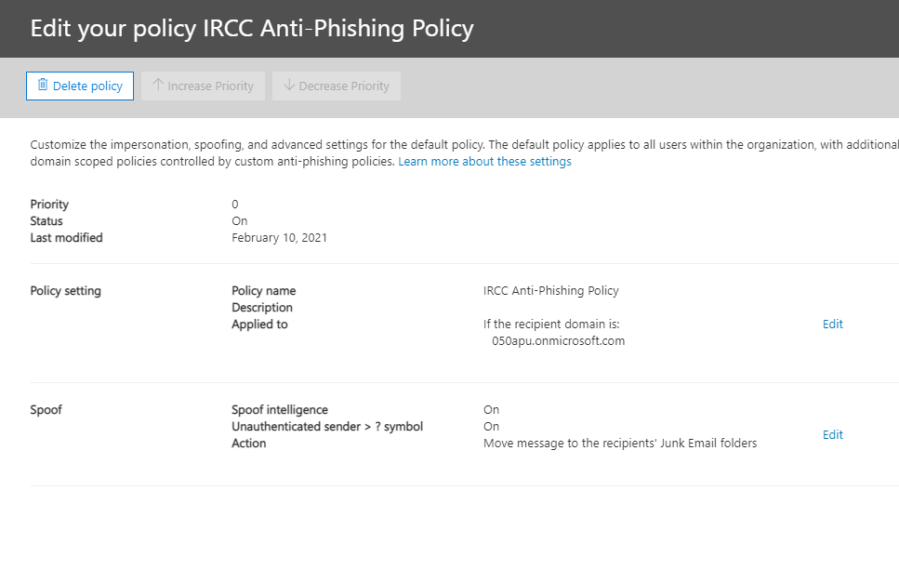

(B) O365-RefID-19. DKIM Configuration completed.

i) Create New DKIM Signing Record:

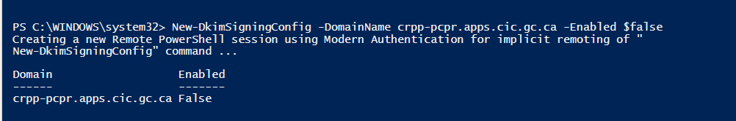

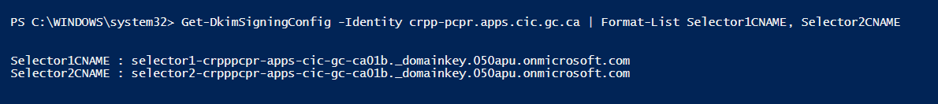

ii) Create CNAME records:

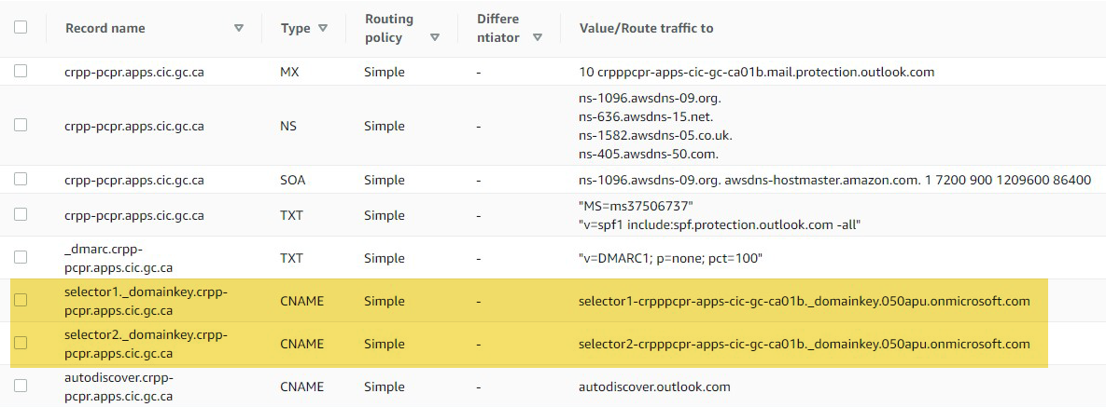

iii) Enable DKIM signing config

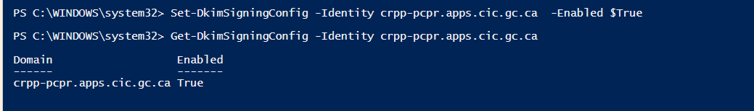

On O365 Admin portal:

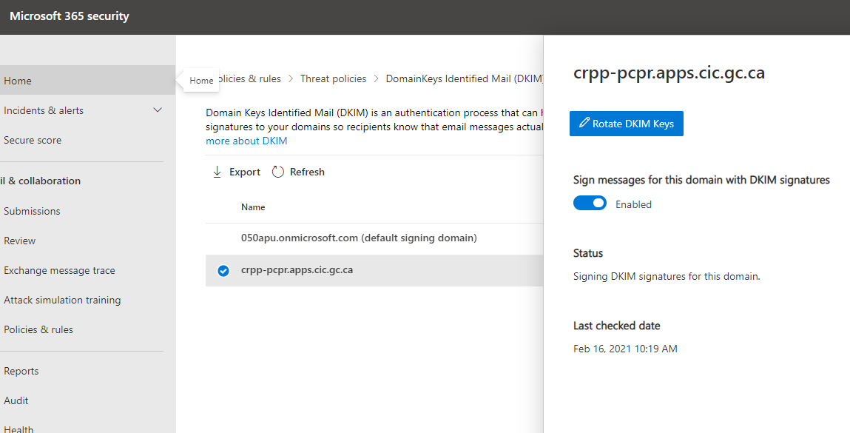

(C) O365-RefID-20. SPF configured by adding TXT DNS record.

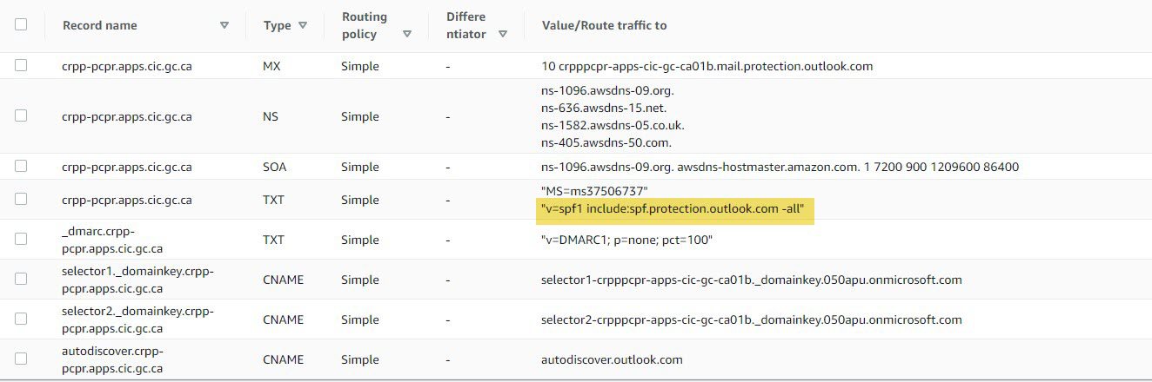

(D) O365-RefID-21. DMARC settings – policy is set to none, which is equivalent to Audit mode. Confirmed with IRCC that this setting is satisfactory for the time being

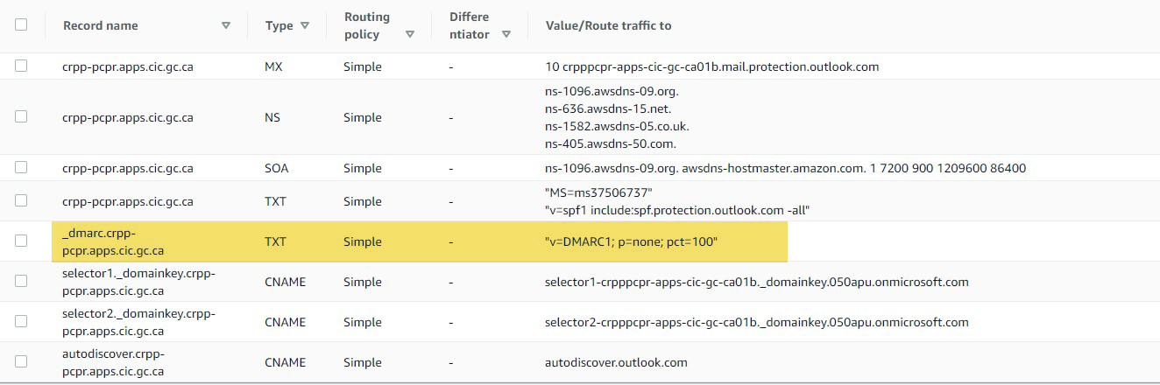

(E) O365 Reference ID 6

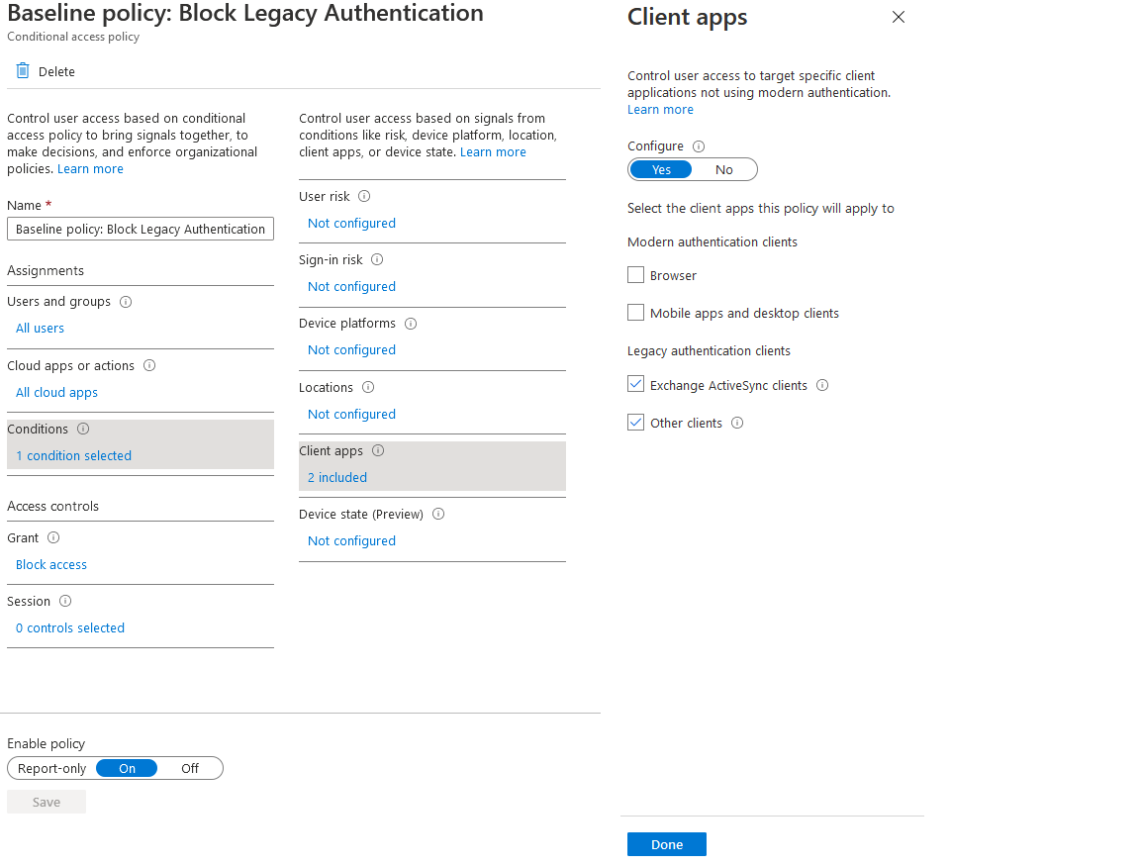

(F) O365 Reference ID 52 – No OneDrive Sync Allowed

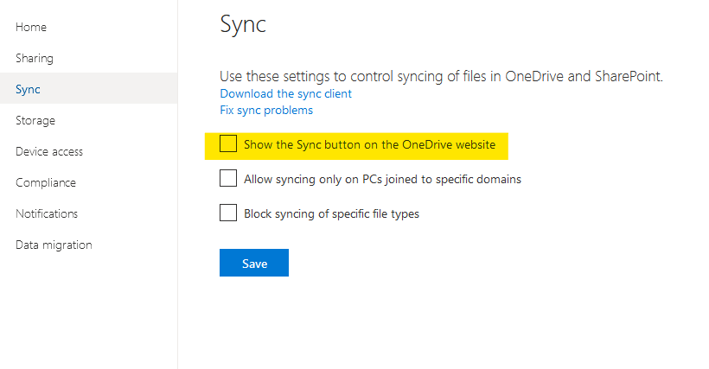

(G) OD-044

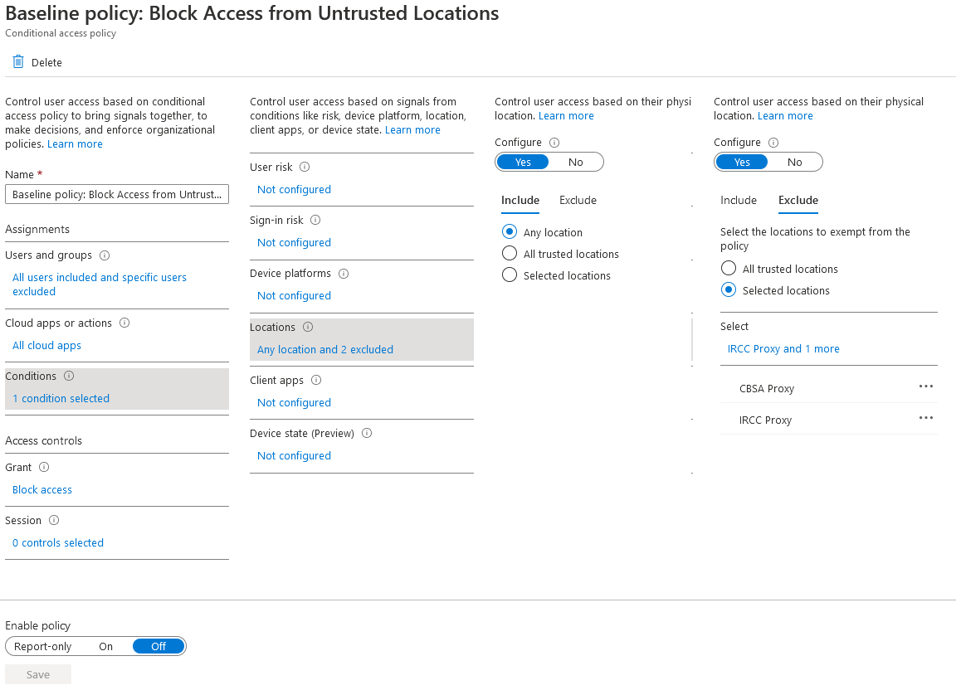

(H) OD045

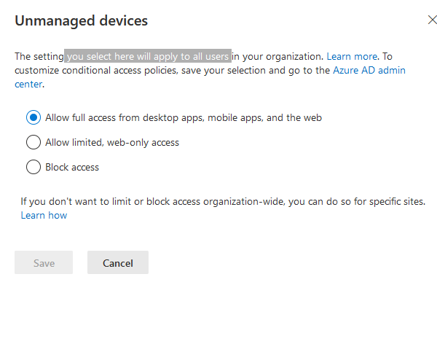

### AC-4(1)

1. O365 Reference ID 36

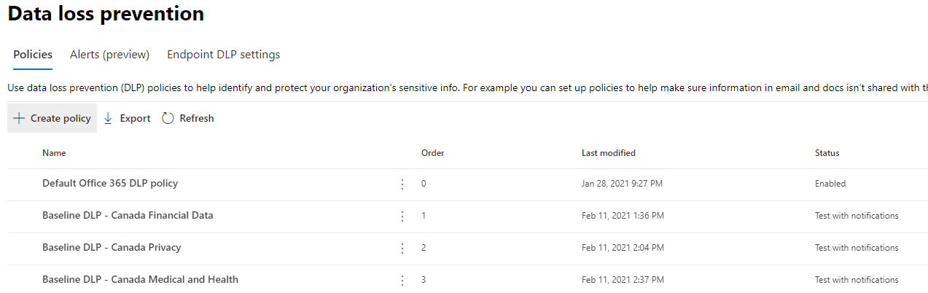

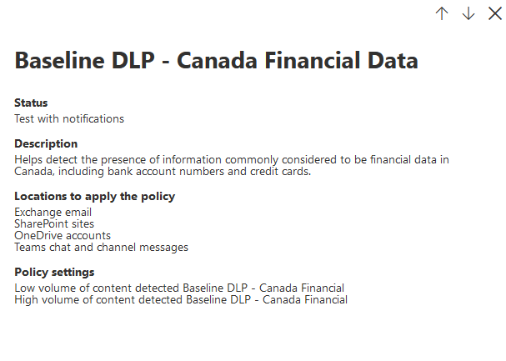

Figure 4 - Canada Finance DLP

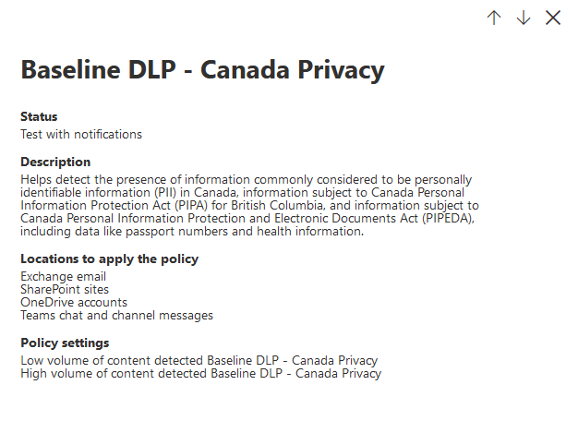

Figure 5 - Canada Privacy

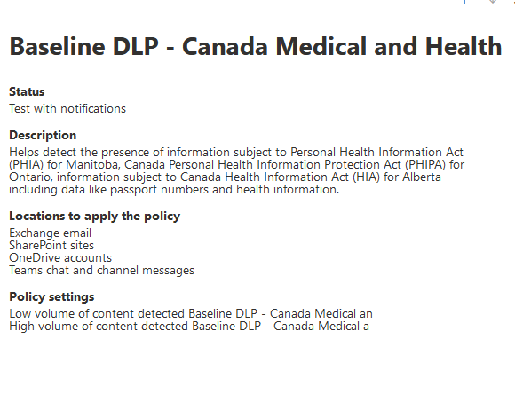

Figure 6 – Canada Medical and Health

### AC-4(8)

(A) O365-RefID-15. Policy added.

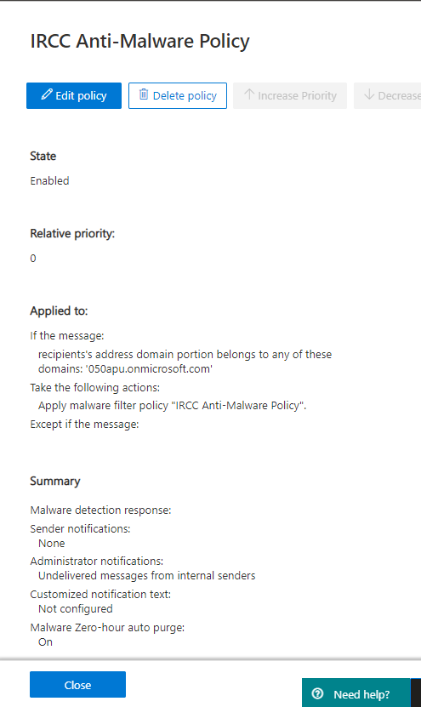

(B) O365-RefID-16

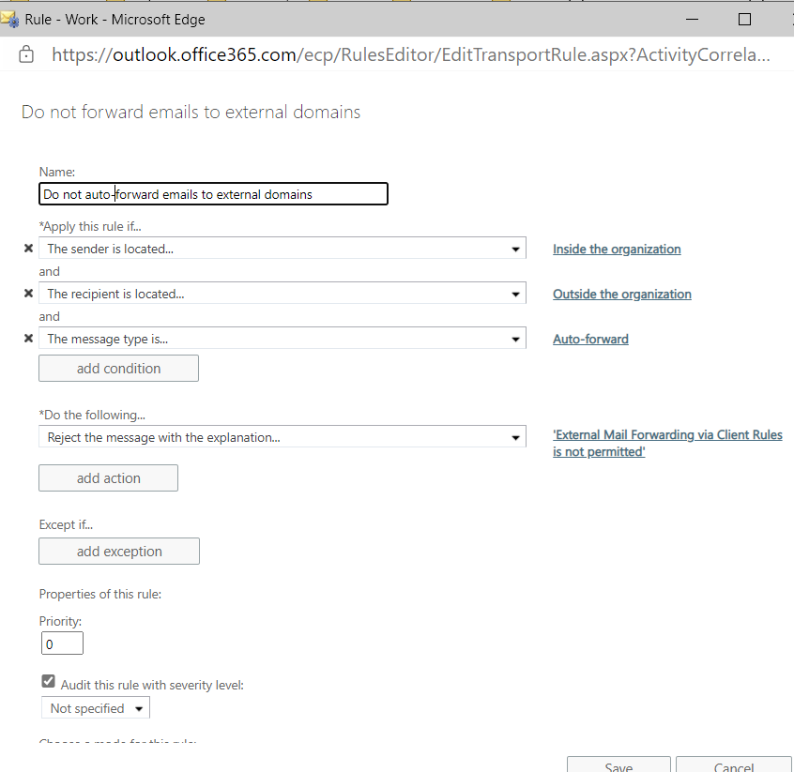

(C) O365-RefID-17. There are no rules with whitelisting of domains.

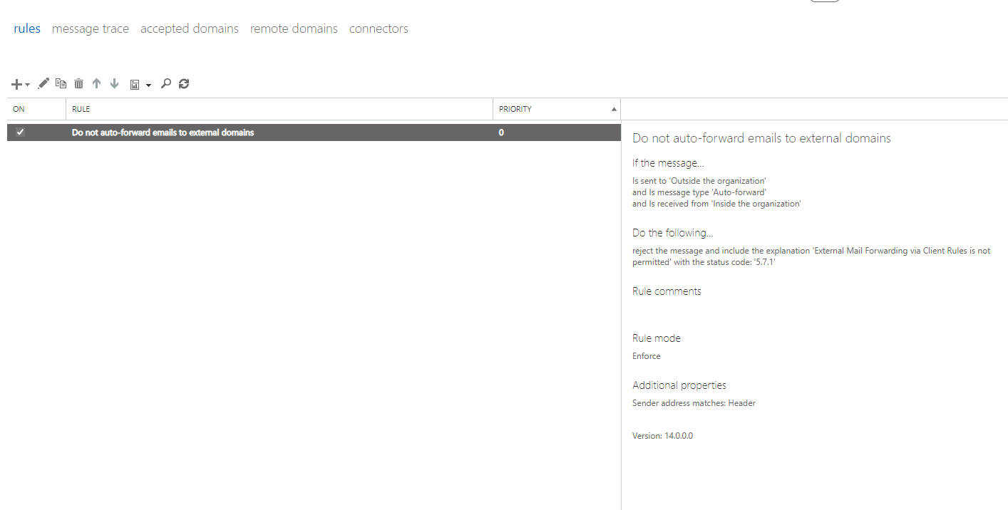

(D) O365-RefID-32. This is the policy created under EXO mail rules to deal with potential malicious email attachments. Note that incident report is being sent to Admin.Glass.Etienne. But IRCC would like to send this email to an external email address - [IRCC.MSAPUAdmin-AdminAPUMS.IRCC@cic.gc.ca](mailto:IRCC.MSAPUAdmin-AdminAPUMS.IRCC@cic.gc.ca). We cannot specify external addresses in this rule. Therefore, had to create a custom outbound spam filter (O365 Security > Policies and Rules > Threat Policies > Antispam) to allow forwarding for Admin.Glass.Etienne:

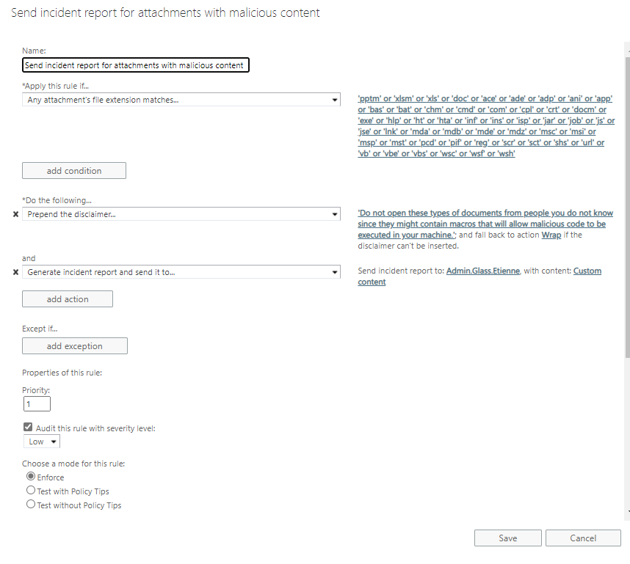

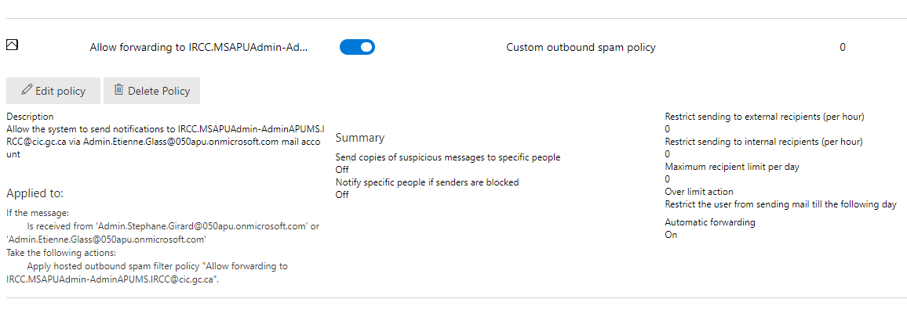

(E) See part (C) of SC-7(10)

(F) O365 Reference ID 75 refer to AC-1 (C)

### AC-6

(A) See part (A) of AC-2

(B) See part (C) of AC-3

(C) See part (D) of AC-3

(D) B2C-015

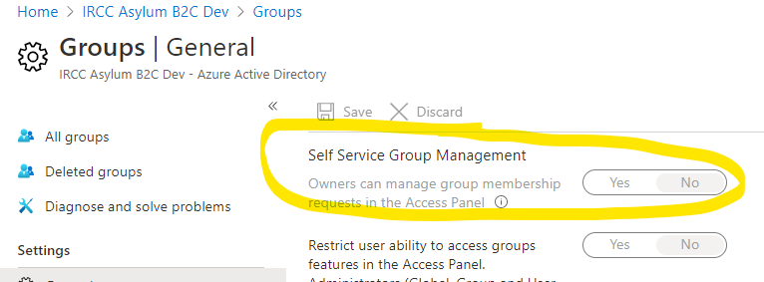

(E) B2C-016

Unable to Complete

Setting is set to 'Yes' and the option is greyed out.

Verified that non-admin users are able to create Security Groups, however are unable to assign any users as members to these groups. Only 'service principals' (applications) and other groups can be chosen as members of user's newly created Security group.

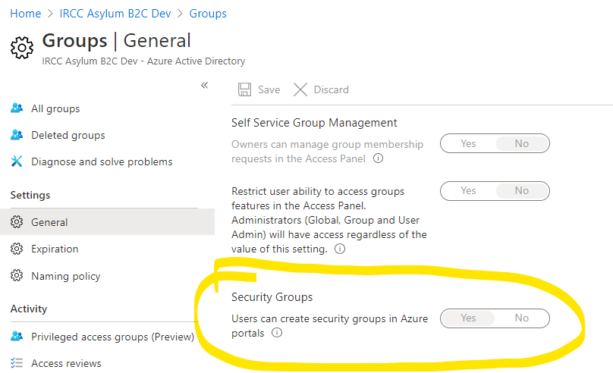

(F) B2C-017

Unable to Complete

Setting is set to 'Yes' and the option is greyed out.

Verified that non-admin users are able to create Microsoft 365 Groups, however are **unable** to add any members to this newly created group, including their own user account.

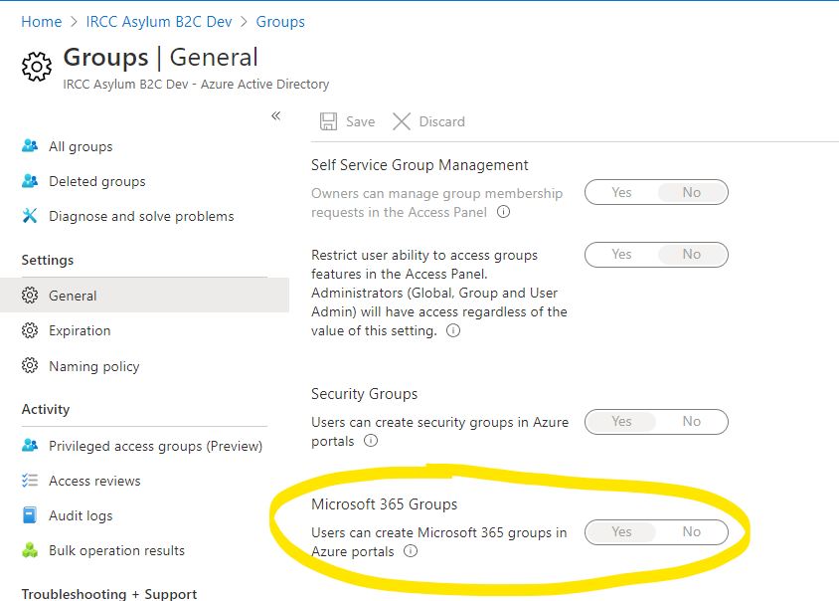

(G) AZ-L2-007 see AC-3 (G)

(H) AZ-L2-008 and AZ-L2-009

(I) AZ-L2-010

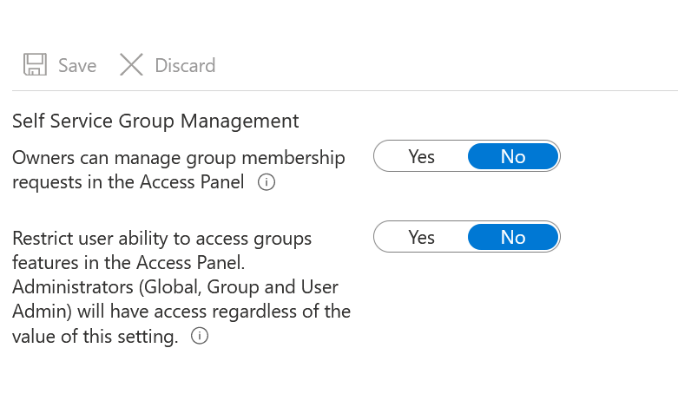

(J) AZ-L2-011

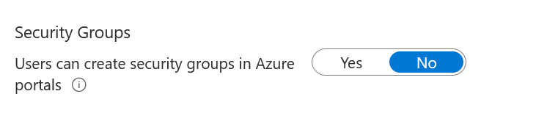

(K) AZ-L2-013

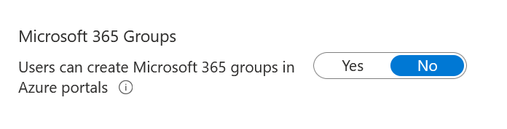

### AC-7

(A) B2C-018

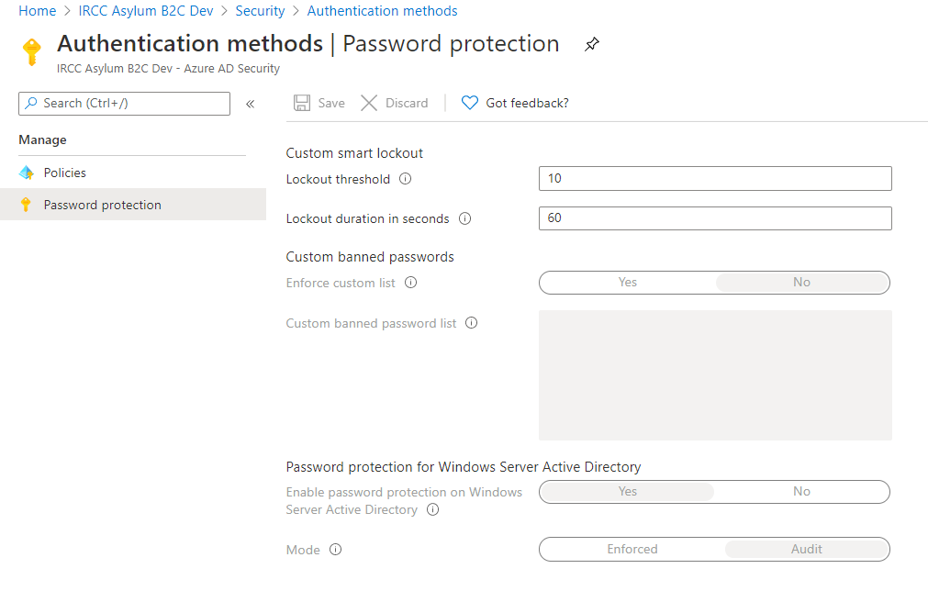

### AC-6(1)

(A) See part (A) of AC-2

(B) B2C-005

Before:

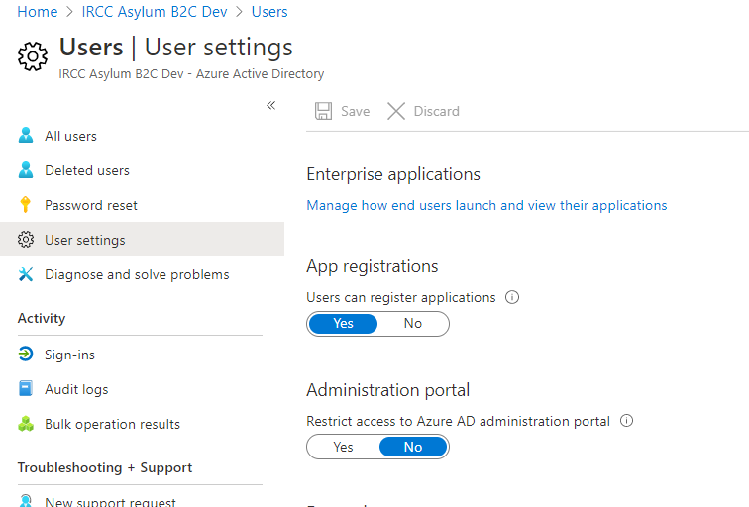

After:

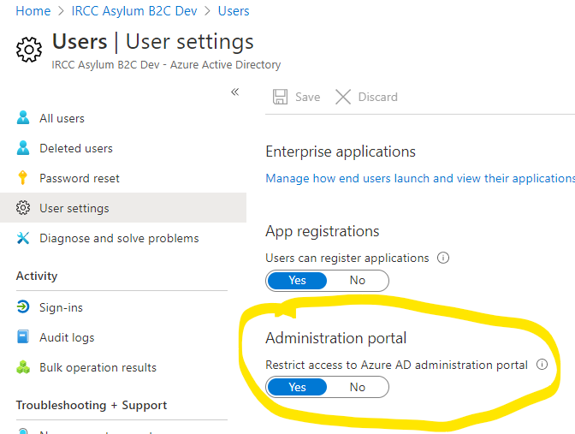

(C) AZ-L1-006

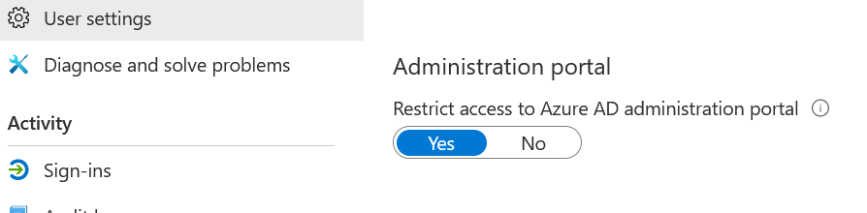

### AC-7

1. AZ-L3-002

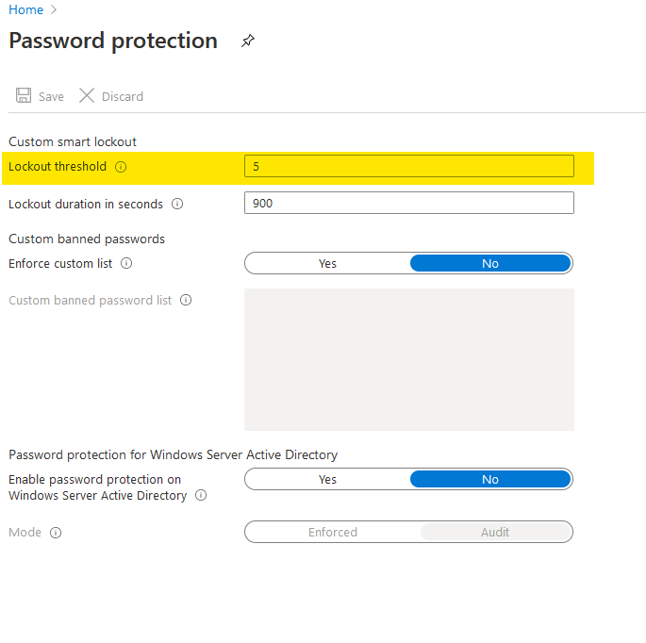

### AC-12

1. OD-046

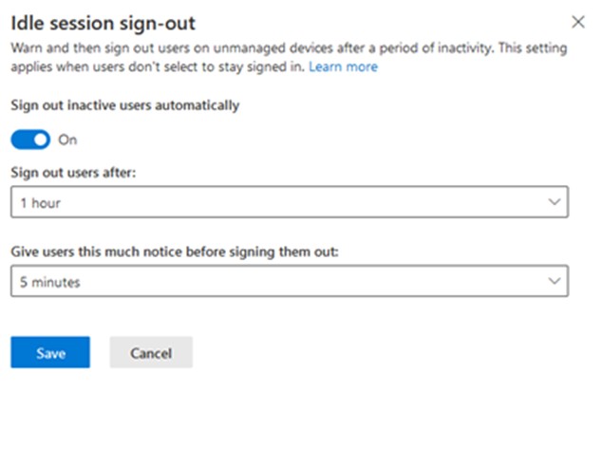

### AC-15

(A) O365 Reference ID 73

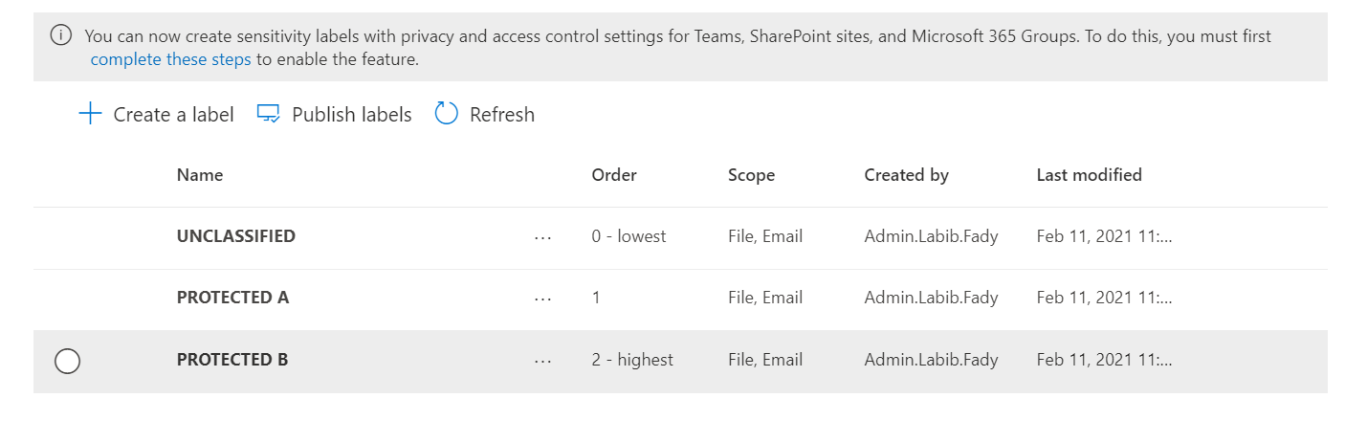

Figure 7 - Classification Labels

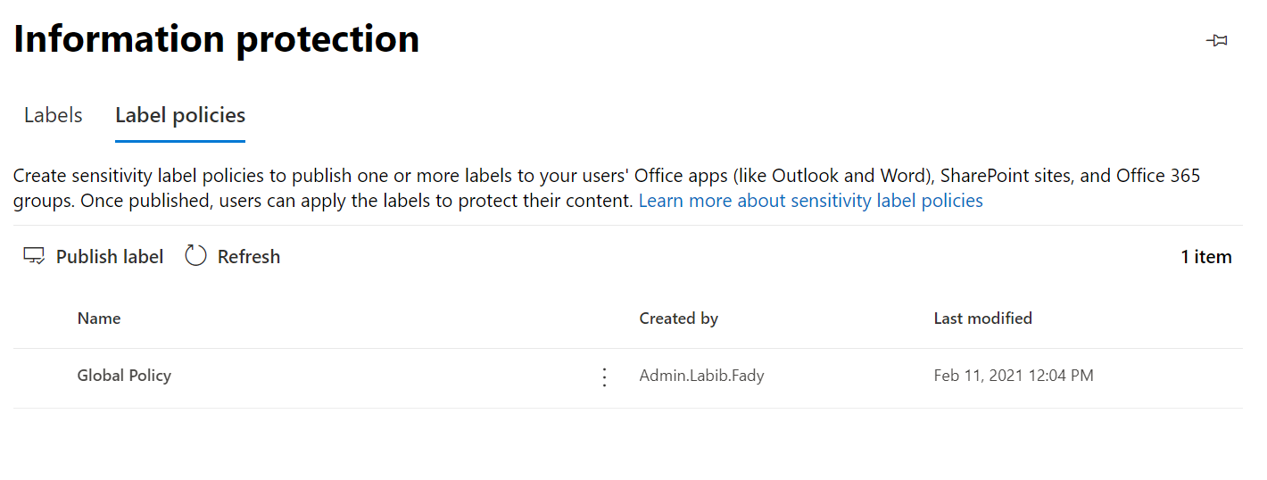

Figure 8 - Classification Policy

### AC-16

1. O365 Reference ID 73 Refer to AC-15 (A)

### AC-20(4)

(A) O365 Reference ID 5

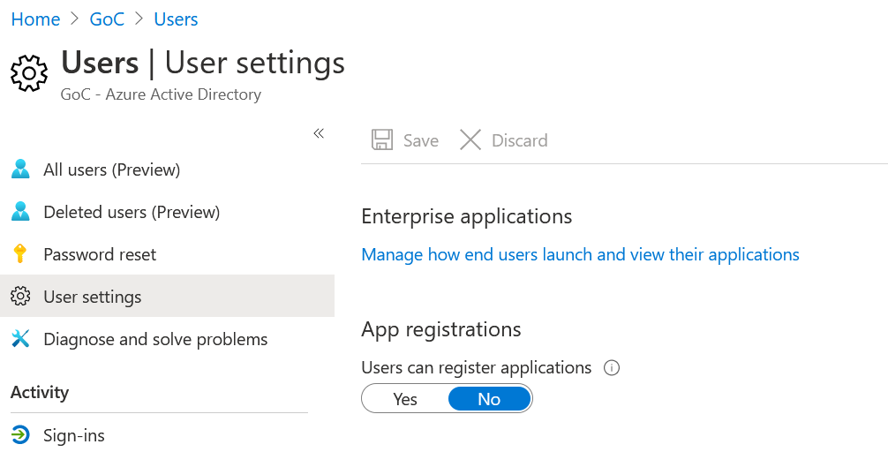

1. O365 Reference ID 79 refer to AC-1 (D)
2. TM-038 – refer to O365 Reference ID 79 AC-1 (D)

## Awareness and training (AT)

## Audit and Accountability (AU)

### AU-2

(A) O365-RefID-23. Mailbox audit is enabled.

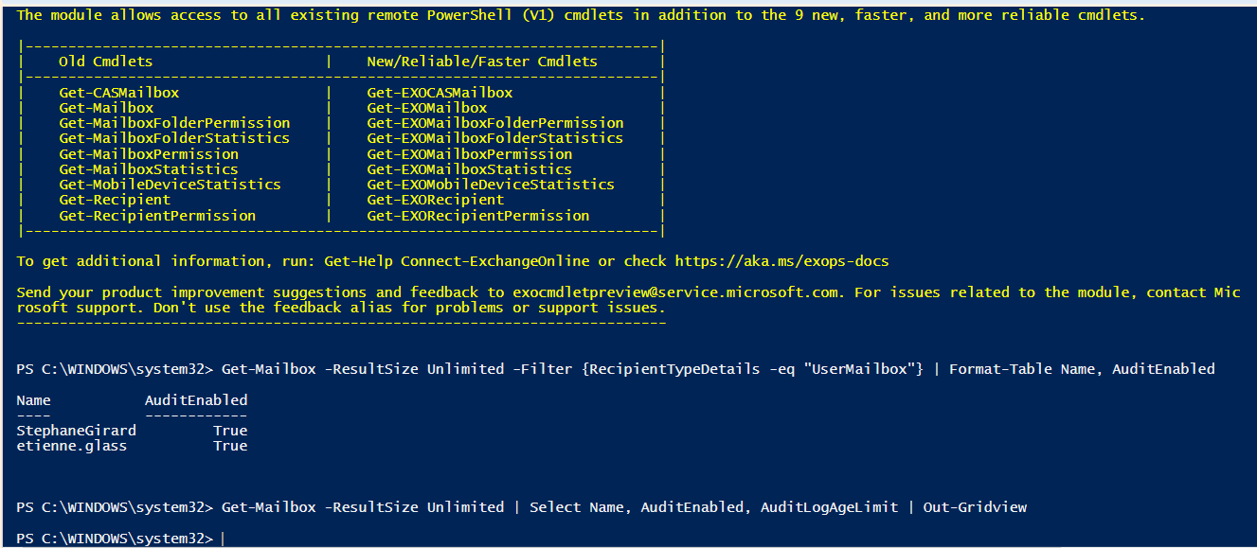

(B) O365-RefID-35

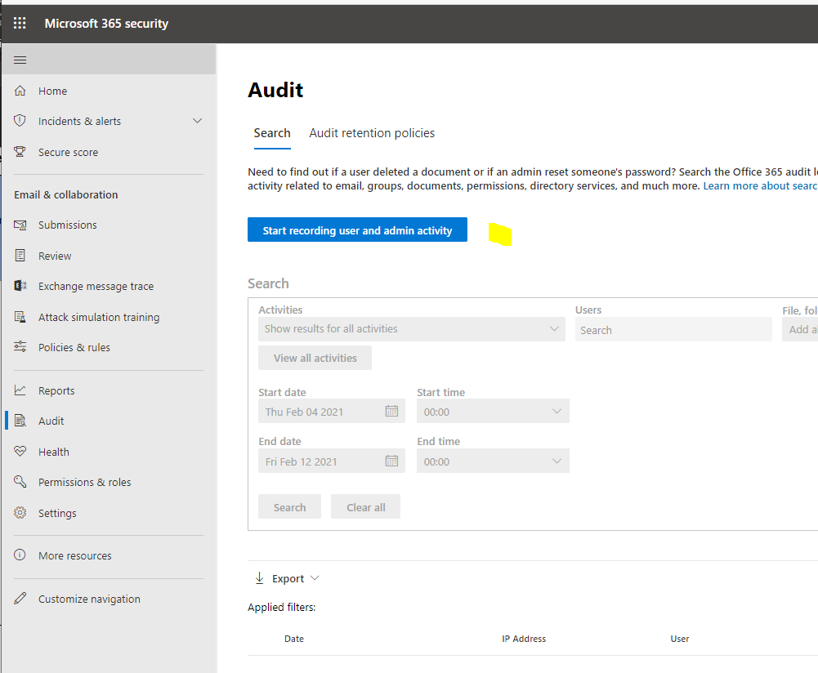

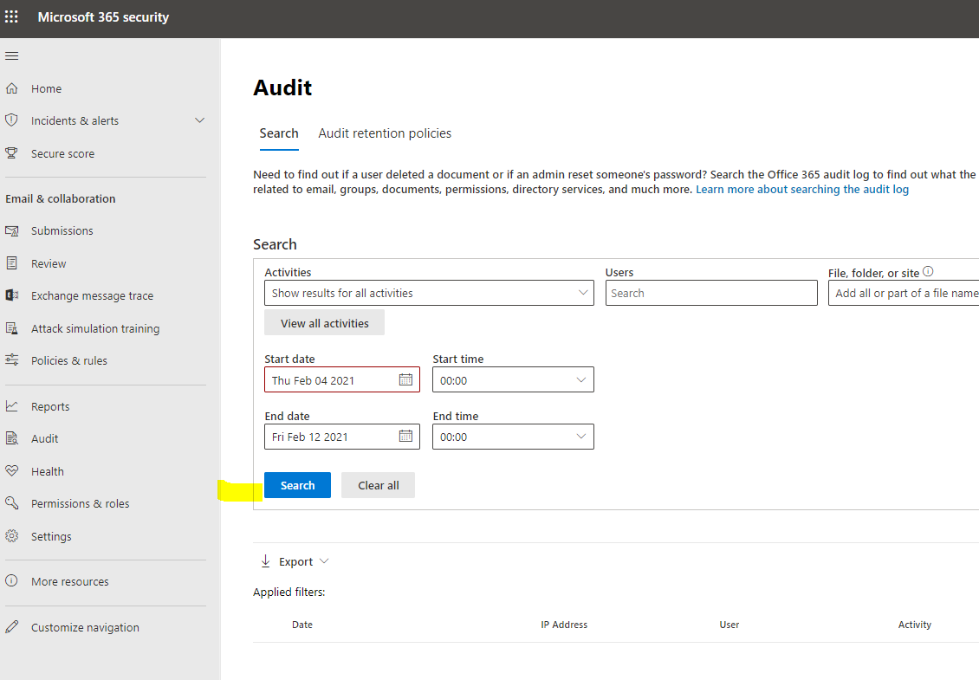

(C) AZ-L1-052

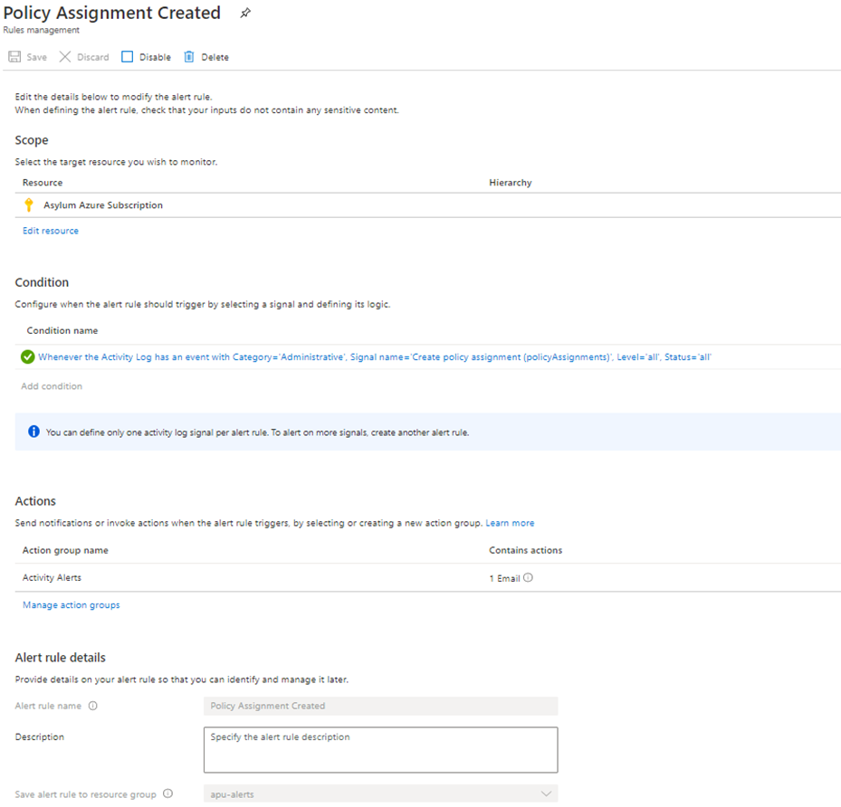

1. TM-047

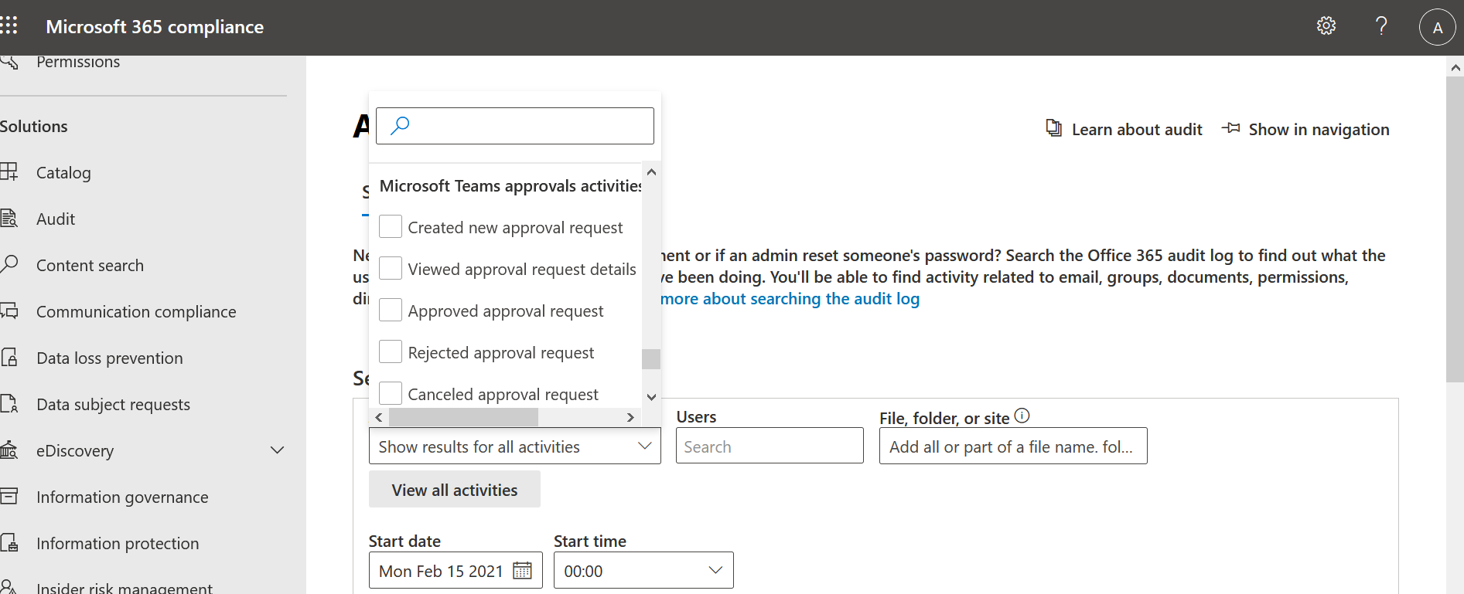

### AU-9

(A) OD-042 and OD-043

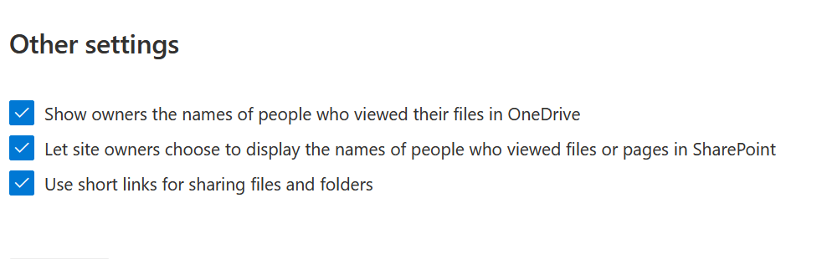

### AU-9 (2)

1. AZ-L1-050

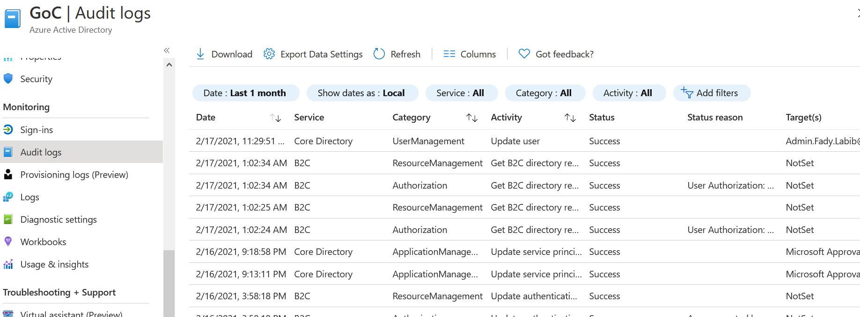

### AU-11

(A) See part (A) of AU-2

(B) See part (B) of AU-2

### AU-12

(A) OD-049

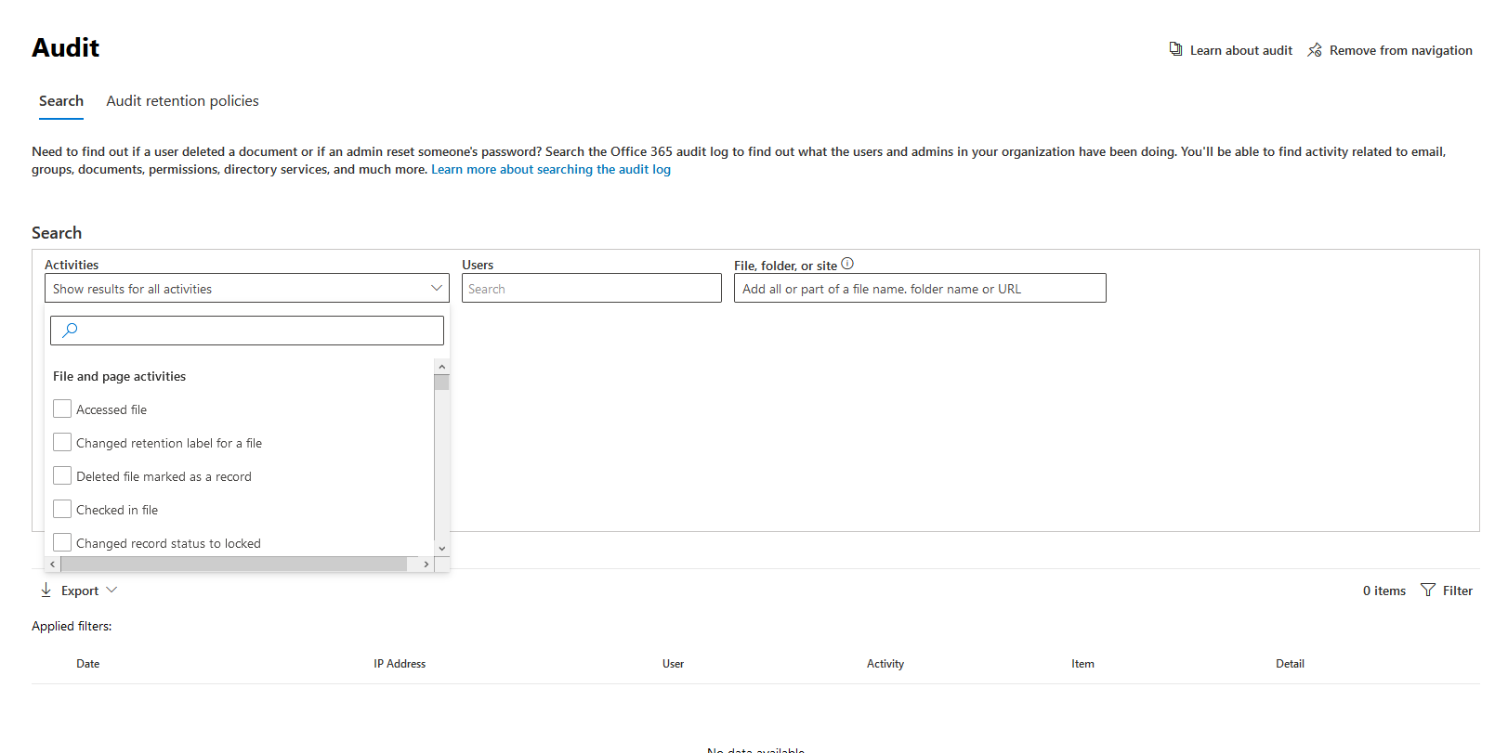

1. TM-047 refer to AU-2 (D)

## Security Assessments (SA)

## Configuration Management (CM)

(A) AZ-L2-020

Unable to complete.

Setting is set to 'All' and the option is greyed out.

This feature is now enabled by "default" in all new Azure tenants (as or Aug 15,2020) and is a recommendation by Microsoft.

Reference:

<https://docs.microsoft.com/en-us/azure/active-directory/authentication/concept-registration-mfa-sspr-combined>

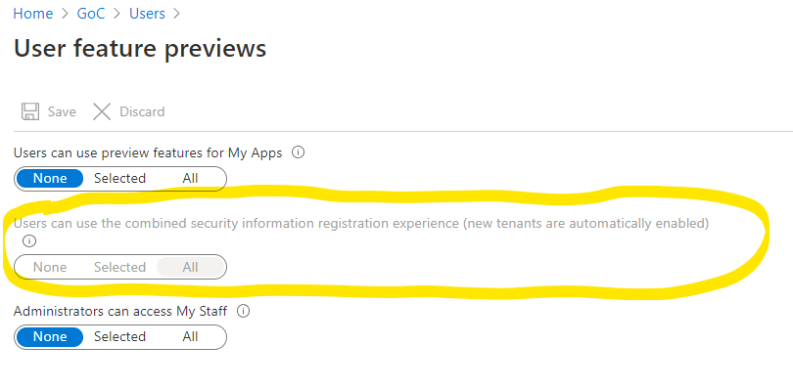

(B) B2C-019

Unable to complete.

Setting is set to 'All' and the option is greyed out.

This feature is now enabled by "default" in all new Azure tenants (as or Aug 15,2020) and is a recommendation by Microsoft.

Reference:

<https://docs.microsoft.com/en-us/azure/active-directory/authentication/concept-registration-mfa-sspr-combined>

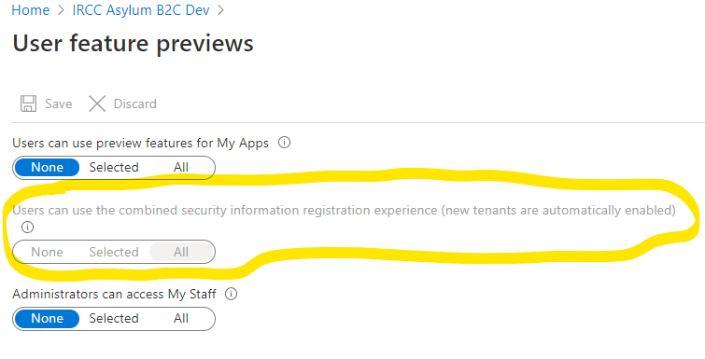

### CM-2(2)

1. TM-010 refer to CM-7 (D)
2. TM-011 refer to CM-7 (E)
3. TM-012 refer to CM-7 (F)
4. TM-020 refer to CM-7 (H)
5. TM-040 refer to CM-7 (P)
6. TM-041 refer to CM-7 (Q)
7. TM-043 refer to TM-042 SA-22 (A)

### CM-6(1)

1. TM-010 refer to CM-7 (D)
2. TM-011 refer to CM-7 (E)
3. TM-012 refer to CM-7 (F)
4. TM-020 refer to CM-7 (H)

### CM-7

(A) O365-RefID-33.

From EXO Admin Ctr:

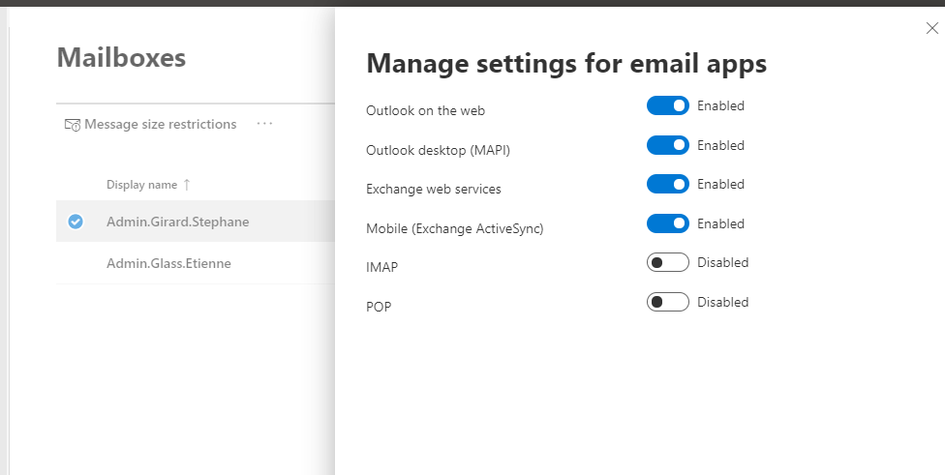

From O365 Portal:

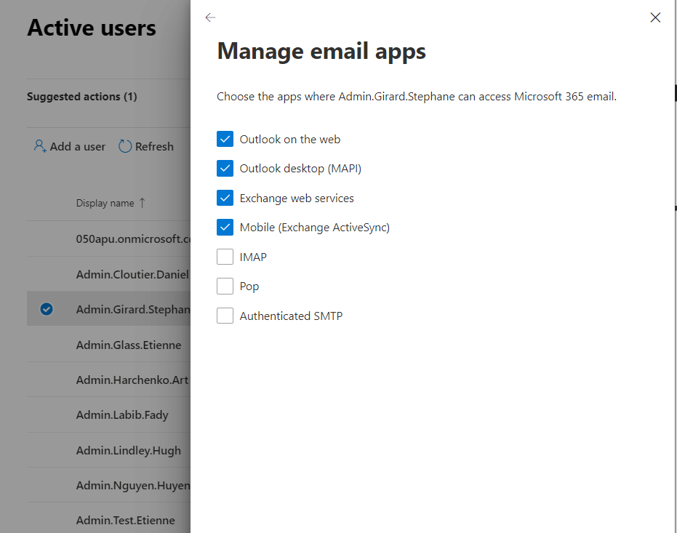

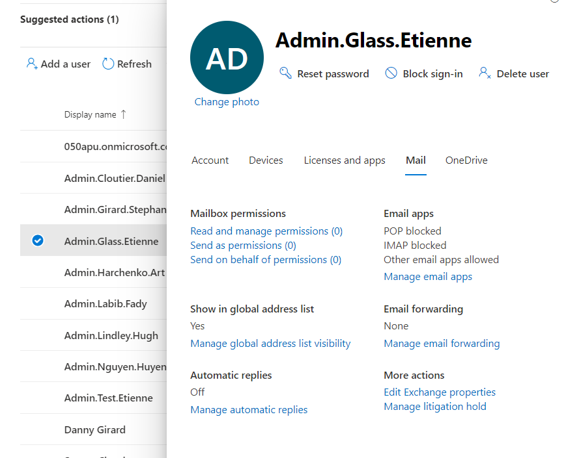

1. TM-038 – refer to O365 Reference ID 79 AC-1 (D)
2. TM-003

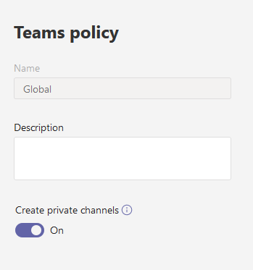

1. TM-010

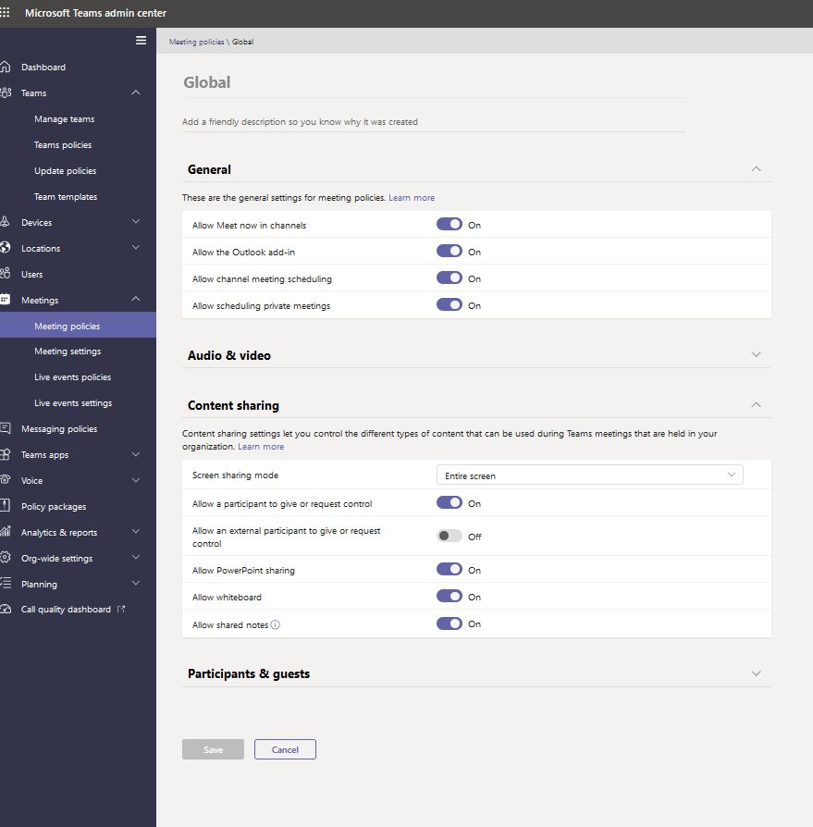

1. TM-011

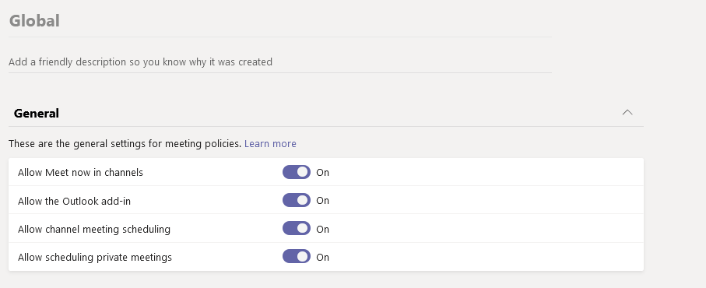

1. TM-012

Before

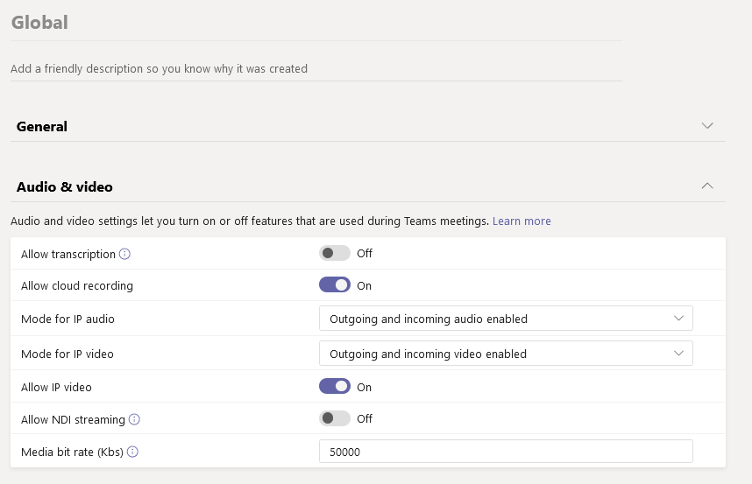

After

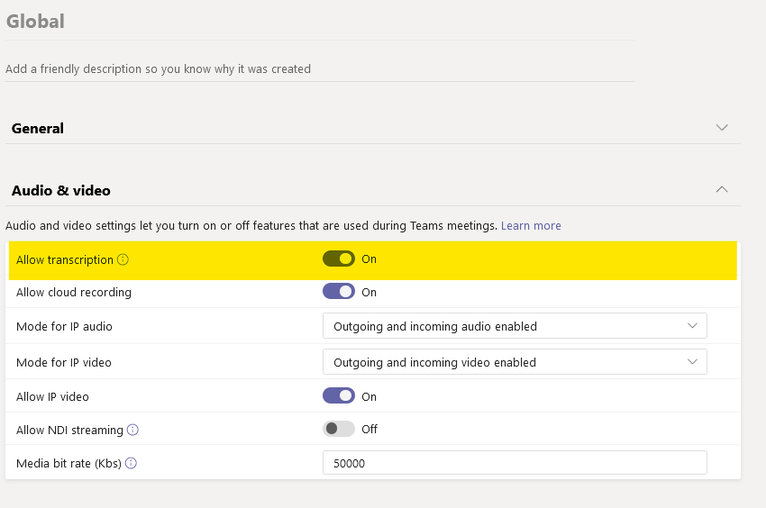

1. TM-019

Before

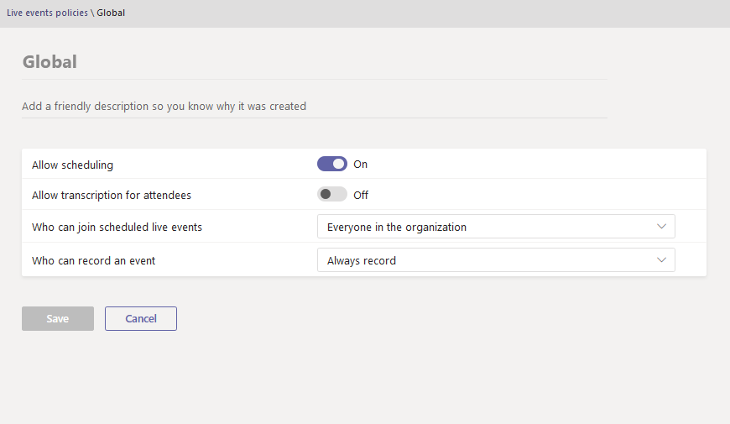

After

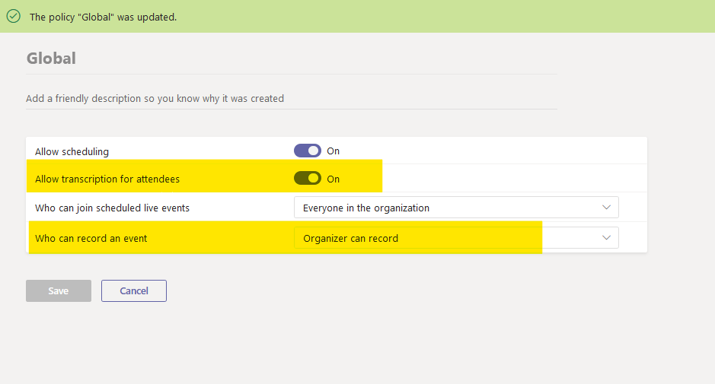

1. TM-020

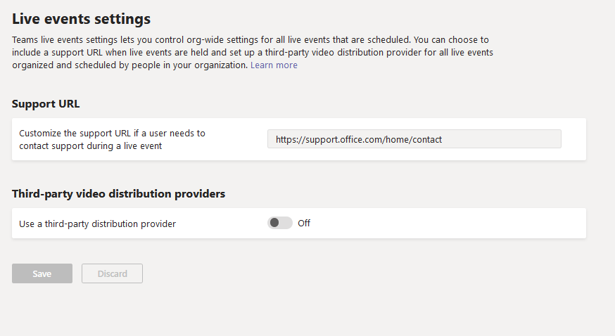

1. TM-021

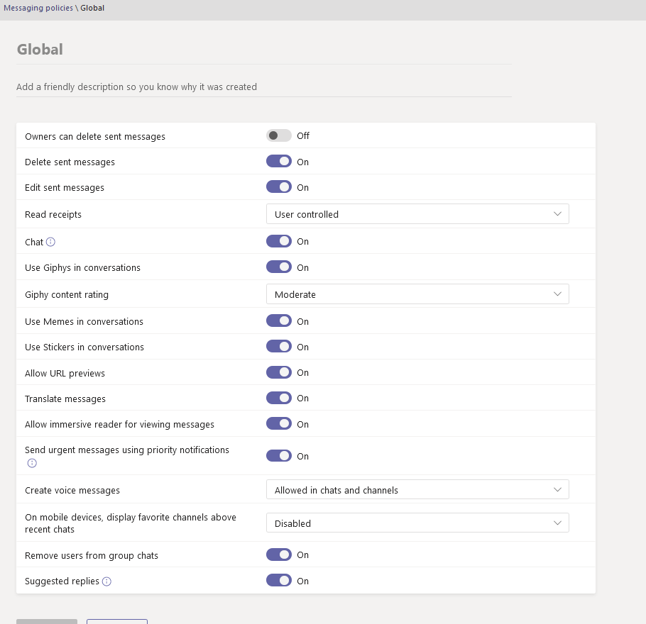

1. TM-033 refer to TM-032 AC-2(G)
2. TM-034 refer to TM-032 AC-2(G)
3. TM-035 refer to TM-032 AC-2(G)
4. TM-036

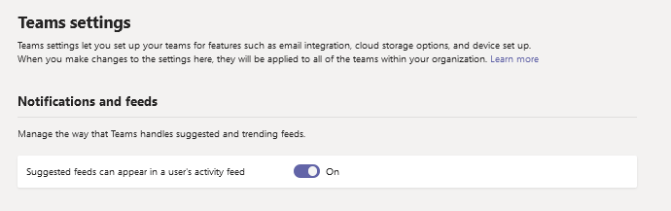

1. TM-037

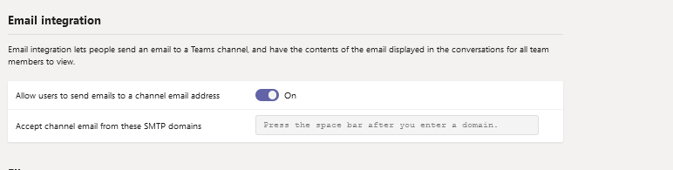

1. TM-039

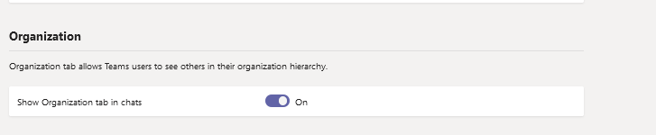

1. TM-040

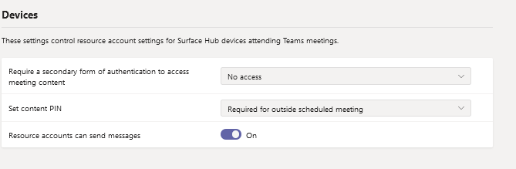

1. TM-041

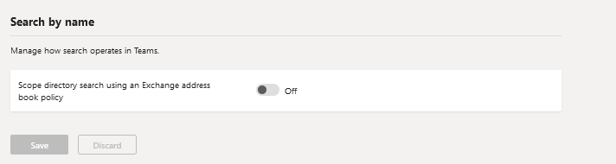

1. TM-043 refer to TM-042 SA-22 (A)

### CM-7(5)

1. TM-022

Before

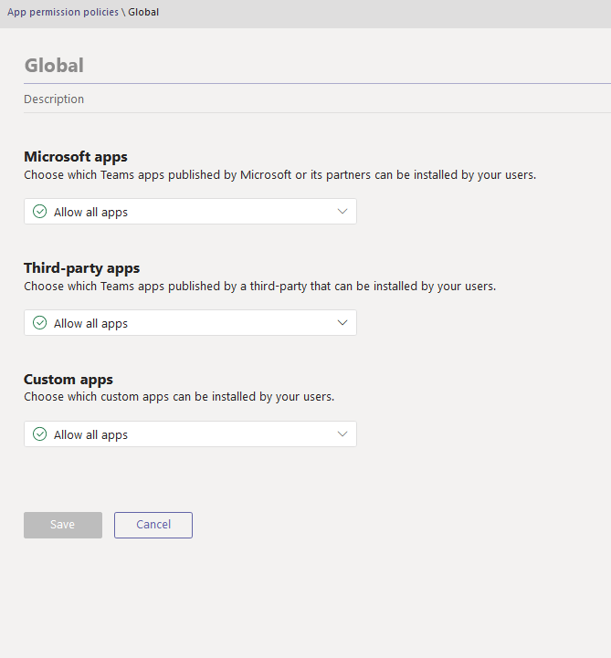

After

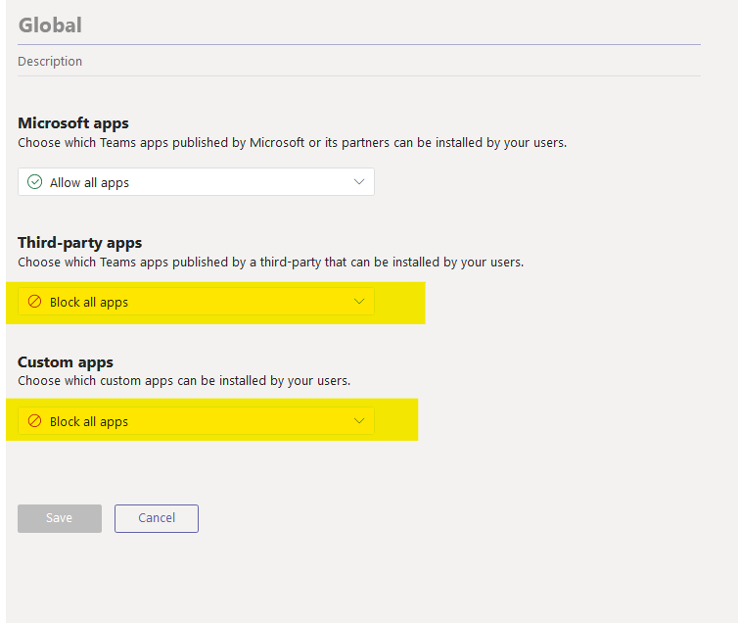

1. TM-023

Before

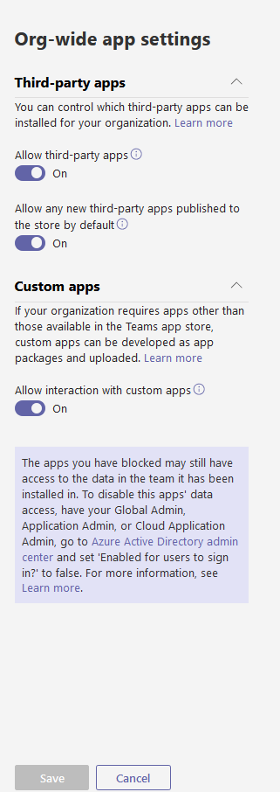

After

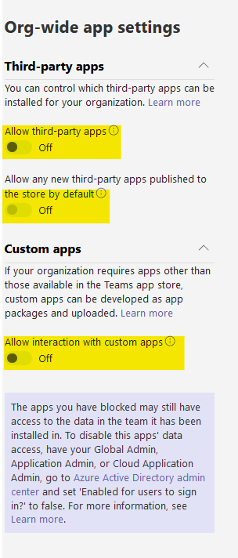

### CM-10

(A) B2C-010

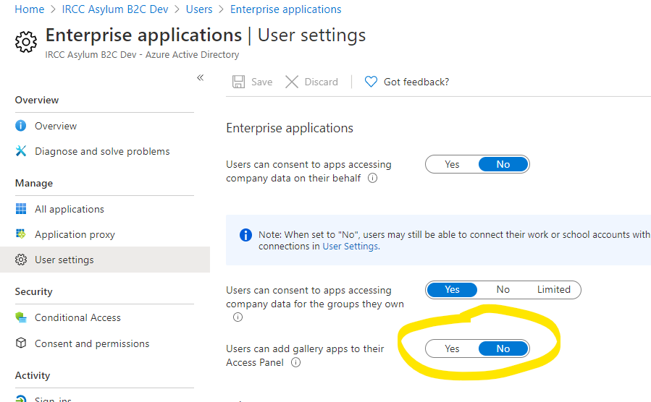

(B) B2C-011

Before:

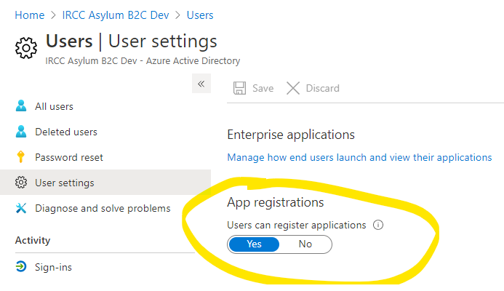

After:

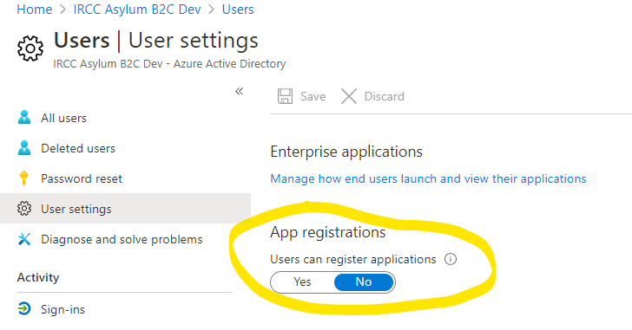

(C) AZ-L2-005

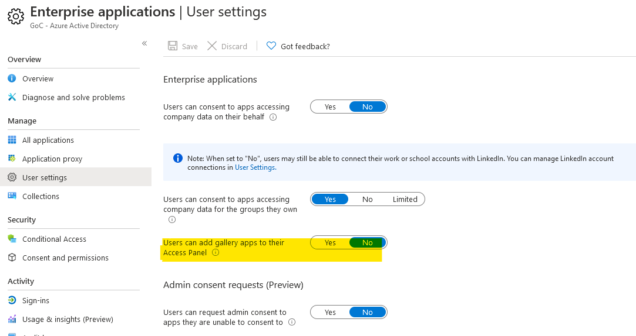

(D) AZ-L2-006

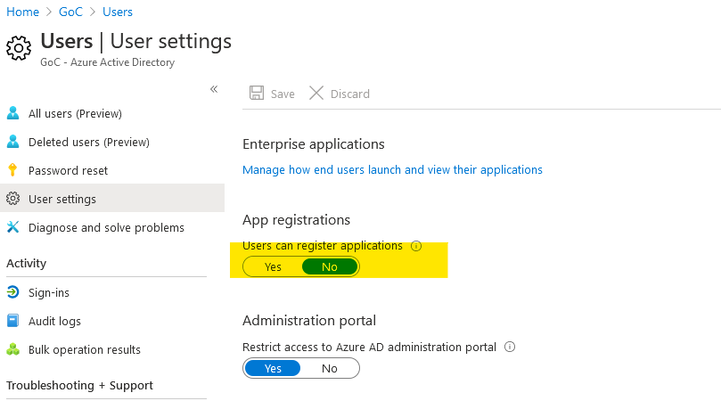

## Contingency Planning (CP)

### CP-2(2)

1. TM-046 - control performed through Conditional Access (refer to OD-044)

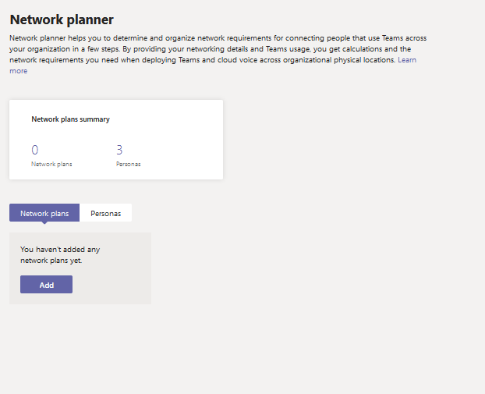

## Identity and Authentication (IA)

### IA-1

(A) See part (A) of AC-2

### IA-2

(A) B2C-003

There are no users with “User Type” of “Guest”, only “Member”

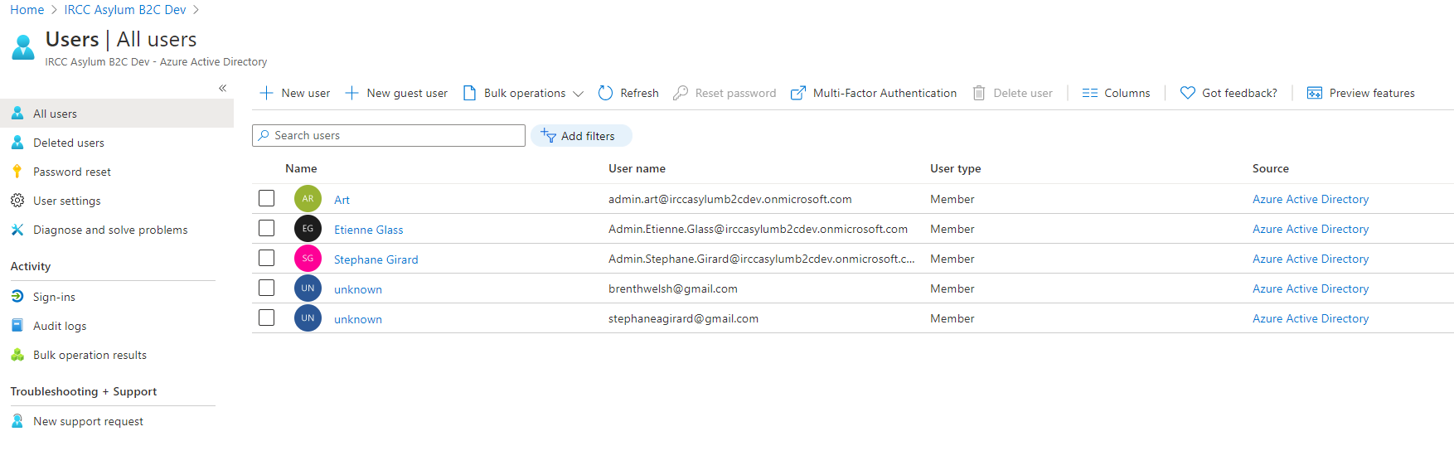

### IA-2(1)

(A) B2C-001

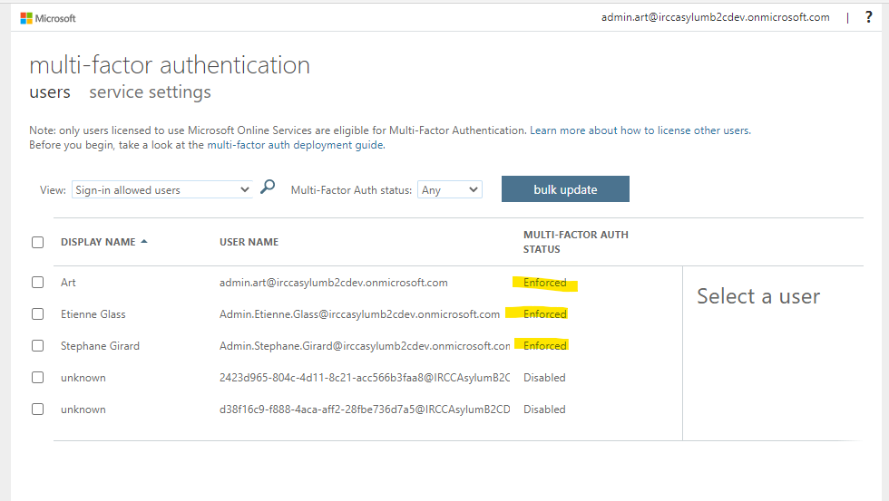

(B) O365 Reference ID 1 and AZ-L1-001

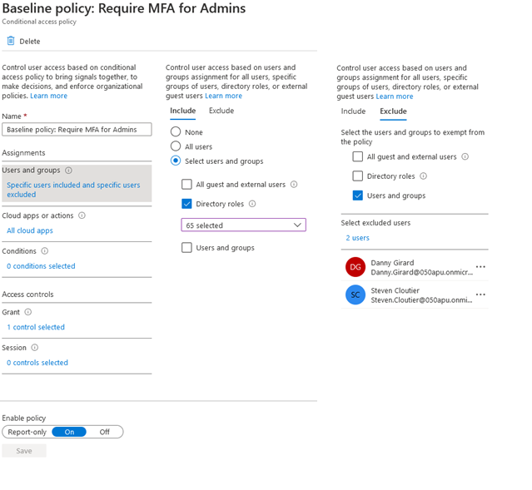

(C) O365 Reference ID 45 and AZ-L2-001

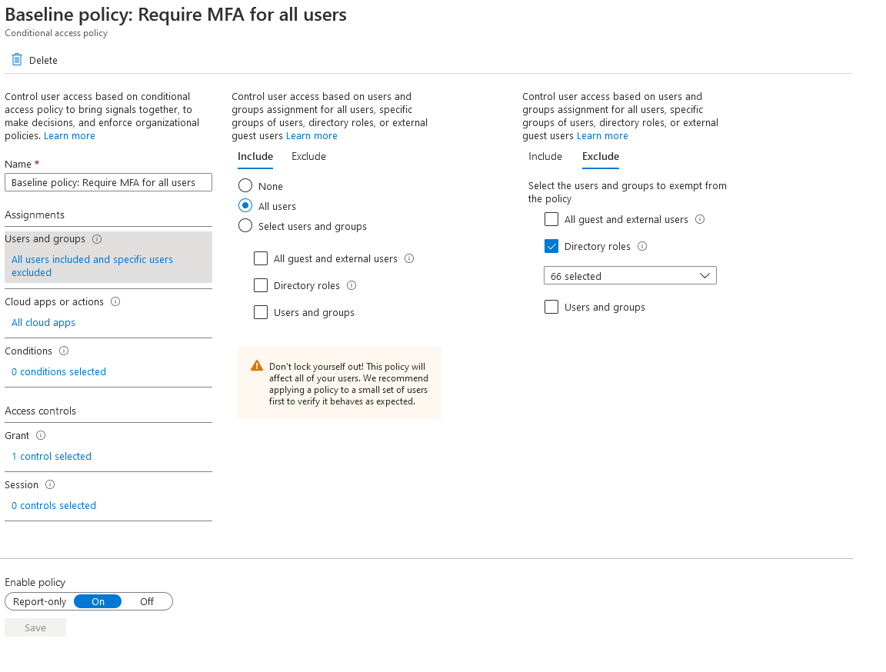

(D) AZ-L1-002

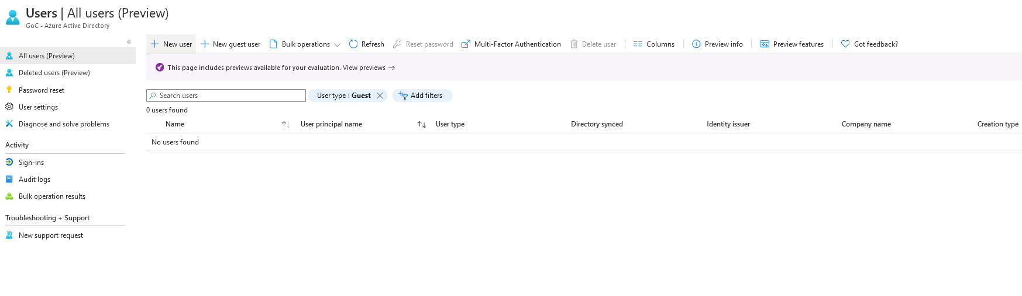

(E ) AZ-L1-003

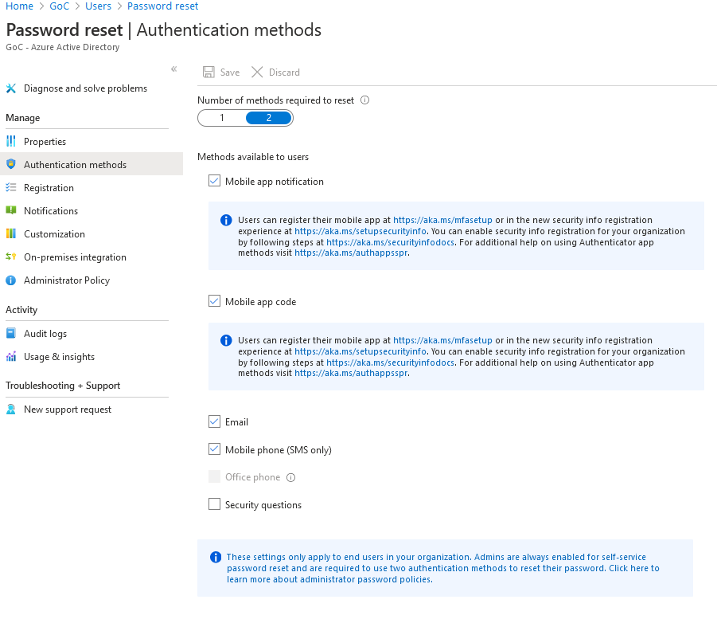

### IA-2(2)

(A) O365-RefID-31.

(B) O365 Reference ID 45 Refer to IA-2 (C)

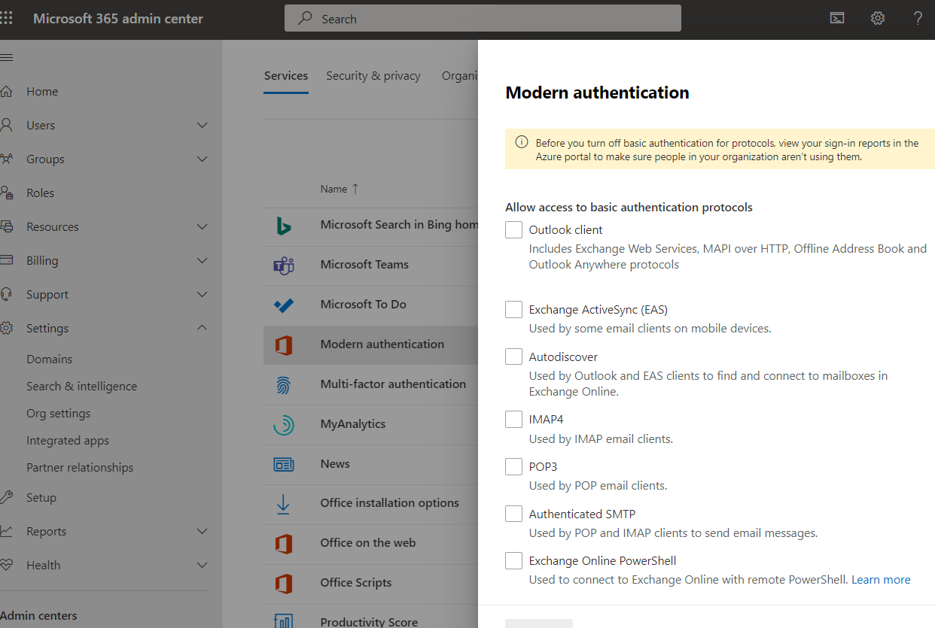

(C) B2C-002

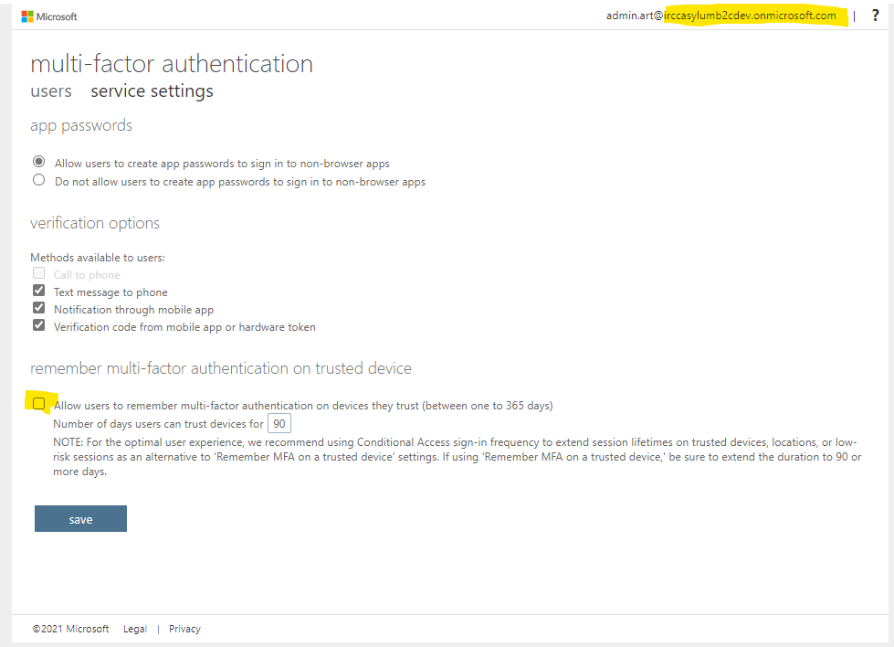

(D) B2C-007

Not Applicable

Azure AD B2C consumer MFA is not a requirement for current phase. It may be implemented as part of future phases of the Asylum application.

(E) AZ-L2-002

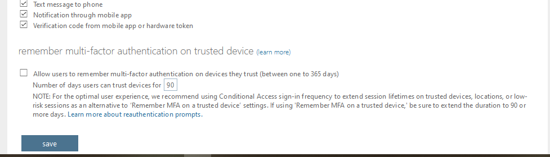

### IA-2(6)

(A) O365 Reference ID 45 Refer to IA-2 (C)

### IA-2(7)

(A) O365-RefID-14

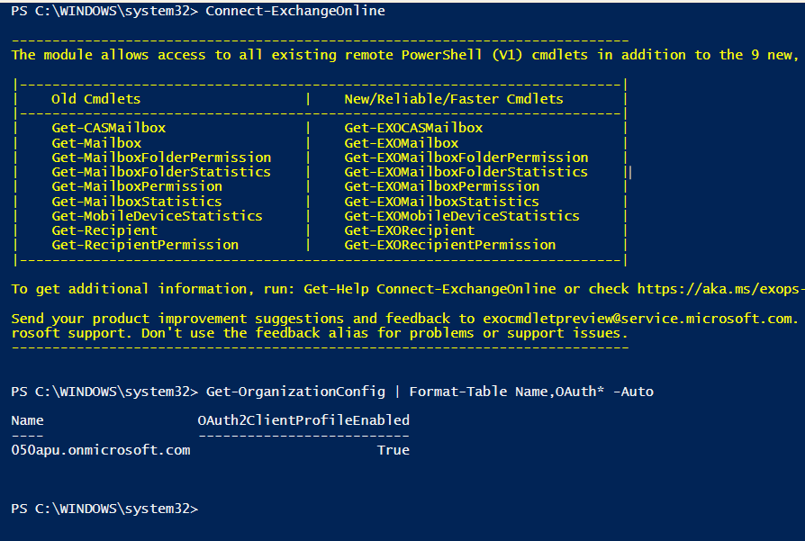

(B) O365 Reference ID 45 Refer to IA-2 (C)

(C) O365 Reference ID 72

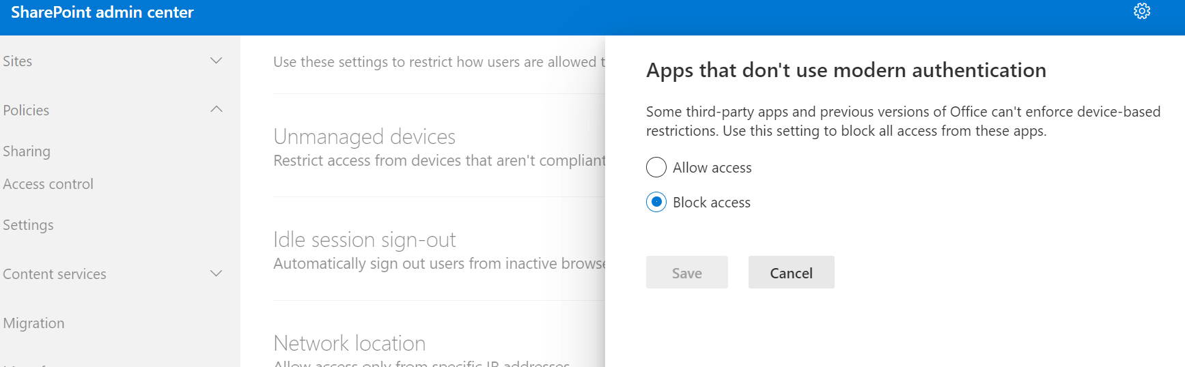

### IA-2(11)

1. O365 Reference ID 45 Refer to IA-2 (C)

### IA-3

1. AZ-L1-008

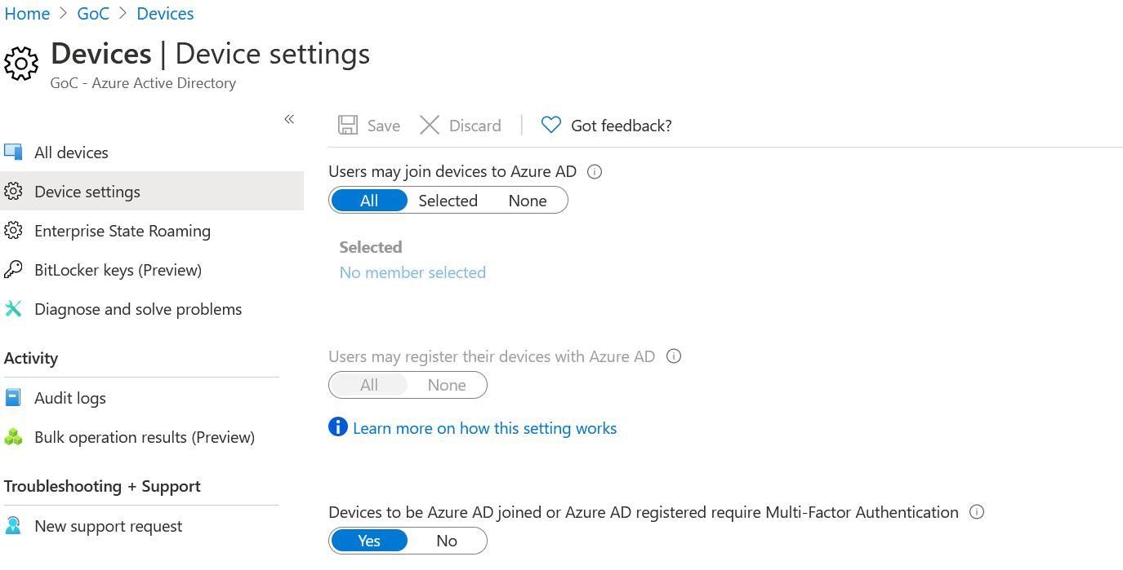

### IA-3(4)

1. AZ-L1-008 see IA-3 (A)

### IA-5

1. See part (A) of AC-2(4)
2. O365 Reference ID 38

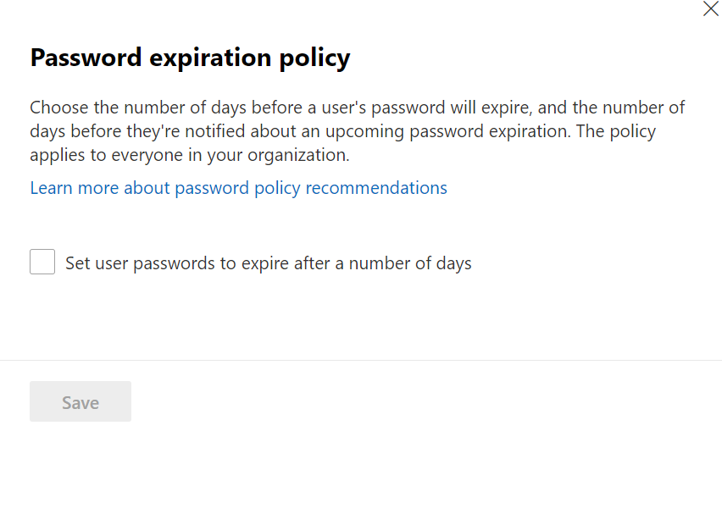

### IA-5(1)

1. O365 Reference ID 3

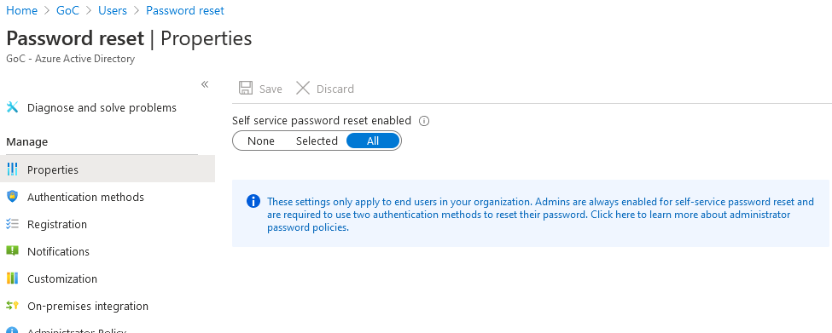

1. O365 Reference ID 38 Refer to IA-5 part (B)
2. AZ-L1-004

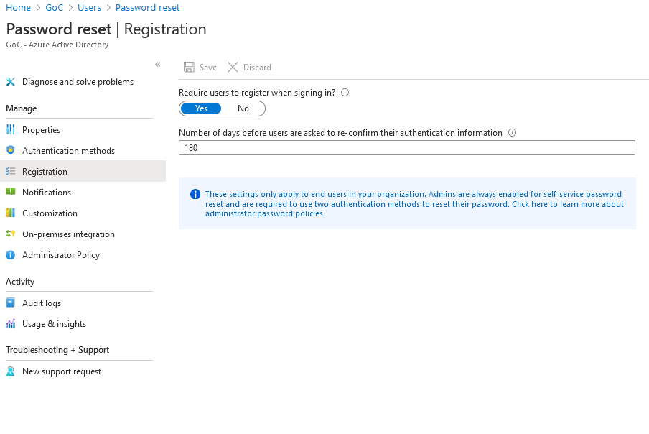

1. AZ-L1-005 and AZ-L2-003 See AC-2(4) (C)

### IA-5 (4)

1. O365 Reference ID 13 and AZ-L3-001

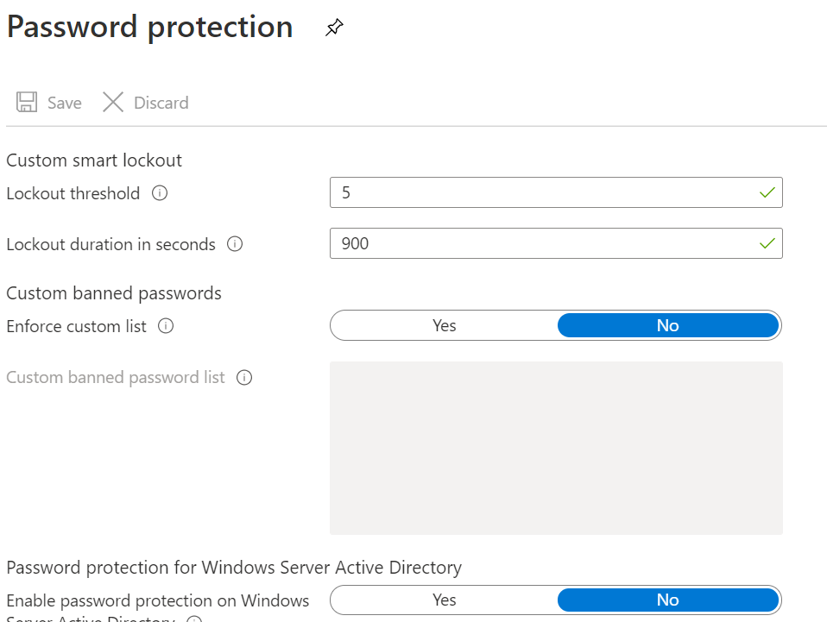

### IA-5 (6)

1. O365 Reference ID 7 ( also AZ-L1-076)

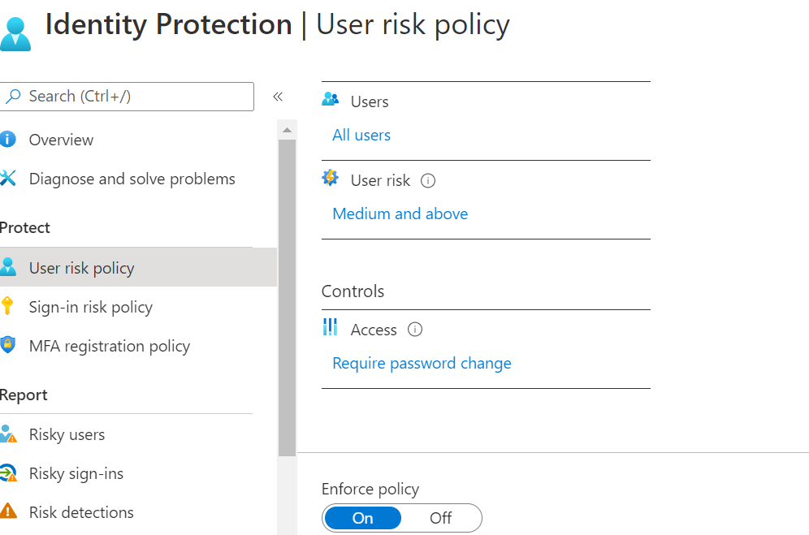

Figure 9 - User Risk Policy

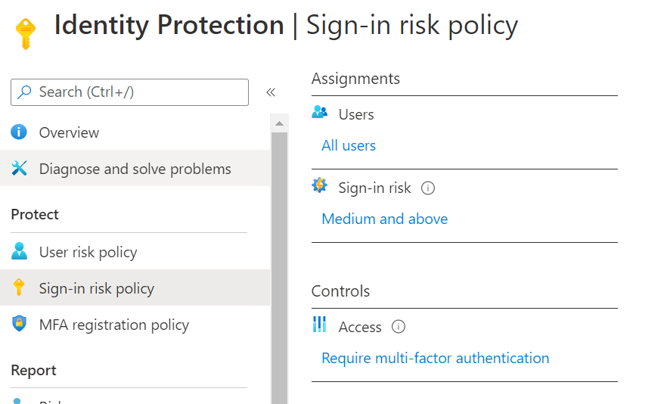

Figure 10 - Sign in Risk

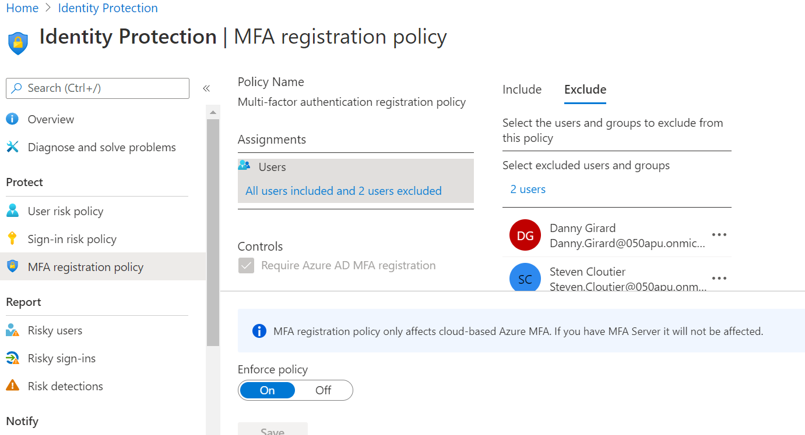

Figure 11 - MFA registration

### IA-5(8)

1. O365-RefID-69. The two permanent Global admin accounts are not day-to-day accounts. There are no other roles other than Global Admin that have assigned users as of Feb 10.

### IA-11

1. See part (B) of IA-2(2)
2. AZ-L2-002 IA-2(2) (E)

## Incident Response (IR)

### IR-6

(A) AZ-L1-023

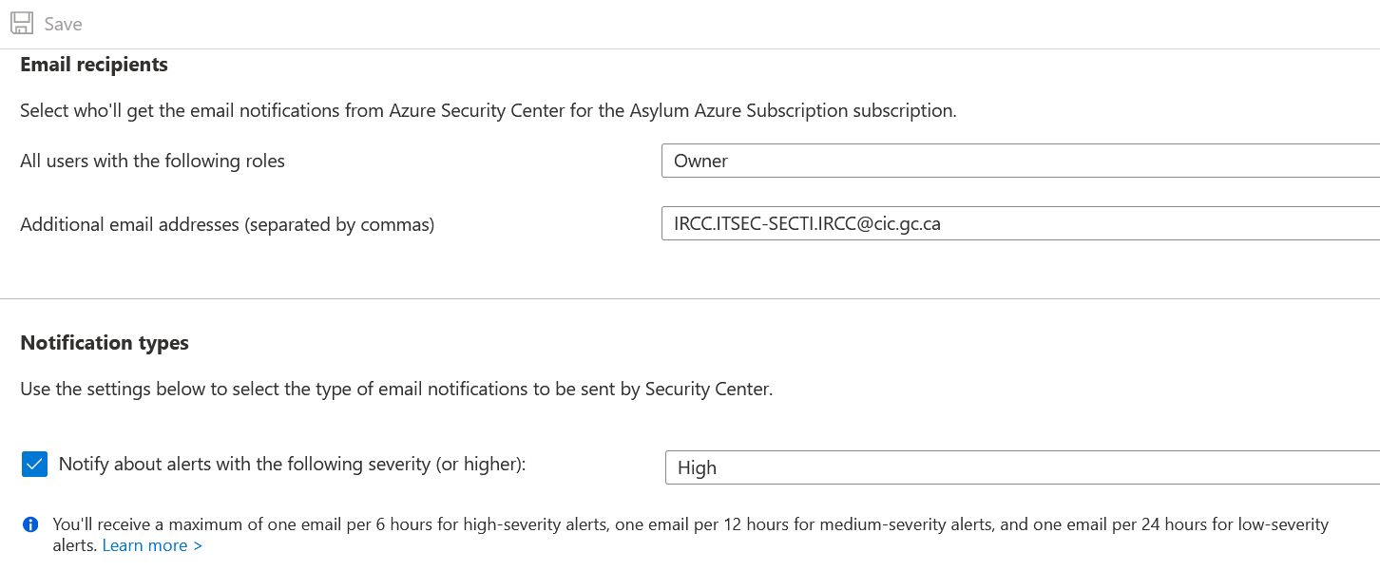

### IR-6(1)

1. AZ-L1-025 – refer to IR-6 (A)
2. AZ-L1-026 – refer to IR-6 (A)

## Maintenance (MA)

### MA-4

(A) See part (A) of SC-7(10)

## Media Protection (MP)

## System Security Plan (PL)

### PL-8

1. TM-046 refer to CP-2(2)

## Personnel (PS)

## Risk Assessment (RA)

## Security Authorization (SA)

### SA-22

1. TM-042

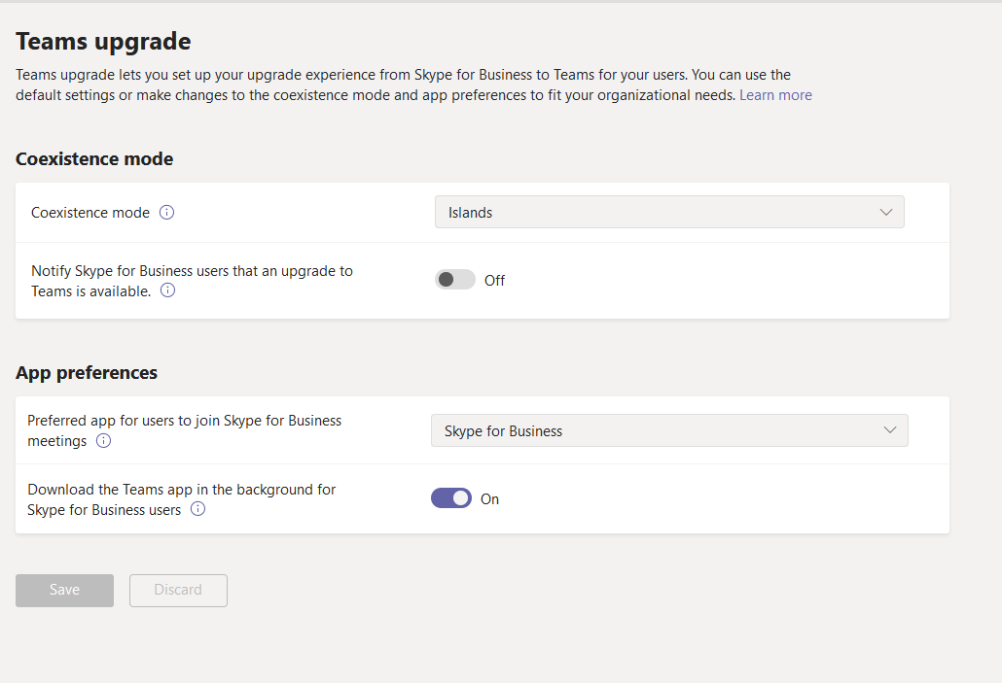

## System Communications (SC)

### SC-7

1. TM-014 refer to SC-15(2)
2. TM-015

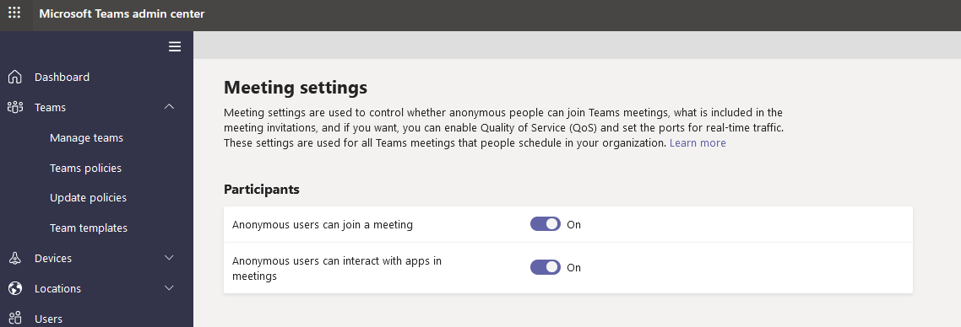

after

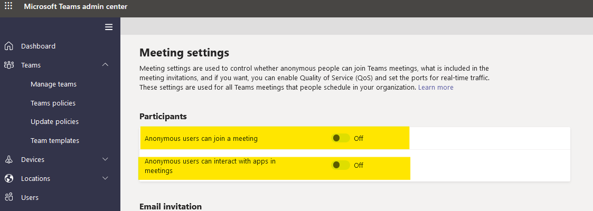

### SC-7(10)

(A) O365-RefID-10. Requires E5 licenses which IRCC does not have.

(B) See part (B) of AC-4(8)

(C) O365-RefID-71. Exchange rule to not allow auto forward.

(D) O365 Reference ID 5

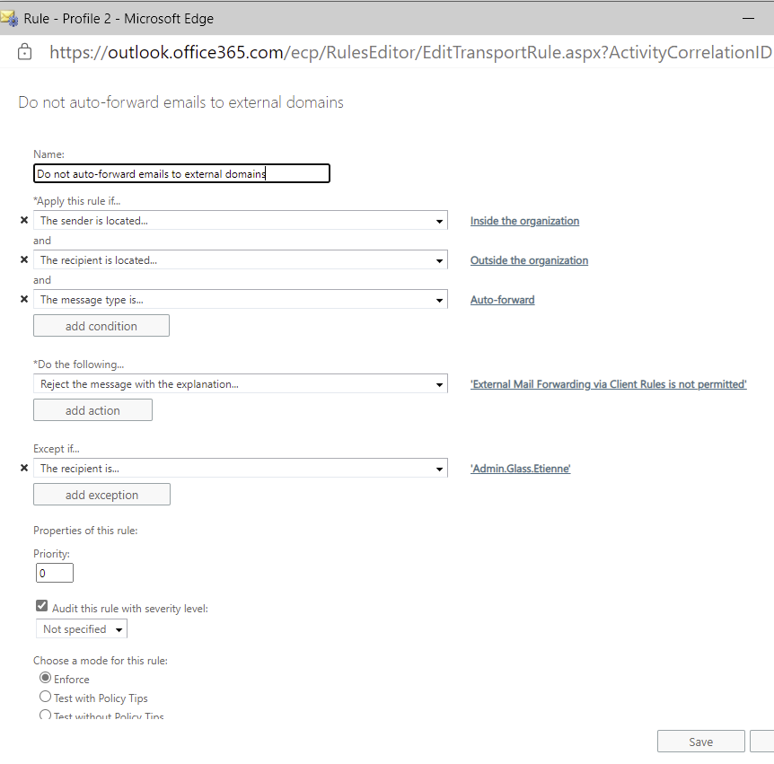

1. O365 Reference ID 75 refer to AC-1 (C)

### SC-15

1. TM-013

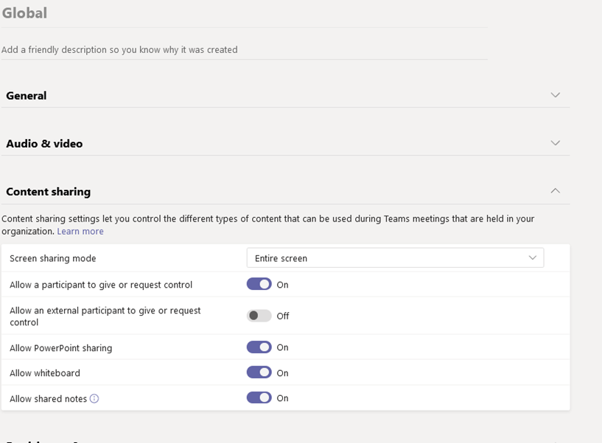

### SC-15(2)

1. TM-014

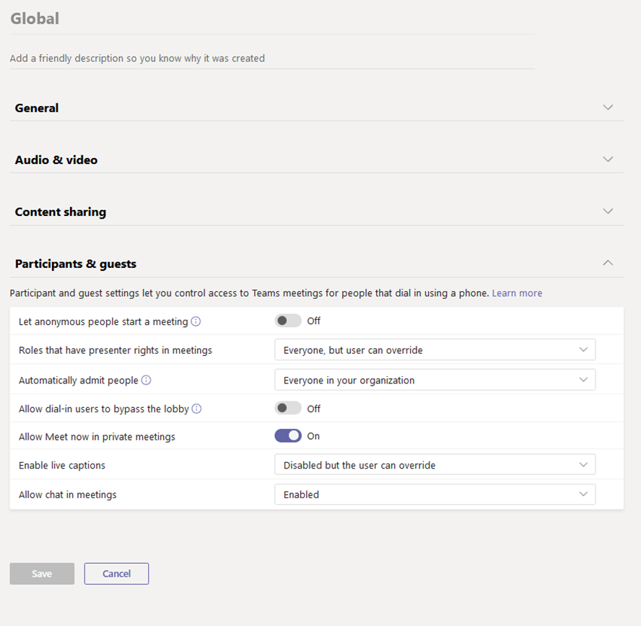

## Information Systems Monitoring (SI)

### SI-3

(A) See part (A) of AC-4(8)

(B) O365-RefID-30. Defender for O365 Safe Links requires E5 licenses – E5 licenses not available0).

(C) Refer to part (D) of AC-4(8)

(D) O365-RefID-51. Defender for O365 requires E5 licenses – E5 licenses not available.

### SI-3(1)

(A) See part (B) of SI-3

### SI-3(7)

(A) See part (B) of SI-3

### SI-4

(A) O365-RefID-09. Report is available for review.

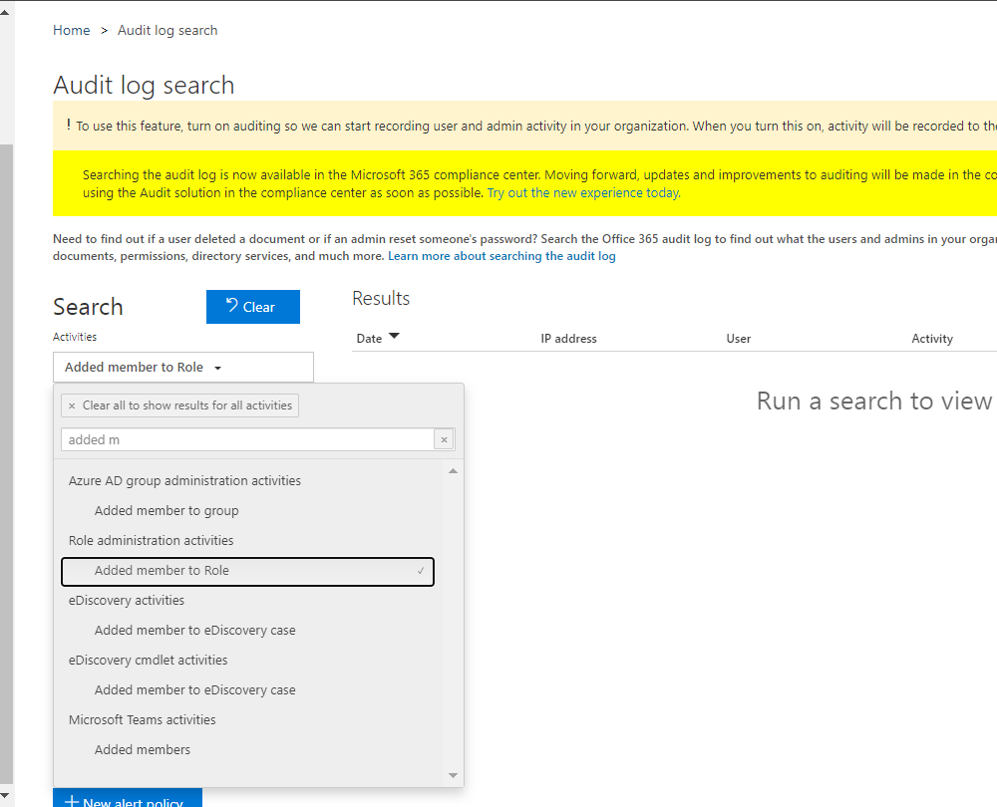

(B) O365-RefID-26. Report is accessible.

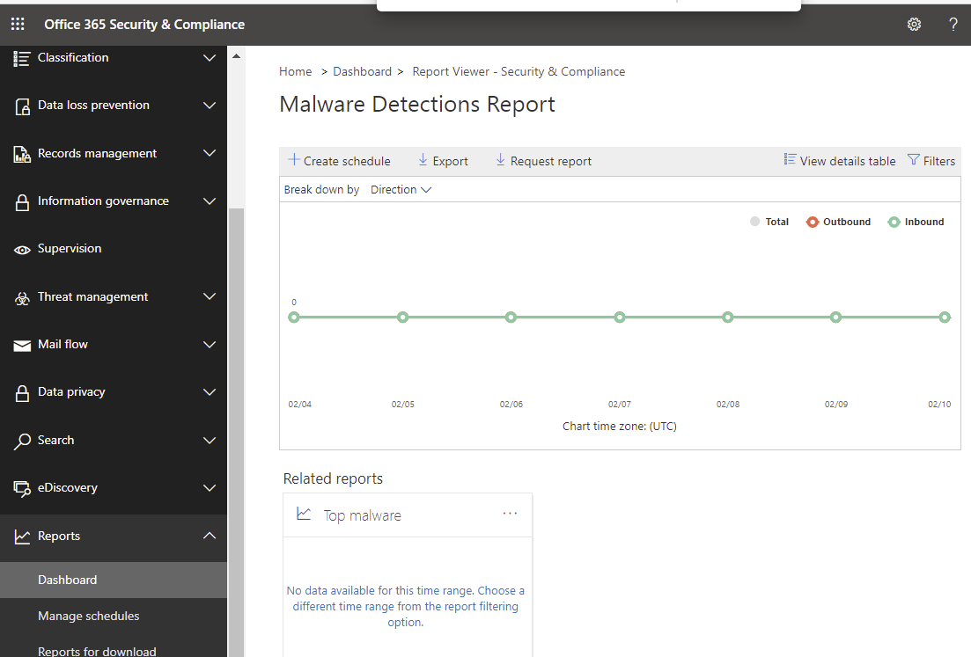

(C) O365-RefID-27. Report is accessible.

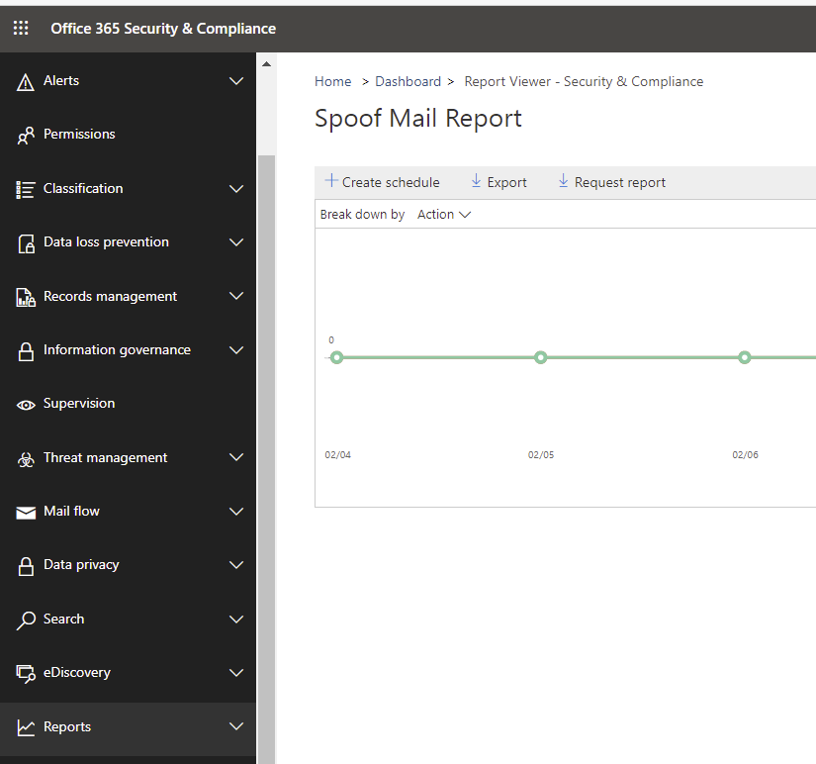

(D) O365-RefID-28. Report is accessible.

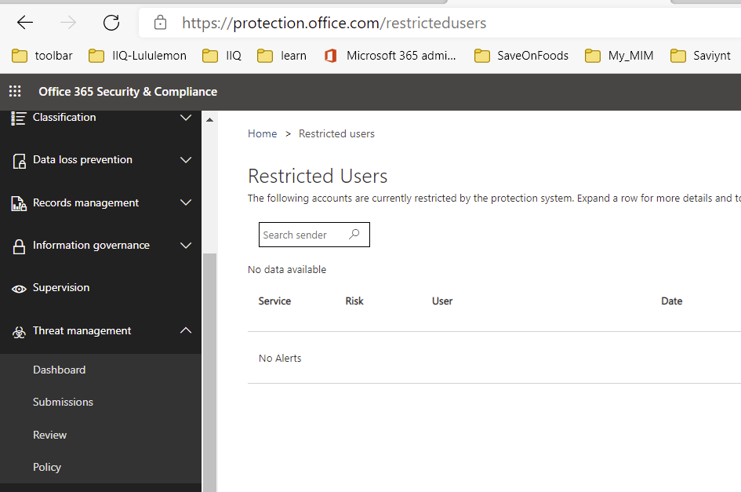

(E) O365 Reference ID 4 Azure AD 'Risky sign-ins' report

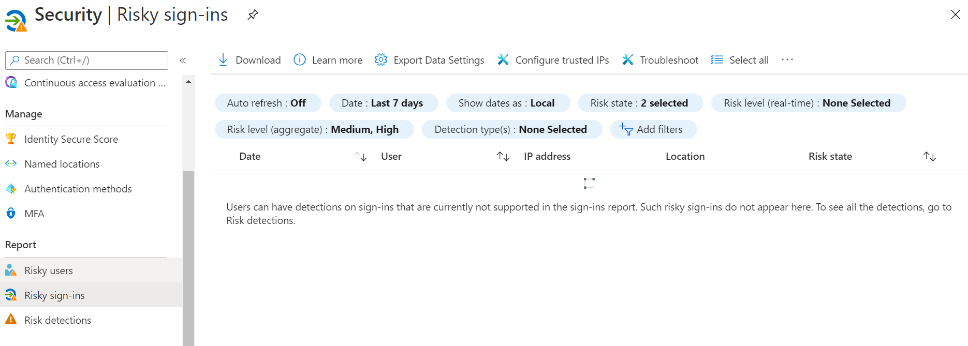

(F) O365 Reference ID 38

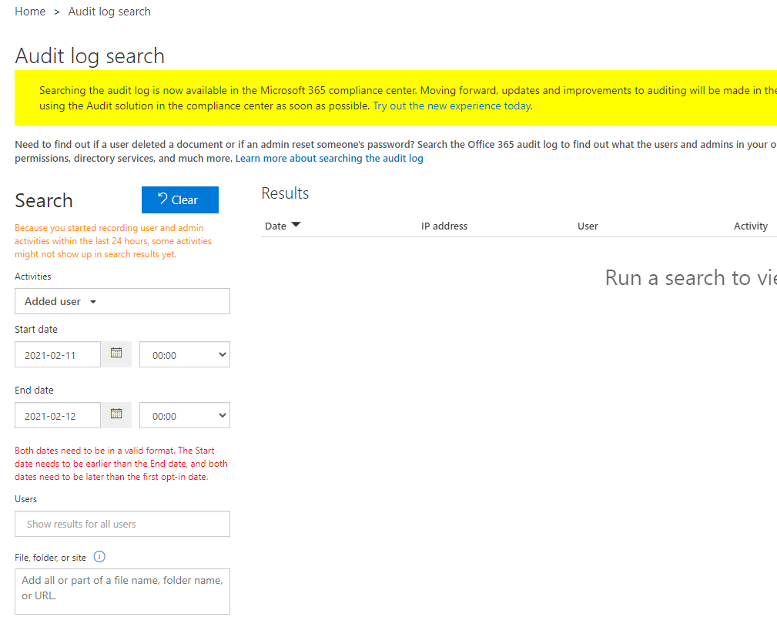

(G) AZ-L1-053

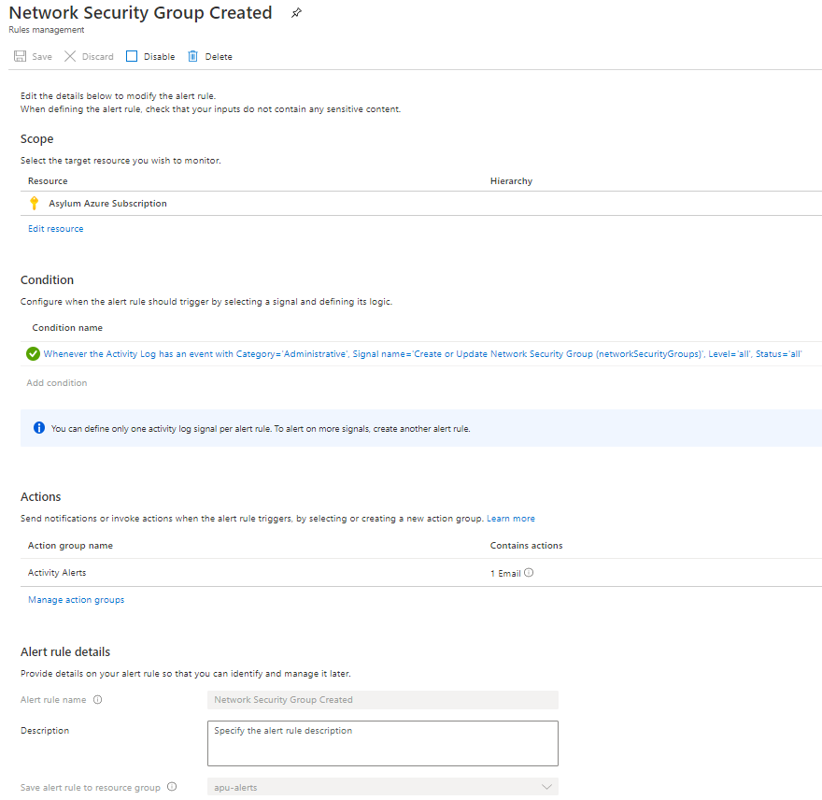

(H) AZ-L1-054

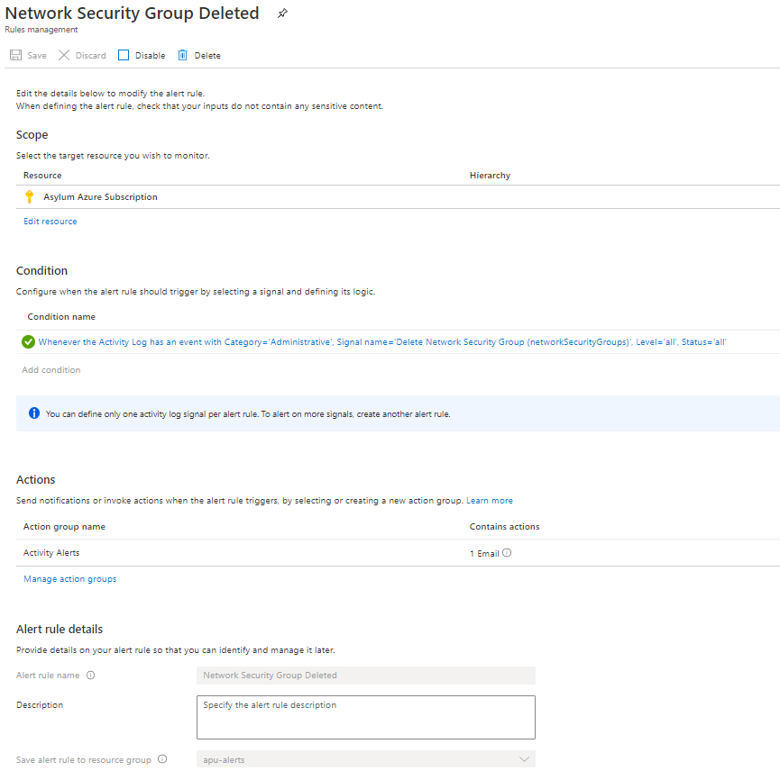

(I) AZ-L1-055

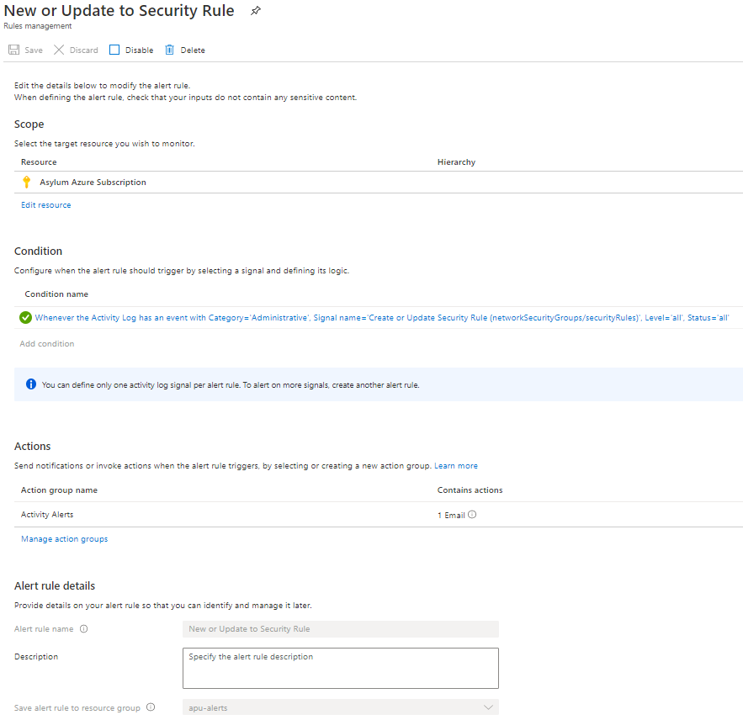

(J) AZ-L1-056

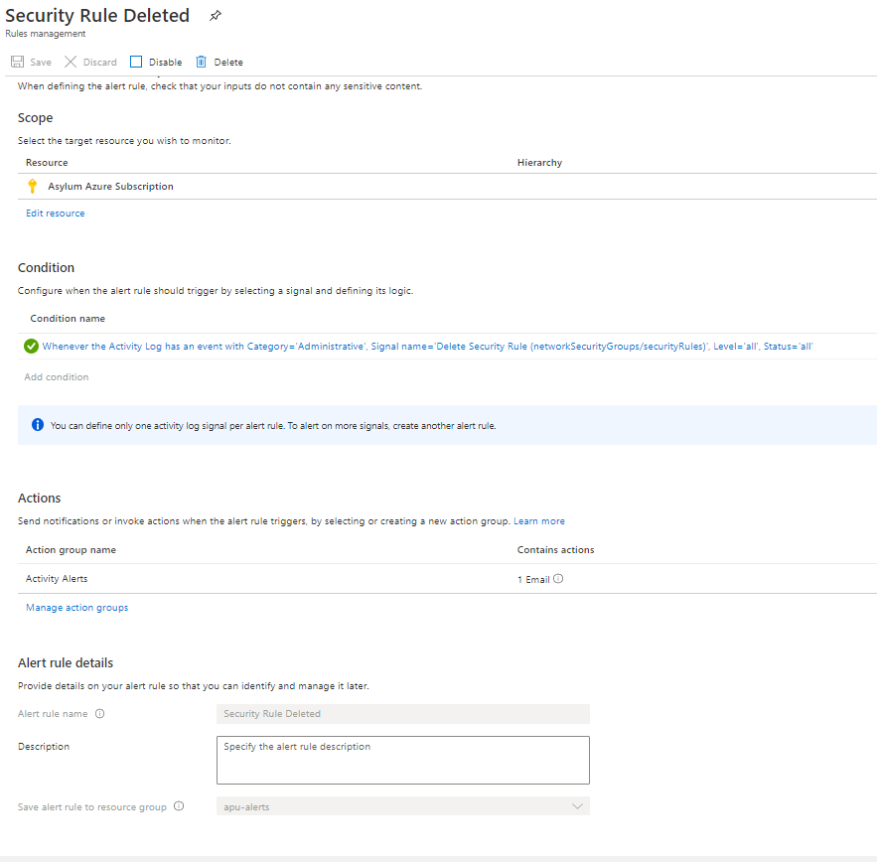

(K) AZ-L1-057

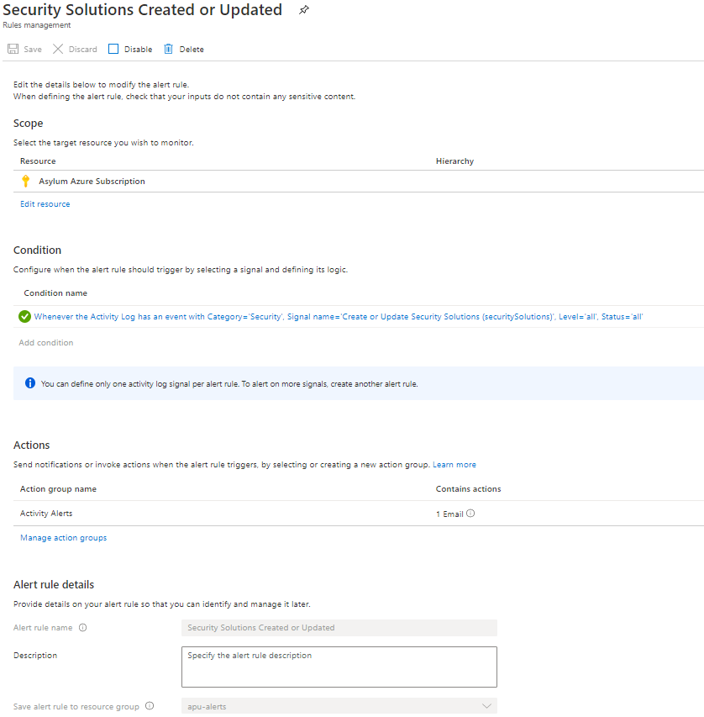

(L) AZ-L1-058

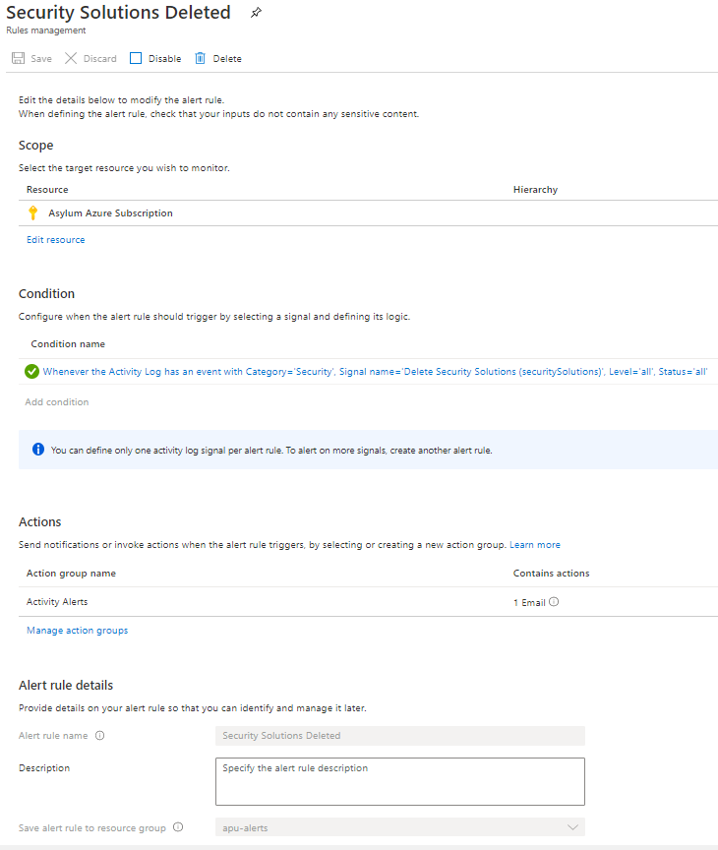

(M) AZ-L1-059

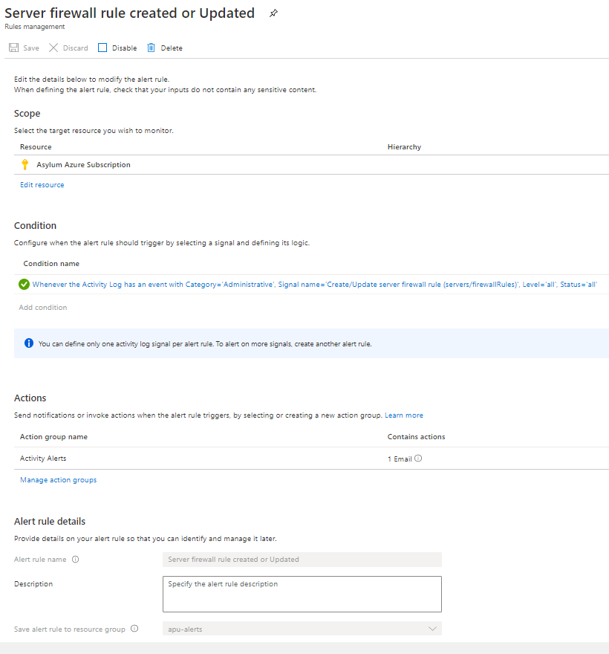

(N) AZ-L1-060

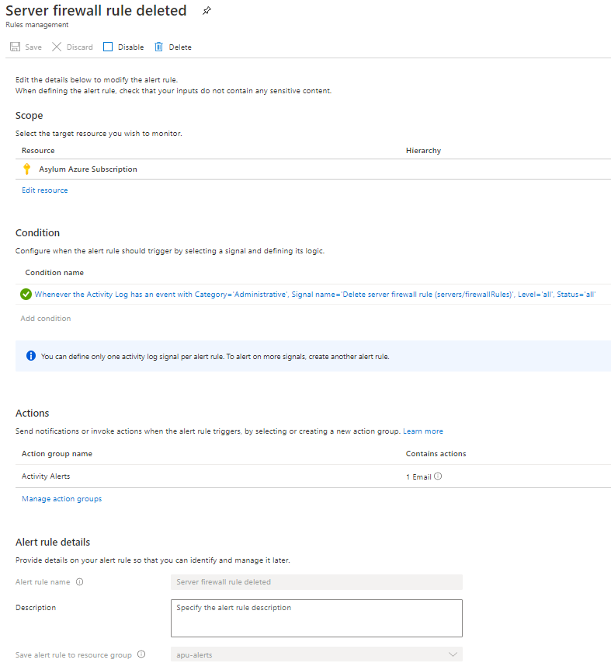

(O) AZ-L1-061

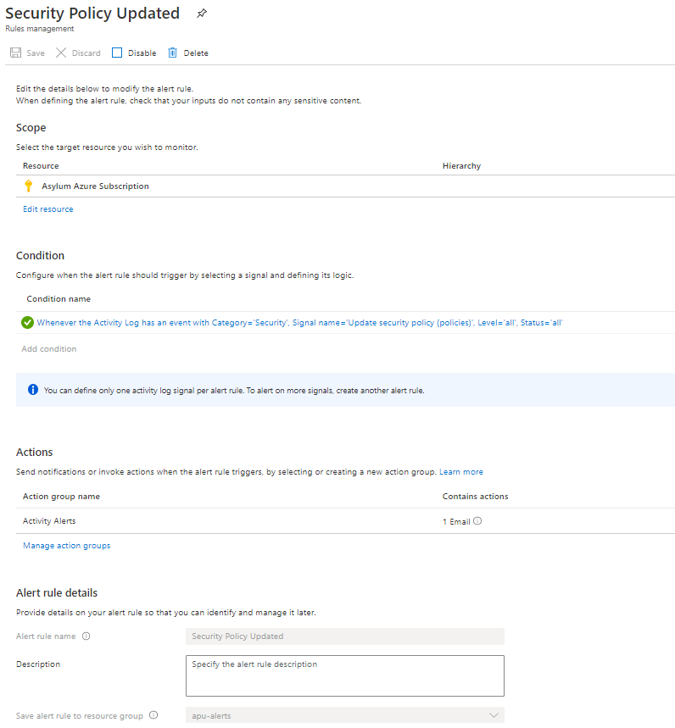

### SI-4(2)

(A) O365-RefID-22. Notifications added…



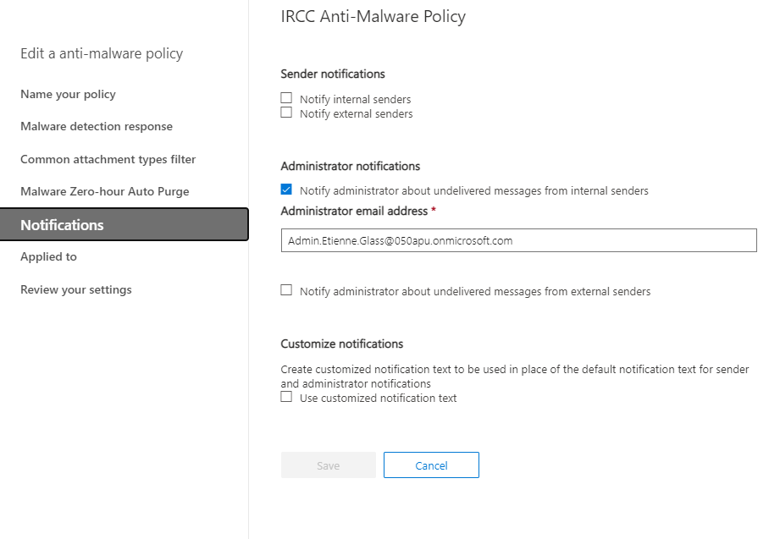

(B) See part (A) of SI-8

### SI-4(5)

(A) See part (A) of SI-4(2)

(B) See part (A) of SI-8

(C) AZ-L1-053 refer to SI-4 (G)

(D) AZ-L1-054 refer to SI-4 (H)

(E) AZ-L1-055 refer to SI-4 (I)

(F) AZ-L1-056 refer to SI-4 (J)

(G) AZ-L1-057 refer to SI-4 (K)

(H) AZ-L1-058 refer to SI-4 (L)

(I) AZ-L1-059 refer to SI-4 (M)

(J) AZ-L1-060 refer to SI-4 (N)

(K) AZ-L1-061 refer to SI-4 (O)

### SI-4(7)

(A) B2C-006

Not Applicable

Risky Users and Risky Sign-ins are required for Azure AD B2C Conditional Access. AAD B2C CA is not a requirement for current phase. It may be implemented as part of future phases of the Asylum application.

(B) AZ-L1-076 (also O365 Reference ID 7) refer to IA-5 (6) (A)

### SI-4(12)

(A) AZ-L1-053 refer to SI-4 (G)

(B) AZ-L1-054 refer to SI-4 (H)

(C) AZ-L1-055 refer to SI-4 (I)

(D) AZ-L1-056 refer to SI-4 (J)

(E) AZ-L1-057 refer to SI-4 (K)

(F) AZ-L1-058 refer to SI-4 (L)

(G) AZ-L1-059 refer to SI-4 (M)

(H) AZ-L1-060 refer to SI-4 (N)

(I) AZ-L1-061 refer to SI-4 (O)

### SI-4(20)

(A) O365-RefID-25. Report is available through the O365 admin portal.

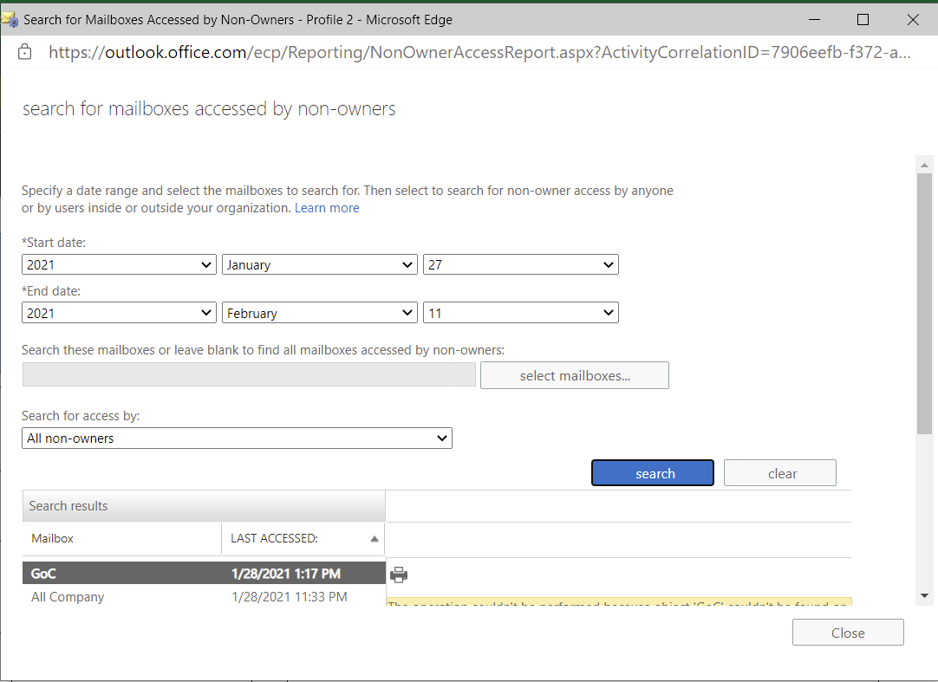

### SI-8

(A) O365-RefID-34

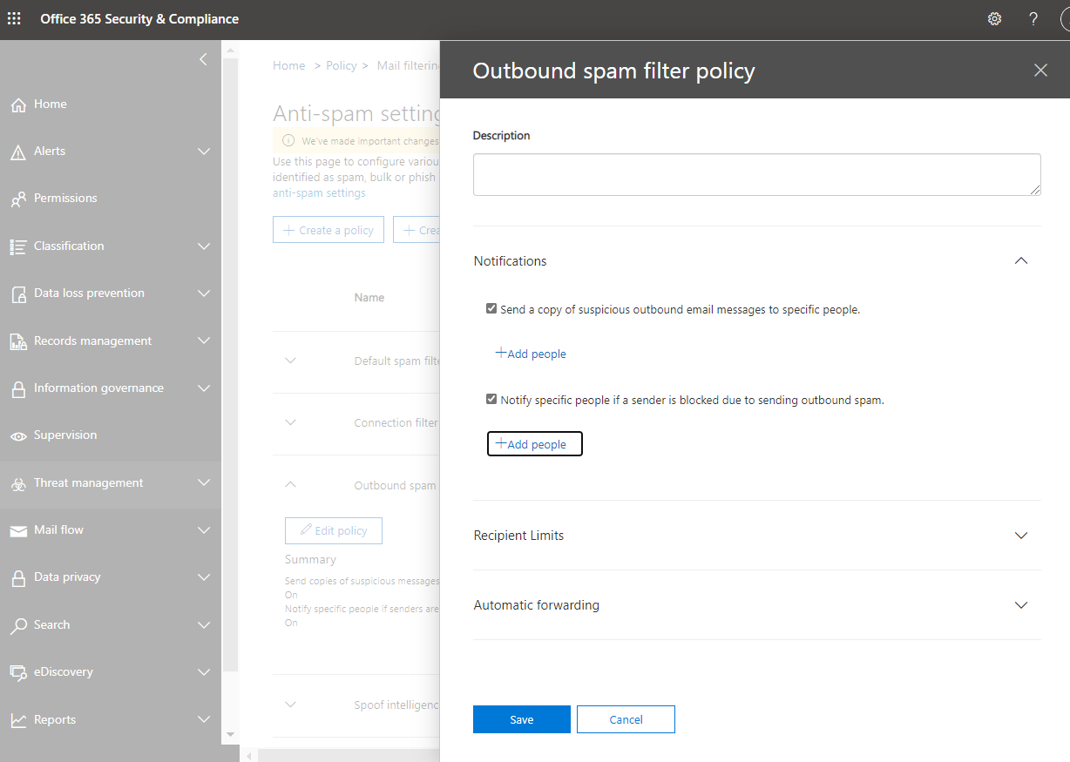

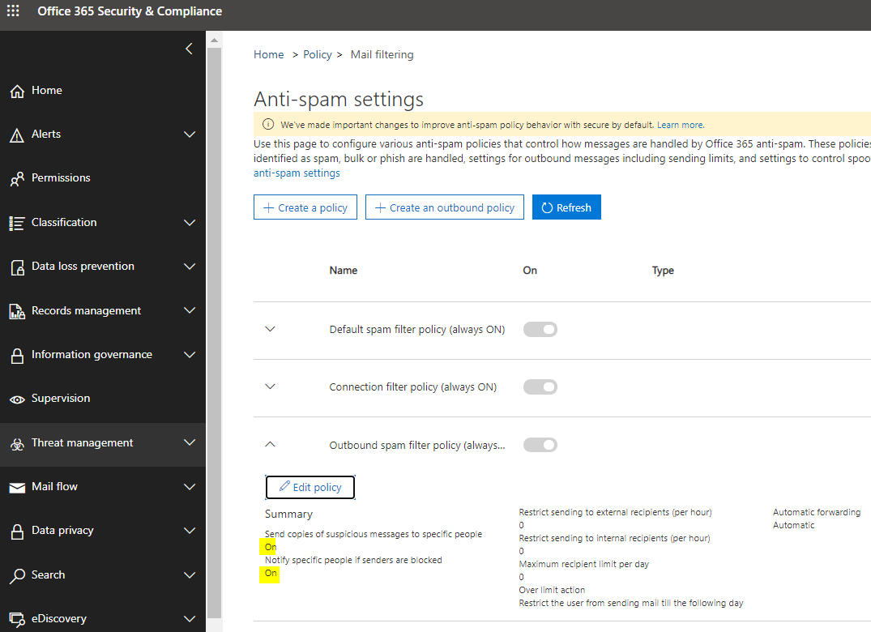

## Physical Environment (PE)

## Others (No ITSG33 Control)



O365 Reference ID 68

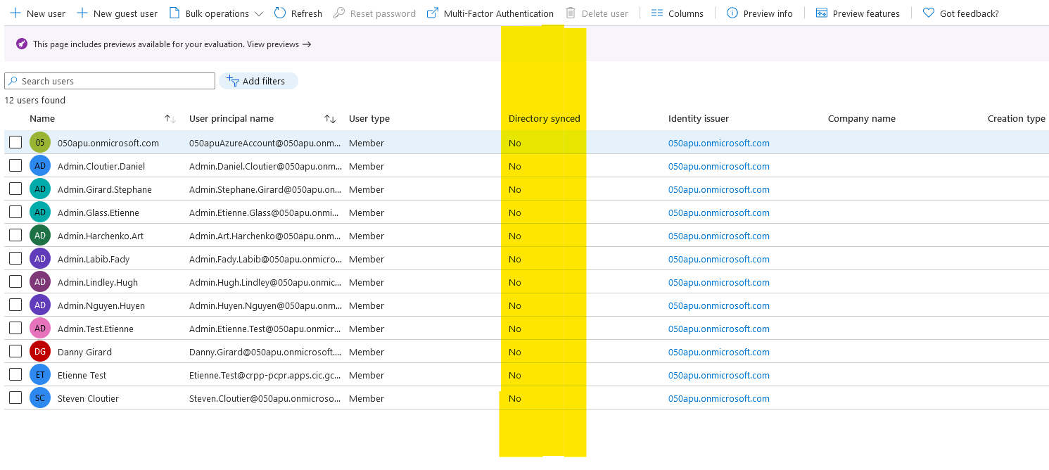

O365 Reference ID 80

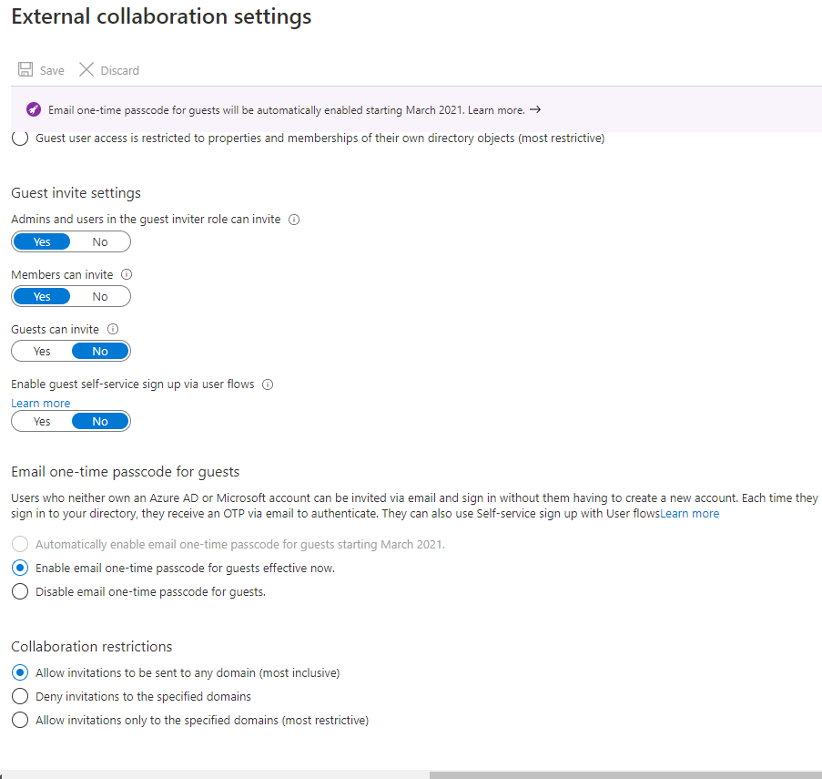

O365 Reference ID 86

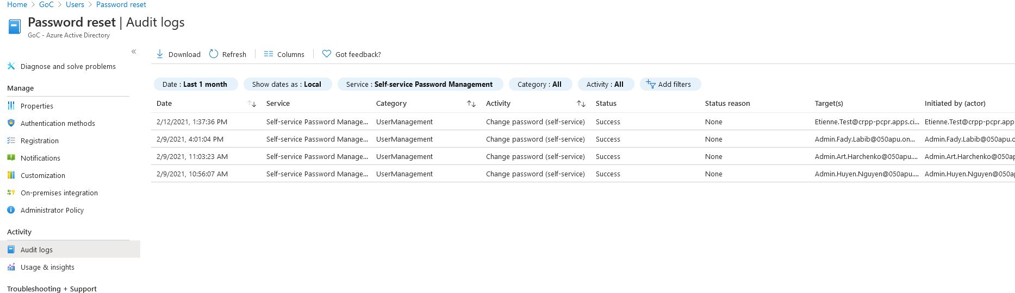

O365 Reference ID 92

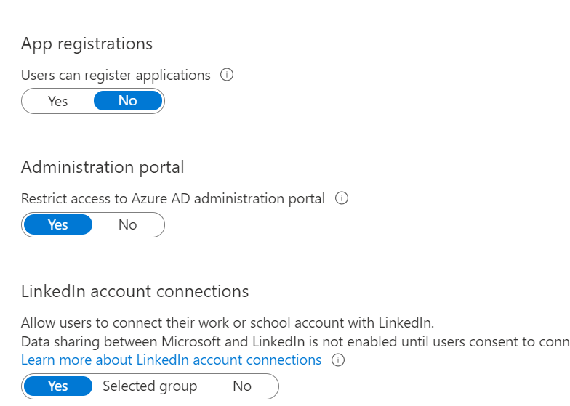

O365 Reference ID 96

Exchange Retention Policy 30 days

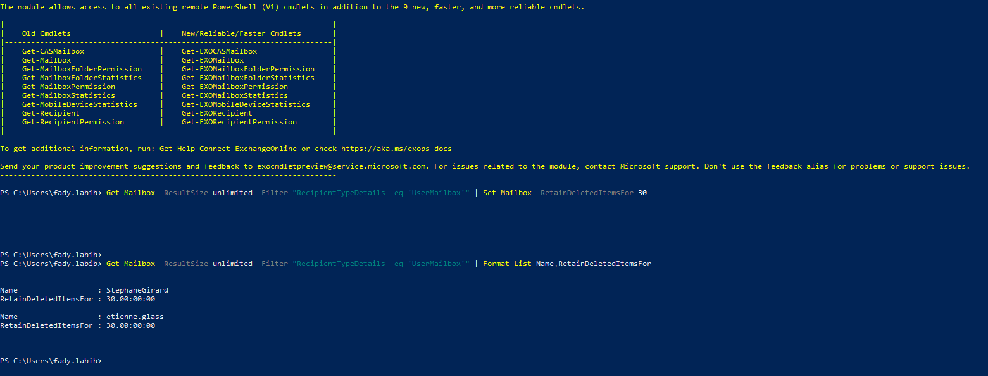

OneDrive Retention Policy 60 Days

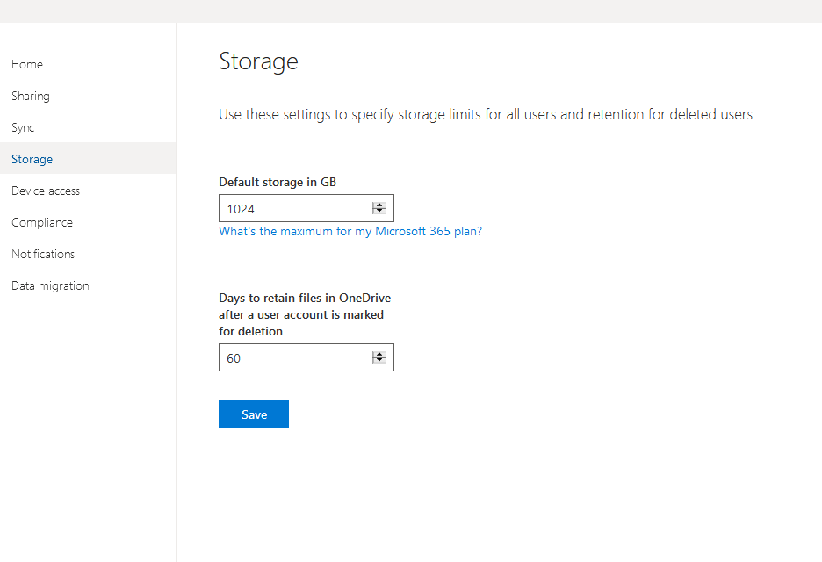

## Conditional Access Policies

The following Conditional Access policies were configured in the APU050 tenant

| **CONDITIONAL ACCESS POLICY NAME** | **DESCRIPTION** | **ASSIGNMENT** | | | | | | **ACCESS CONTROL [GRANT/**  **BLOCK]** |
| --- | --- | --- | --- | --- | --- | --- | --- | --- |
| **USERS** | **GROUPS** | **CLOUD APPS** | **CONDITIONS** | | |
| **LOCATIONS** | **CLIENT APPS** | **Sign-in Risk** |
| Baseline policy: Block Legacy Authentication | This global policy blocks all connections from unsecure legacy protocols like ActiveSync, IMAP, PO3, etc. |  | All Users | All Cloud Apps |  | Exchange ActiveSync clients and Other clients |  | Block |
| Baseline policy: Require MFA for Admins | This global policy requires all Administrators to authenticate using MFA. |  | Directory Roles (check all)  **Exclude**  Danny Girard and Steven Cloutier Break Glass accounts | All Cloud Apps |  |  |  | Require multi-factor authentication |
| Baseline policy: Require MFA for all users | This global policy requires all Users to authenticate using MFA. |  | All Users; exclude Directory Roles (check all) | All Cloud Apps |  |  |  | Require multi-factor authentication |
| Baseline policy: Block Prohibited Locations | This global policy blocks all connections from any country except Canada |  | All Users | All Cloud Apps | Prohibited Countries **exclude** Allowed Country |  |  | Block |
| Baseline policy: Block Access from Untrusted Locations | This global policy requires all connections from IRCC & CBSA Locations |  | All users; **Exclude**  Danny Girard and Steven Cloutier Break Glass accounts | All Cloud Apps | All Location; **Exclude** IRCC and CBS Proxy IP |  |  | Block |
| Baseline policy: Block High Sign-in Risk | This global policy blocks all high-risk authentications |  | All Users; **Exclude**  Danny Girard and Steven Cloutier Break Glass accounts | All Cloud Apps |  |  | High | Block |
| Baseline policy: Block Guest and External Users | This global policy blocks all guest and external users authentications |  | All Guests and external users | All Cloud Apps |  |  |  | Block |
| Terms of Use | This global policy forces Terms of Use on all authentications. | All users |  | All Cloud Apps |  |  |  | Terms of Use / Condition utilisation |

### Baseline policy: Block Legacy Authentication



### Baseline policy: Require MFA for Admins

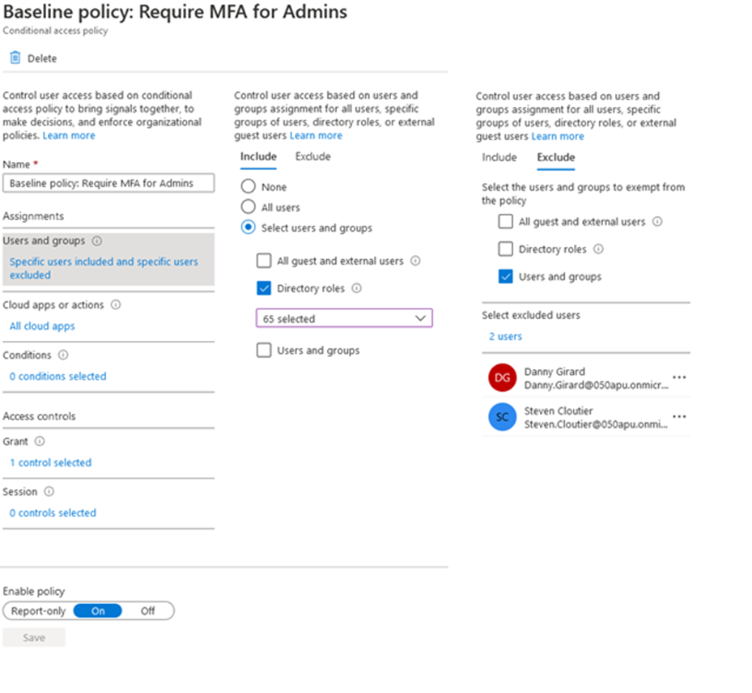

### Baseline policy: Require MFA for all users



### Baseline policy: Block Prohibited Locations

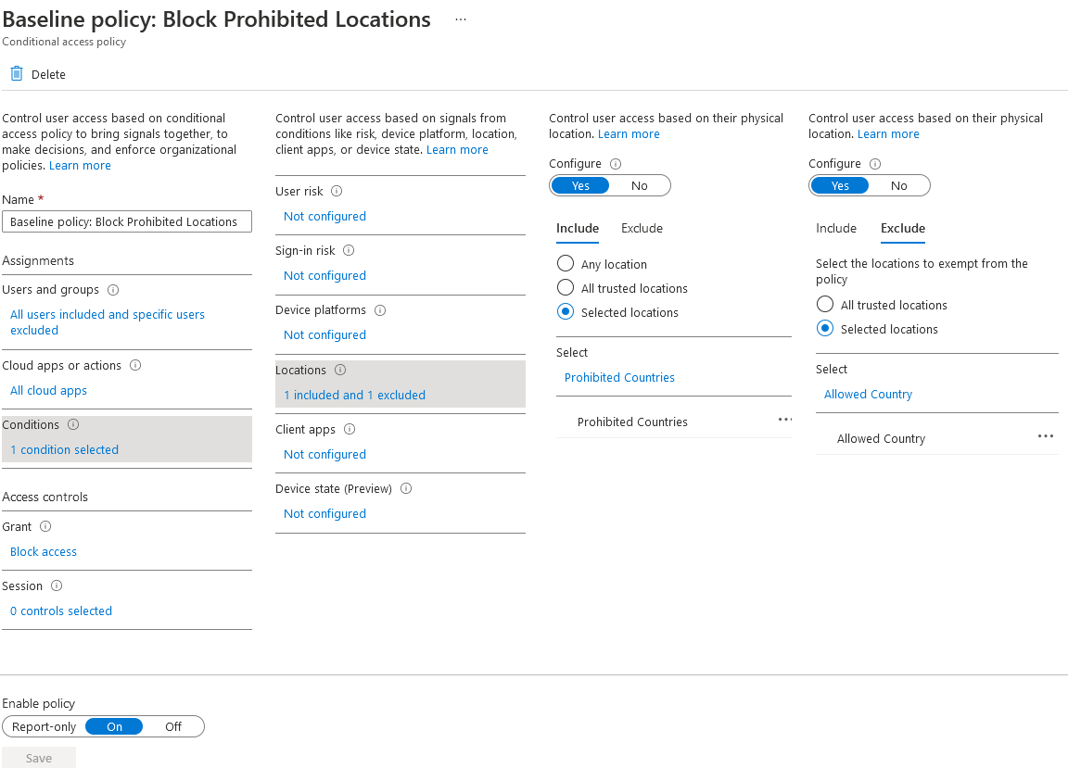

### Baseline policy: Block Access from Untrusted Locations



### Baseline policy: Block High Sign-in Risk

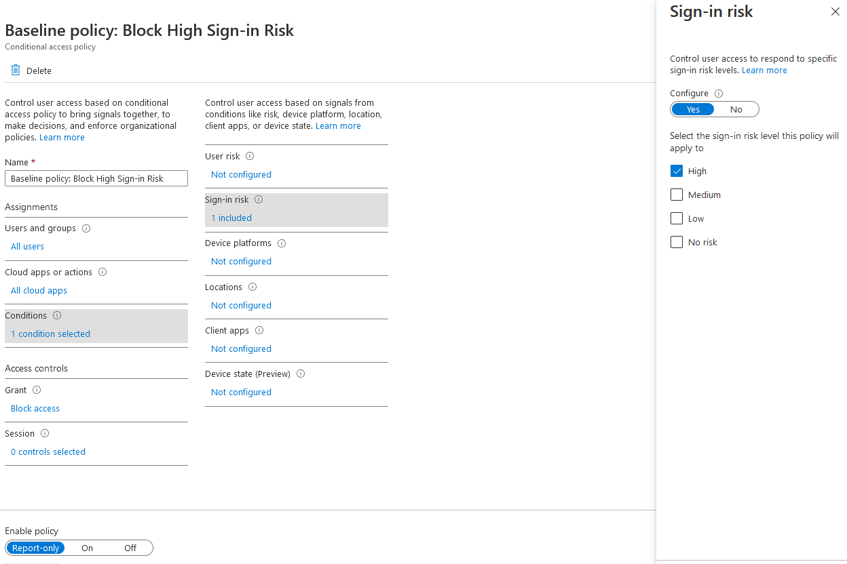

### Baseline policy: Block Guest and External Users

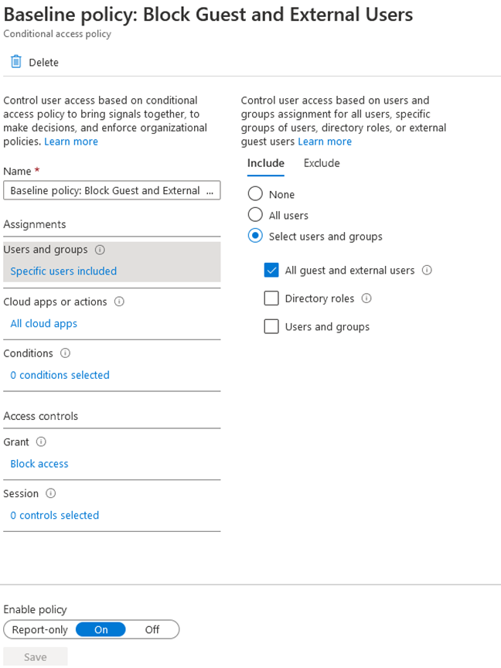

### Term of Use

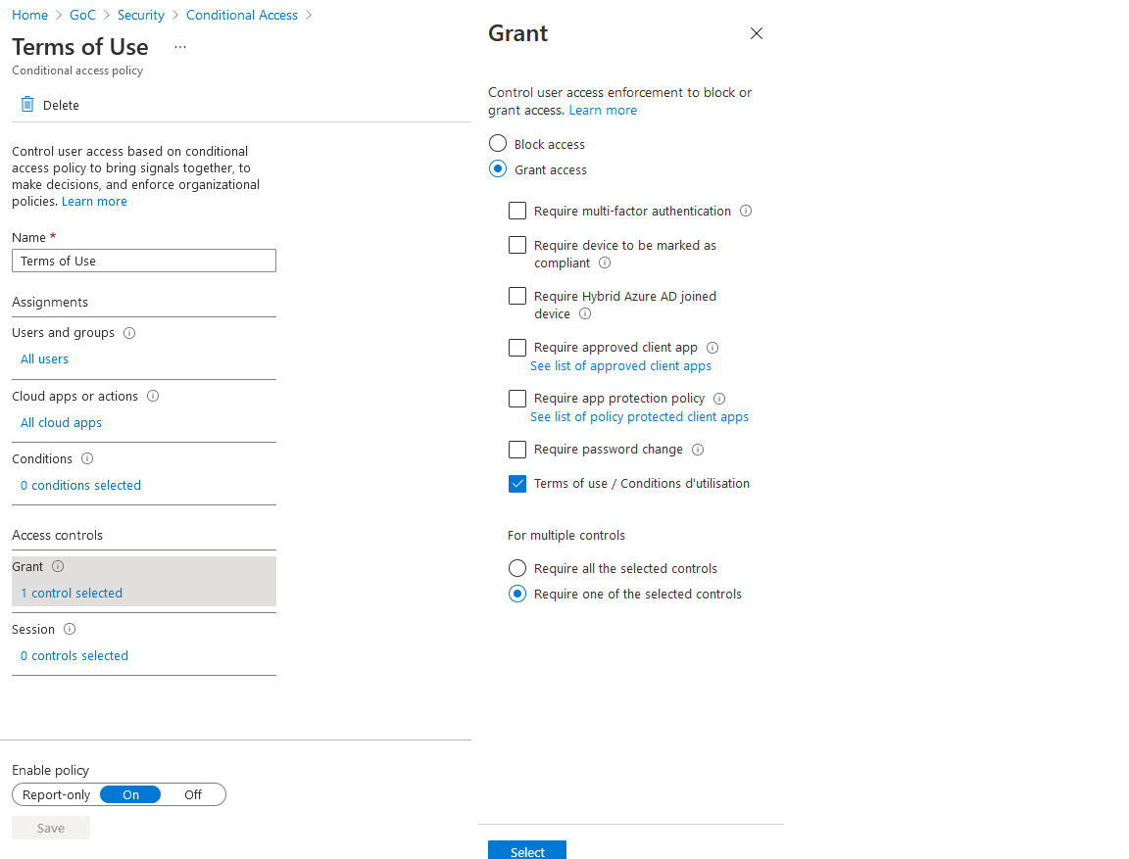

1. Asylum Application Architecture
2. Office 365 Security Baseline 1.1 – Asylum